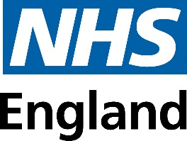

Appendix 3
NHS Equality Delivery System
EDS Report for Lincolnshire ICB (covering period April 23 to March 24).
Report 3 for EDS Domain 3 – Inclusive Leadership – February 2025

NHS Equality Delivery System (EDS) – LICB Domain 3 report for data 2023-24
Name of Organisation |  | Lincolnshire ICB | Organisation Board Sponsor/Lead
 |  | Lincolnshire ICB | Martin Fahy – Chief Nurse
Name of Integrated Care System |  | Lincolnshire ICS

EDS Lead | Kamljit Obhi/Vanessa Wort |  | At what level has this been completed?
 |  |  |  | *List organisations
EDS engagement date(s) | 8 January 2025 - Peer Review |  | Individual organisation | Regular updates of the EDS process and findings were shared/discussed at the ICB business meetings, equality forum meetings with providers and benchmarked with other ICBs in the midlands.
 |  |  | Partnership* (two or more organisations)
 |  |  | Integrated Care System-wide*

Date completed | February 2025 | Month and year published | February 2025
Date authorised | 27 February 2025 | Revision date | February 2026

Completed actions from previous year
Action/activity | Related equality objectives
EDS Domain 3 completed for the first time in 2023  EDI Objectives agreed and published  Work on Strategy commenced | Inclusive Leadership – relating to LICB Objective 1 and NHSE EDI improvement plan - high impact area 1

Glossary
BAF | Board Assurance Framework
CYP | Children and Young People
EDI | Equality Delivery System
EDS | Equality Delivery System
EIA | Equality Impact Assessment
GPG | Gender Pay Gap
HIE | Health Inequalities
HEAT | Health Equity Assessment Tool
LGBT+ | Lesbian, Gay, Bisexual, Transgender, Queer Plus
LeDeR | LeDeR is a service improvement programme for people with a learning disability and more recently autistic people.
LWC | Living with Cancer
OQAG | Operations Quality Assessment Group
PCQAG | Primary Care Quality Assessment Group
PCPG | Primary Care People Group
PCN | Primary Care Network
PSED | Public Sector Equality Duty
QIA | Quality Impact Assessment
SEND | Special Educational Needs
SMODG | Senior Manager Operational Delivery Group
WDES | Workforce Disability Equality Standard
WRES | Workforce Race Equality Standard

- EDS Domain 3, Inclusive Leadership: Report of findings relating to EDS outcomes – Draft
This report focuses on LICB implementation of NHSE EDS Domain 3 for April 2023 to March 2024 period. Domain 3 comprises three outcomes that are a test of commitment and inclusive leadership. Scores have been allocated to each outcome in this domain.
The three outcomes and how we collected information/evidence for each:
Domain 3 – Inclusive Leadership.
3A: Board members, system leaders (Band 9 and VSM) and those with line management responsibilities routinely demonstrate their understanding of, and commitment to, equality and health inequalities – A letter and online form were developed to all leaders Band 8a and above and those with line management responsibilities (mainly bands 6+). The responses have been analysed to inform the evidence for this outcome.
3B: Board/Committee papers (including minutes) identify equality and health inequalities related impacts and risks and how they will be mitigated and managed – Evidence was collected in liaison with the Head of Corporate Governance. A random sample of substantive Board or prime committee papers from April 23 to March 2024, was collected. The percentage of papers that identified equality-related impacts, through analyses or other assessments was defined, and how negative impacts were mitigated, monitored, and managed.
3C: Board members, system, and senior leaders (Band 9 and VSM) ensure levers are in place to manage performance and monitor progress with staff and patients – A template was provided, and information was gathered on the levers that are in place to manage performance and monitor progress with staff and patients. This was provided by the Head of Corporate Governance.
- Independent Review
An independent Peer review meeting was held on 8 January 2025 with other ICBs undertaking work around EDS Domain 3 including Northants ICB and Leicester Leicestershire and Rutland (LLR). This meeting provided an opportunity to review and discuss findings and agree a final scoring of Domain 3. Regular updates of the EDS process and findings were also shared/discussed at the ICB business meetings, Equality Forum meetings and with EDI leads of the Provider Trusts.

- Analysis of evidence/information collected for EDS D3 outcomes

3.1 Outcome 3a – Board members, system leaders (Band 9 and VSM) and those with line management responsibilities routinely demonstrate their understanding of, and commitment to, equality and health inequalities. Summary of questionnaire findings (15 questions). Please note the summary focuses on the most relevant Q areas:
44 responses (44/129 – 34.02%)
Q3 Job title/position: job titles were mainly a range of managers from different areas e.g. care manager, delivery manager, office manager etc., and directors).
Q4 Band and role – Out of the 44 responses
- 13 responses were from Board/VSM/B9 (10%)
- 25 responses were from Band 8 a,b,c,d (19.37%)
- 6 responses were from Band 7,6 (4.65%)

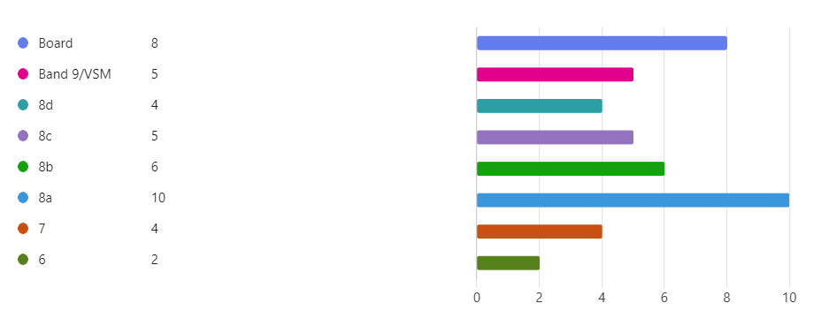
Q5 Directorate: The responses were from a wide range of directorates; the majority were from the Nursing directorate.
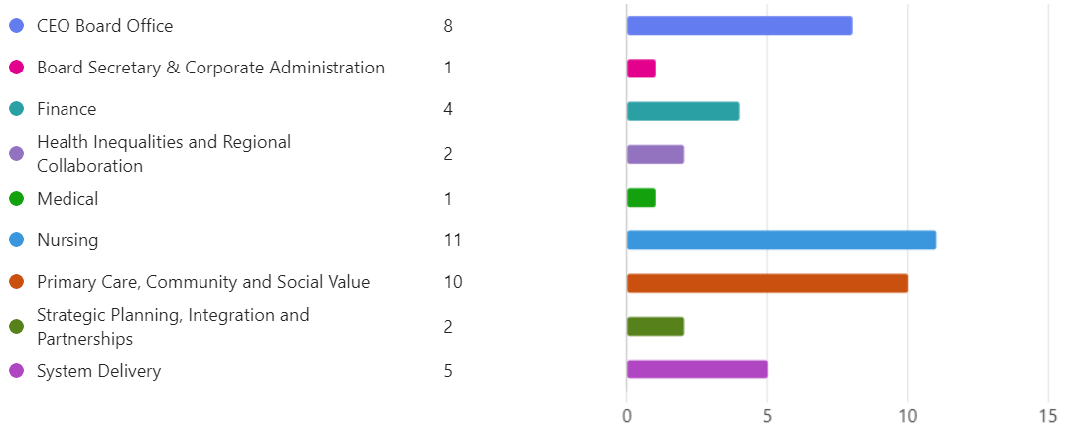

Q6 Involvement in Committees and Decision-making meetings
16 (36%) of the respondents are involved in a range of committees/boards – the list of responses is fairly extensive some examples of committees include: -
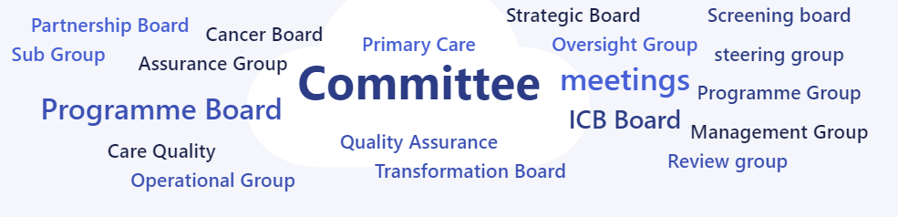

Q7-8 Authored any papers or reports relating to Equality Diversity Inclusion (EDI) and/or health inequalities (HI) – if so which papers?
29 (66%) - have not authored papers
15 (34%) - have authored papers or reports relating to EDI/HIE – examples include: -

- EDI quarterly reports
- Lincolnshire ICB EDI Equality Objectives 2024-27 and Public Sector Equality Duty (PSED) Report of EDI outcomes 2023-24
- Health Inequalities legal duties and completed HEAT (Health Equity Assessment Tool)
- Primary care networks approach to tackling inequalities
- Lincolnshire Living with Cancer Strategy 2023 - 2025 Published September 2023 https://lincolnshire.icb.nhs.uk/your-health-and-services/cancer-services/living-with-cancer-strategy-for-lincolnshire/ 'Developing a ‘Living with Cancer’ programme in a rural and coastal setting: Experiences of collaborative and innovative co-production across an Integrated Health System' Published December 2023
- Health Inequalities update report in February 2023. The ICB Executive team has also received updates on EDI progress
- Assignments on Golden thread of EDI. Whilst these assignments are not necessarily for the ICB, it does show that EDI elements are being considered and learned about and how, as a leader, EDI principles are implemented and embedded in practice. https://www.leadershipacademy.nhs.uk/programmes/elizabeth-garrett-anderson-programme/
- Supported line manager with business case for Safeguarding Children Strategy discussions.
- Childrens Safeguarding Front Door paper for FSIP (HEAT and HI referenced throughout) Supported development of LICB EDI Board Development Session - Feb 2024. Chair System EDI Forum - miniated meeting

Q9-10 attended any cultural, religious or EDI related events not connected to your own heritage or culture, as part of your role internally or externally as a member of the community? If so, include details
No 26 (59%)
Yes 18 (42%) of respondents attended certain cultural, religious or EDI related events, which included: -

- Black History Month event at the showroom. LGBTQ+ annual conference at the Lincs showground.
- Attended ICB EDI training sessions and board training
- Cultural Awareness Training; Oliver McGowan Training; Equality and Diversity Training
- Regional health inequalities conference
- 22/5/23 - Midlands Inequalities & Innovation Network Meeting (hosted by NHSE Midlands Covid vaccination team) 12/3/24 - HI Workshop: People from Eastern European Backgrounds (run by Lincs ICB Health Inequalities Team)
- Connected Cultures Network; Black History Month virtual session 11/10/24 Let's Talk: Tackling Racism & Discrimination in the Workplace 31/10/24
- NHS Communicate - Ethnic diversity in NHS communications Webinar. Cultural Awareness sessions for NHS-focus on healthcare, engagement, challenges and more. Midlands - Equality Training for ICB leadership teams (Lincolnshire)
- Reciprocal Mentoring Programme
- Networking with Senior EDI leader within NHS. Attendance and input into CQC well-led inspections. Consideration of Equality impact assessments and how best to embed
- Cultural awareness training relating to East European families. National training relating to poor outcomes in areas of deprivation and Black and Asian families
- Attended Connecting Cultures network meetings

Q11-12 have you given any EDI related presentations, speeches or talks at local events? If yes, please give details
No 38 (86%)
Yes 6 (14%) have given EDI related speeches or talks at local events, responses included: -
- Workshop at the Lincolnshire Cancer Summit, University of Lincoln
- Spoke at annual Community Nurse Conference
- Spoke at Staff network meetings - LGBTQ+, REACH. Chaired our Council of Staff Networks meeting those reports to our board. Opened the Lincoln Pride on stage, recorded speech for system Black History Month
- 14/3/24 - Start for Life/Family Hubs Steering Group - Presentation on childhood vaccination uptake in Lincolnshire including Health Inequalities
- Team Talk Live: Presentation on Health Inequalities/Health Inequalities Programme 25/9/23 https://vimeo.com/showcase/7367966?page=2&page=3&page=4&page=5&page=6&page=5; Dementia Conference - Health Inequalities Presentation 11/10/23
- Presented Allyship and the LGBTQ+ community presentation to the Finance Directorate - September presented Human Rights and Finance presentation to the Finance directorate on Human Rights Day- 10th December

Q13 have you been involved in supporting EDI in the following standards and tools?
Leaders have been involved in supporting around the tools, especially with EIAs, HEAT and WRES: -
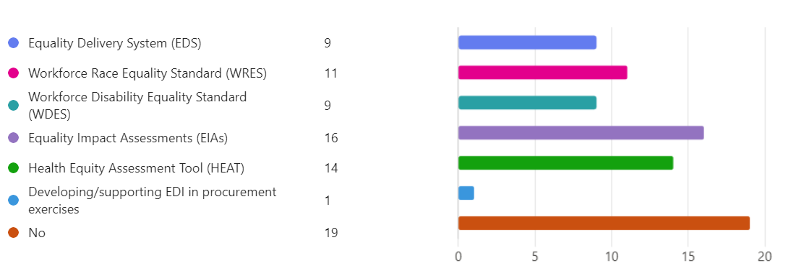

Q14 how have you helped to ensure that results from these standards, have improved the ICB's equality performance? Some key examples of responses received: -
- Information is reviewed for OQAG when Arden and GEM produce the reports for OQAG. Similarly, the same for the PCQAG (as was). Also, for my master’s course, national figures have been read and utilised for assignments. The information gives such an insight into the quality of a service and also the culture, a real sense check, identification of issues or good work being undertaken.
- New policies written and have had new EIA and QIA's completed.
- By questioning and challenging in Board meetings, including highlighting the lack of diverse images in the ICB's quality report
- Raising awareness especially in the fields of addressing health inequalities and prevention agendas. Ensuring that EDI remains a live issue and risk.
- My team review completed. HEATs ensuring each section is filled in appropriately and highlighting where the inequalities are and the action that should be taken.
- Board/executive team reporting and development session, taking EDI into refresh of trust strategy.
- Completed and signed off EIAs and HEAT for projects within my portfolio. Outputs and any recommendations are discussed through system governance processes.
- In my role as Chair of the Primary Care People Group (PCPG) and Clinical Workforce Lead for primary care, I commissioned a review of EDI needs and standards in primary care. This was accepted and the PCPG have a theme of EDI in the Primary care people plan. We are also part of the national primary care programme which is being developed in how to embed EDI in primary care more thoroughly.
- Implementation of Lincolnshire Living with Cancer Strategy 2023 - 2025 Published September 2023 https://lincolnshire.icb.nhs.uk/your-health-and-services/cancer-services/living-with-cancer-strategy-for-lincolnshire/
- Through my work in the clinical and care directorate and cancer any new piece of work ensures a HEAT tool is completed as part of the scoping phase to consider the inequities across the system
- I have worked with the HR team and members of the Quality and Nursing directors to interpret and provide evidence in relation to the Staff Survey findings which includes elements of EDI using a toolset used by my team.
- Reporting to SMODG and Execs Schedule 6 reporting is via OQAG
- The approach to all service delivery areas includes focus on health inequalities and how the system is identifying, measuring, prioritising, monitoring and reporting these. As a non-exec, my role is oversight to ensure we are delivering on our HI objectives and we are looking at EDI in the context of the Lincolnshire population, listening to our population, reaching in to ‘hard to reach’ sections and adapting our approaches accordingly. This is frequently discussed and challenged at Service Delivery Committee and at Board.
- Input into the ICB WRES/WDES Task Group; Advice and support to colleagues with HEAT
- I have completed and have ensured that my colleagues have completed the necessary forms (HEAT and EIA) when preparing finance business cases. In terms of standards, I have given refresher presentations on human rights, human rights law and the plight of the LGBTQ+ community in and out of a work setting.

Q15 please share any other activity that you feel demonstrates where you actively promoted equality in the last year as part of your Board, Executive, or line management role? Some examples of the responses received: -
- Inherent in my work with CYP with SEND
- Supporting team members who is an active Health Inequalities Champion work within UEC delivery helping to develop EIAs within the programme of work.
- Senior LeDeR review in the LeDeR programme
- I have spoken at Linc's university to student nurses. I also attended the GPN annual forum to speak about the importance of nursing in primary care and advancing their profile. I am also a mentor for aspiring leaders from Black, Asian and Minority Ethnic backgrounds
- The work being undertaken on the master’s has altered my whole mindset about EDI and really opened up the exposure of topics.
- Ensure staff in the team have received access to appropriate assessments and equipment assessments where there has been an identified health need.
- As a line manager EDI and Health Inequalities are a prominent feature in all aspects of Primary Care operational and commissioning responsibilities. Team complete mandatory and optional training and development sessions as and when available.
- I regularly ask about the impact of policies on the diverse and often disadvantaged communities we serve, and also challenged the CEO & Chair to ensure that they always consider appointing diverse Board members
- Attendance at Health Inequality workshops and completion of training. I have encouraged members of the team to attend these workshops. Ensuring the completion of EIAs when initiating a project and reviewing
- Presented the Lincolnshire LWC Programme at IPOS 2023 Milan, Italy September 2023 ID38059: Developing a ‘living with cancer’ programme in a rural setting: experiences of collaborative and innovative co-production across an Integrated Health System. Abstract accepted 10-minute oral presentation. https://journals.lww.com/jporp/citation/2023/09001/ipos_2023_abstracts_booklet.1.aspx
- HI focus and CORE20 Plus forms a central part of our engagement activity / involvement in zero tolerance system policy development (initial stages)
- Supported direct report to attend the DAL programme for aspirant leaders from a global majority background.
- Chair System Gender Identity Framework T&F group; Chair ICB EDS 1 T&F Group; Chair ICS CYP Integrated Transformation Board - CYP CORE20+5 (HI) is integral part of the work programme overseen via this Transformation Board
- Support of the Women’s Health Hub, successfully launched to support equality for women, particularly their ‘reproductive’ health and wellbeing which is often under served.
- Promotion of EDI and HI responsibilities throughout project management, procurement, staff development and recruitment activities within the directorate. Inclusion of HI metrics within directorate performance report. Involvement in development of collaborative working arrangements with ICB HI team.
- Programme Lead for Health Inequalities & Prevention. Development and delivery of the annual programme of work and including work to raise the profile of and embed Health Inequalities across the system. This included induction/training of new staff into the HI Team.
- Presented Allyship and the LGBTQ+ Community presentation to the Finance Directorate, September. Presented Human Rights and Finance presentation to the Finance directorate on Human Rights Day, 10th December. I have also written an article on Black history month and another article on Human rights for the Finance Monthly News Bulletin.

3.2 Outcome 3a – Recommendations for action:
- Committee Papers: Ensure EDI elements of committee papers are fully documented to present the depth of EDI considerations
- Leadership Representation at cultural, religious or EDI events: Ensure ongoing visibility of ICB leaders to attend such events and networks by prioritising appropriate time or delegating within teams
- EIA and HEAT: Ensure EIA and HEAT tools are completed is part of any service extension/transformation and/or development. Ensure EIA underpin any financial decision making.
- Training: Provide ongoing EIA training for staff across the organisation will help build confidence and understanding in this area. It is particularly valuable for senior staff and Board Members with staff responsibilities to participate in this training to support their roles effectively. By embedding these practices, the organization can continue to strengthen its commitment to equality, diversity, and inclusion.

3.3 Scoring for outcome 3a = 3 (Excelling)
3.4 Outcome 3b – analysis of evidence/information.
Outcome 3B: Board/Committee papers (including minutes) identify equality and health inequalities related impacts and risks and how they will be mitigated and managed.

Equality and health inequalities related impacts and risks and how they will be mitigated and managed:

Cttee. | Paper Title | Date | Risks | Mitigations | Managed
Integrated Care Board | Public meeting of the Lincolnshire care Board and  Minutes | x 6 meetings April 2023 to March 2024 | all reports cover contents relating to health inequalities included as core purpose 1 and health outcomes included as core purpose 2  e.g., of areas: autism strategy, reducing health inequalities for people with severe mental health, PCN health inequalities – reports provided  checklist includes the requirement for EIA/QIA and HEAT to be undertaken  EDI items brought to SMODG to review/discussion and sign off.  EDI quarterly reports and feedback presentation and final approvals. | all reports focus on priorities and include overview of key data/information to highlight changes/improvements or requirement of further work – references to the use of heat and EIAs to assess impact on protected characteristics and social exclusion groups where relevant are given. Findings of different reports are shared. | ongoing review and updates provided through these meetings relevant sub-meetings required actions and interventions are measured and monitored.
 | Clinical polices sub-groups meetings | Up to 6 meeting
 | SMODG meetings | Up to 12 meetings
 | Executive meetings | Weekly
 | Finance and Resource Cttee | Monthly | All reports include front cover sheets that ask for Equality and health inequality implications information and whether EIA and HEAT are under-taken. All agendas and notes have some reference to equality and particularly financial implications of Health inequalities outcomes.

3.5 Outcome 3b: Recommendations for Action
- Encourage managers to specify in their reports how mitigations, actions and interventions are having the anticipated outcomes against the diversity strands and how these are being monitored
- Improve scheduling of EDI priorities/monitoring on SMODG and Executive meeting agendas
3.6 Scoring 3b = 3 (excelling)
3.7 Outcome 3c: Board members, system, and senior leaders (Band 9 and VSM) ensure levers are in place to manage performance and monitor progress with staff and patients/service users.
- Bi-weekly EDI meeting between AGEM and LICB EDI champion – updates on work and ongoing implementation/review of EDI work plan
- SMODG reports re EDI work – WRES and EDS and other quantitative and qualitative data reports including equality developments and initiatives
- Executive quarterly reports – updates on all equality areas and ongoing priorities for each new quarter
- ICB Board Cover Sheet – all reports cover EDI and HIE elements
- SMODG cover sheet – all reports cover EDI and HIE elements
- Clinical Policies Sub-Group reports includes a checklist which includes the requirement to undertake EIA, HEAT and QIA’s as part of the review and or development of all clinical policies
- Annual report – includes EDI report and is communicated to staff and services users
- Team Talk live and Team Talk news weekly allows for regular EDI briefing and circulation of information via newsletters

3.8 Outcome 3c: Recommendations for Action
- Regular attendance at SMODG to support implementation and monitoring of WRES, EDS and future work around WDES and GPG
- Consider the setting up of a data collection and analysis group to enable annual collation of data to be produced, so that information can be compared and gaps to be identified – this would support ongoing review of WRES, EDS implementation ICB EDI objectives work
- WRES action plan – Continue implementation of WRES action plans via the WRES task and finish group established 23-24. Incorporate WDES and EDS actions as part of this group. Outcomes of work to be reflected in quarterly executive reports.
3.9 Scoring 3c = 2 (Achieving)
Total score for Domain 3 = 8
- Domain 3 Inclusive Leadership – action plan 25-26
Outcome | Objective | Action | Strategic links | Completion date
- 3A: Board members, system leaders (Band 9 and VSM) and those with line management responsibilities routinely demonstrate their understanding of, and commitment to, equality and health inequalities | - Publication of the LICB EDI strategy 2024-28 based on EDI objectives.  - Be able to demonstrate how Lincolnshire demographics information has informed action to address health inequalities.  - Demonstrate Visible leadership – proactive involvement in communicating EDI within the ICB and externally. | - Development of strategy with clear engagement with staff, senior leaders and public.  - Review Lincolnshire wide demographics and health inequalities data to assess disparities and compare trends amongst different communities and associated factors.  - ICB leaders to attend EDI related events and networks by prioritising appropriate time or delegating team members. | NHSE Workforce improvement plan High impact area 1  Local demographics profiles and Population health profiles Public Health Management data  EDS domain 3 Outcomes 3A, 3B and 3C | March 26
- 3B: Board/Committee papers (including minutes) identify equality and health inequalities related impacts and risks and how they will be mitigated and managed | - All reports provide information on EDI risks, mitigations and how they are managed.  - EDI and Health inequalities are integral part of the organisation and the Board decision making processes. | - Review and update of reporting templates to ensure EDI/HIE aspects are not lost.  - Quarterly monitoring and review of EDI outcomes – qualitative and quantitative |  | March 26
- 3C: Board members, system, and senior leaders (Band 9 and VSM) ensure levers are in place to manage performance and monitor progress with staff and service users | - Annual Chair/CEO appraisals on EDI objectives.  - Senior managers and board members are committed to monitoring EDI progress through regular reporting. | To be included as part of the Board Assurance Framework (BAF)  - Regular attendance at SMODG to support implementation and monitoring of WRES, EDS and future work around WDES and GPG.  - Continue implementation of WRES action plans via the WRES task and finish group established 23-24. Incorporate WDES and EDS actions as part of this group.  - Quarterly EDI updates to Executive Team  - Annual Board EDI Development session to be delivered.

