NHS Lincolnshire ICB (LICB) Gender Pay Gap (GPG) Report
August 2025 - Redacted
- Introduction
All Public Sector organisations within the United Kingdom with more than 250 employees have been required since April 2017 to publish details of their gender pay gap annually. This organisation is therefore required by law to carry out Gender Pay Reporting in accordance with the Equality Act 2010 (Gender Pay Gap Information) Regulations 2017.

- Calculations
This involves carrying out calculations that show the difference between the average earnings of men and women in our organisation. The data is taken from the existing employee records held in ESR.
- percentage of females and males in each hourly pay quarter
- mean (average) gender pay gap using hourly pay
- median gender pay gap using hourly pay
- percentages of employees in each hourly pay group by gender in LICB

The two other measures
- mean bonus gender pay gap and
- median bonus gender pay gap
do not apply to LICB as the LICB does not pay bonuses and therefore has no data to report in this regard.
The ICB publishes the results on its own website and the government website www.gov.uk/genderpaygap.
The calculations make use of two types of averages, a mean average and a median average. Using these two different types of average is helpful to give a more balanced overview of an employer’s overall gender pay gap. We can use these results to assess:
- the levels of gender equality in our workplace
- the balance of male and female employees at different levels
- how effectively talent is being maximised and rewarded.

The gender pay gap shows the difference in the average hourly rate of pay between women and men in an organisation, expressed as a percentage of the average male earnings. A gender pay gap can be driven by a number of factors, including crucially, a lack of women in senior positions.
It is important to note that gender pay reporting is different to equal pay.
• Equal pay deals with the pay difference between men and women who carry out the same jobs, similar jobs, or work of equal value. It is unlawful to pay people unequally because they are a man or woman.
• The gender pay gap shows the difference in the average pay between all men and women in a workforce This report follows the calculation methodology set out by the Government Equalities Office to report the mean and median gender pay gap across pay quartiles.

- Summary

  - Highlights of what the data is telling us



Women get paid less than men by 15.61%
Using median (average) hourly pay
Women get paid less than men by 23.77%
Using mean (average) hourly pay
Pay Gap
25.68%
Of the LICB workforce are male
74.32%
Of the LICB workforce are female

3.2 Workforce Composition:
LICB employs 405 people on the payroll. 301 (74.32%) are female and 104 (25.68%) are male. Calculated on, the basis of earnings as at the pay period which includes 31 March 2025.
3.3 Pay Gap Statistics:
- Our mean gender pay gap is 23.77%. This is a widening of 1.48% on last year’s mean pay gap of 22.29%.
- Our median gender pay gap is 15.61% This is a widening of 3% on last year’s median gender pay gap of 12.61%
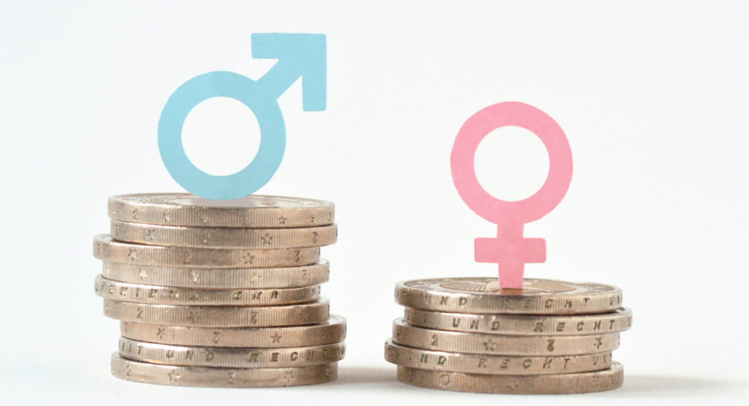
£1.00
76.2p

This means for every £1 a man earns, a woman will earn 76.21p.

This suggests, disproportionally there are more men working at the higher levels, and therefore paid more, coupled to the number of women in the most junior roles, paid less.
3.4 Pay Quartiles:
Despite women being in the majority, men dominate the upper pay quartiles, indicating underrepresentation of women in senior and higher paid roles.
3.5 Comparative context:
LICB’s pay gap is significantly higher than the national average (13.01%) and regional benchmarks.
3.6 Structural Risks:
Upcoming NHS Reforms (e.g. ICB restructuring, redundancies, digital transformation) may disproportionately impact female staff, especially in lower bands.
Risks include reduced career progression, increased stress, and loss of leadership diversity.

- Gender Pay Gap in the UK
In April 2024, the Office for National Statistics shows that among all employees (full and part time), the gender pay gap decreased to 13.01% in April 2024, from 14.2% in April 2023 nationally
The TUC points out this pay gap means that the average woman nationally must work 48 days before she starts getting paid in comparison to the average man.

  - How LICB compares with other ICBs.
It is useful to have a benchmark by comparing published 2024-25 data of similar ICB Workforce in the Midlands region.
- Taking the overall mean and median for 2023-24 for some of our neighbouring Midlands ICBs, the combined mean and median are 29.60 and 17.75 respectively.
- Taking the overall mean and median for 2024-25 for some of our neighbouring Midlands ICBs, the combined mean and median are 26.37 and 14.92 respectively.
- For 2024-25, LICB had a 23.77 hourly rate which is lower than the average neighbouring Midlands ICBs mean of 26.37 (-2.60) and the median of 15.61 a higher median average of neighbouring ICBs of 14.92 (+0.71).

ICB | Year | Mean % | Median %
Lincolnshire ICB | 2023-24  2024-25 | 22.29  23.77 | 12.61  15.61
Black Country | 2022-23  2023-24 | 35.92  26.92 | 32.05  24.68
Coventry & Warwickshire | 2022-23  2023-24 | 24.66  19.42 | 16.36  14.15
Derby and Derbyshire | 2022-23  2023-24 | 31.9  Not  published | 25.2  Not  published
Leicester, Leicestershire, and Rutland | 2022-23  2023-24 | 19.60  21.30 | 5.46  11.15
Nottingham and Nottinghamshire ICB | 2022-23  2023-24 | 35.95  37.84 | 9.72  9.72

4.2. How the LICB 2025 figures compare with other previous years.
It is useful to see the previous years’ GPG figures for LICB to understand our journey.

Year | Mean % | Median %
2024-2025 | 24.27 | 15.61
2023-2024 | 22.29 | 12.61

- Why do we have a gender pay gap?
The main reason for the gender pay gap is to review the in-balance in the numbers of men and women’s pay across the whole workforce. The LICB pay quartiles broadly reflect the uneven distribution of women through the grades in LICB.
- Proportionately more men are in the upper quartile than other quartiles, meaning that proportionally more women than men are in lower paid grades.
- It is important to note that as a small organisation a 1% change represents about 4 people moving. By looking at our data over time we can see that since 2024 the trend is that the gender pay gap is not improving and we need to be vigilant moving forward to encourage and develop women to progress within the organisation.
6. Calculation 1: percentage of females and males in each hourly pay quarter
Pay quarters show the percentage of full-time female and male relevant employees in four equal sized groups based on their hourly pay. The pay quartiles are created by ranking each full-time employee in order from lowest earning (first quartile) to highest earning (fourth quartile).
Pay quarters give an indication of women's representation at different levels of the organisation. In the ICB in each pay quarter, as illustrated in the below table, female and males occupy:
Proportion of females and males in each quartile band



Quartile

2024-25 - Quartile | Female | Male
Q4 Upper (highest paid jobs) | 57.80% | 42.20%
Q3 Upper Middle | 82.00% | 18.00%
Q2 Lower Middle | 80.00% | 20.00%
Q1 Lower (lowest paid jobs) | 79.17% | 20.83%

More women are employed in Q3, Q2 and Q1 the lower paid roles with Q3= 82% female. In Q4 proportionally more females are in the highest paid roles. In addition, men tend to be in roles that receive higher pay, with 42.20% of the male staff being in the upper quartile.

The contrast can be seen in the graph below.

Number of female and male staff in each quartile
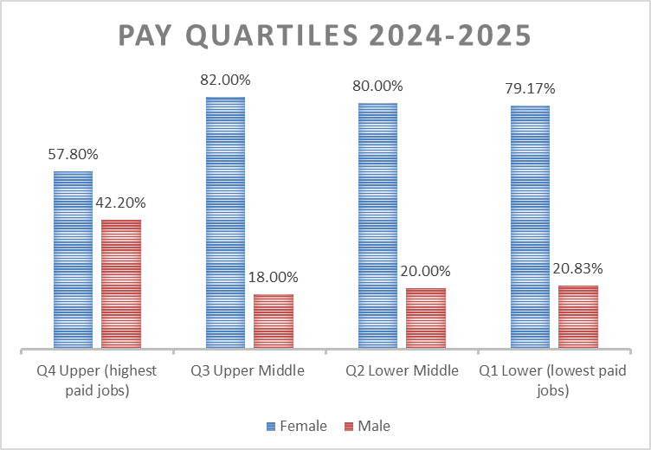

A comparison of the pay quartile tables over the last two years shows that the gender pay gap widening over time. The percentage of females in the upper quartile has decreased, whilst the percentage of males has increased. The percentage of women in the lowest percentile has also increased, whilst that of males has decreased.

Women continue to be underrepresented within the highest pay quartile (57.80%), compared to their level of representation amongst all full-pay relevant employees (73.09% female), and men continue to be overrepresented within the highest pay quartile (42.20%), compared to their level of representation amongst all full-pay relevant employees (26.10% male).
Moreover, this worsening situation means the LICB is not reflective of the national situation whereby the gap is closing marginally over time. The TUC calculate that at current rates it will take until 2044 to close the gap.

Quartile | 2024  Female | 2025  Female | 2024  Male | 2025  Male
Q4 Upper (highest paid jobs) | 61.00% | 57.80% | 39.00% | 42.20%
Q3 Upper Middle | 82.00% | 82.00% | 18.00% | 18.00%
Q2 Lower Middle | 78.02% | 80.00% | 21.98% | 20.00%
Q1 Lower (lowest paid jobs) | 76.04% | 79.17% | 23.96% | 20.83%

7. Calculations 2 and 3: The mean (average) and median gender pay gap for hourly pay

7.1. Mean Calculation
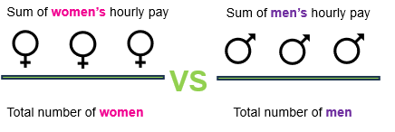

The mean (average) is calculated by adding up the wages of all relevant employees and dividing the figure by the number of employees. The mean gender pay gap is calculated based on the difference between mean male pay and mean female pay.
7.2. Median Calculation
The median is the figure that falls in the middle of a range when the wages of all relevant employees are lined up from smallest to largest. The median gap is calculated based on the difference between the employee in the middle of the range of male wages and the middle employee in the range of female.

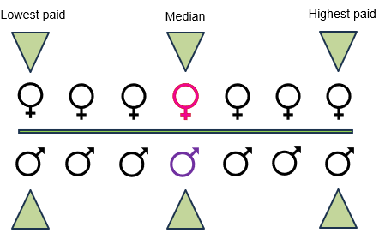

The table below also shows the overall median and mean gender pay gap based on hourly rates of pay as the snapshot date of 31 March 2025.
Mean | Median
23.77% | 15.61%

8. Calculation 4: representation of gender in LICB Organisation structure and pay
LICB uses the standard NHSE Agenda for Change (AFC) grading system ranging from Band 1 - 9. In addition, there are other localised grades for some VSM (very senior manager) roles.
LICB employs 405 people on the payroll. 301 (74.32%) are female and 104 (25.68%) are male. Graph below:
Number of female and male staff in the Workforce
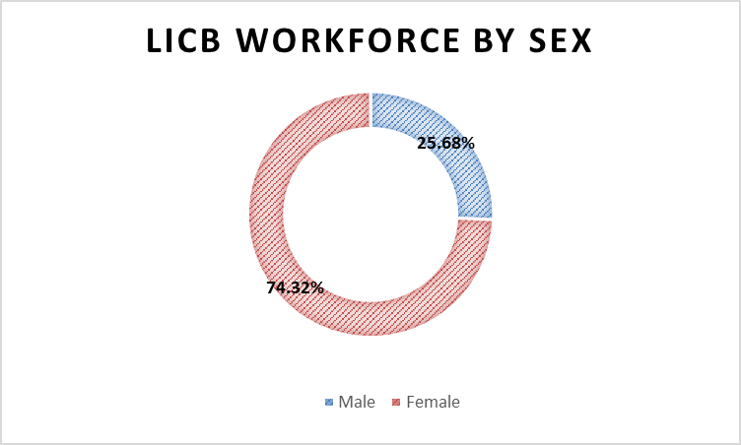

9. Number of people in each pay group (Redacted)
A note on redacted data
Where the numbers of staff (or associated identifying data) for a category are below ten, the detail has been redacted. This is to ensure anonymity and that individual members of staff cannot be easily identified. The numbers less than ten are represented in the data by the symbol ‘-‘. This does not mean that there were zero numbers rather that they are less than ten.
If there were no counts at all the number zero would be kept in the data.
Band | Female | % Total of workforce | Male | % Total of workforce | Total
Band 2 | ‘-‘ | 1.48% | ‘-‘ | 0.49% | 8
Band 3 | 37 | 9.14% | 11 | 2.72% | 48
Band 4 | 32 | 7.90% | ‘-‘ | 0.99% | 36
Band 5 | 31 | 7.65% | ‘-‘ | 1.98% | 39
Band 6 | 44 | 10.86% | 13 | 3.21% | 57
Band 7 | 54 | 13.33% | 11 | 2.72% | 65
Band 8 - Range A | 41 | 10.12% | 12 | 2.96% | 53
Band 8 - Range B | 15 | 3.70% | 12 | 2.96% | 27
Band 8 - Range C | 16 | 3.95% | ‘-‘ | 1.48% | 22
Band 8 - Range D | ‘-‘ | 0.99% | ‘-‘ | 1.23% | 9
Band 9 | ‘-‘ | 1.48% | ‘-‘ | 1.23% | 11
Other/Non AfC | 15 | 3.71% | 15 | 3.70% | 30
Grand Total | 301 | 74.32% | 104 | 25.68% | 405
Grand Total | 269 | 73.90% | 95 | 26.10% | 364
Women continue to be over-represented in more junior grades, where pay is lower, and under-represented in more senior grades.
10. What the Data is Telling Us
This is the second reporting year, according to the data, with the mean average, men are paid 23.77% more than women. Which means for every £1 a man earns, a woman will earn 0.76p. This compares to 2023-24 where for every £1 a man earned a woman earned 77.7p.
As shown in the comparison tables below of those employees on agenda for change AfC, males have the highest representation in Bands 8a and above of 44.94% compared to 28.67% females at the same level.
The percentage of male staff in bands 8a and above has decreased slightly by 3.47% from 48.42% in 2023-2024 to 44.94% in 2024-2025. For female staff there is also a decrease however it is more marked, down 5.16% from 33.83% in 2023 – 2024 to 28.67% in 2024 -2025.
There has been a corresponding increase of staff in bands 5-7. For males an increase of 3.33% and for females an increase of 5.05%.
Bands 2 – 4 remained broadly static for the same period.
AfC Band | Female  2023 - 2024 | Male  2023 - 2024 | Female  2024 - 2025 | Male  2024 - 2025
Band 8a and above | 33.83% | 48.42% | 28.67% | 44.94%
Bands 5 - 7 | 40.05% | 32.63% | 45.10% | 35.96%
Bands 2 - 4 | 26.02% | 18.95% | 26.23% | 19.10%
Total | 100% | 100% | 100% | 100%

11. What can LICB do close the Gender Pay Gap?
1. Strategic Action Planning
- Implement the Gender Pay Gap Action Plan (2024 – 2026) aligned with the NHSE’s EDI Improvement Plan and consider working with the wider Cluster Group
- Use evidence-based frameworks from government and TUC resources

2. Leadership and Career Development
- Promote gender balance in senior roles through:
  - Leadership development programmes
  - Mentoring schemes
  - Transparent promotion pathways
3. Pay structure review
- Ensure transparent job evaluation, equitable recruitment, and fair progression criteria
4. Bias Mitigation & Training
- Train managers on unconscious bias, inclusive hiring, and equitable performance reviews.
- Introduce regular pay audits and publish findings to maintain accountability.
5. Flexible & Inclusive Work Culture
- Expand flexible working policies and support for carers.
- Ensure digital transformation is inclusive and accessible to all staff.
6. Staff Engagement & Governance
- Engage EDI networks, staff forums, and senior leaders in co-designing solutions.
- Monitor reform impacts and ensure diversity is preserved in leadership during mergers or restructuring.
To ensure the below plan is effectively implemented, the EDI network, Staff Engagement Group and key Executives will be engaged to ensure an effective delivery and achievement of the below action plan.

NHS ICB Reform – 2025
The government’s 10-Year Health Plan introduces major reforms to NHS Integrated Care Boards (ICBs), aiming to modernise services, improve outcomes, and ensure long-term sustainability. Central to this change are three strategic shifts: moving care from hospitals into communities, prioritising prevention over treatment, and expanding digital innovation through tools such as the NHS App and AI.
Structurally, NHS England will be abolished, with its functions moving to the Department of Health and Social Care. ICBs will be reshaped to focus on strategic commissioning, reduce running costs, and potentially merge or share leadership teams. Operational responsibilities will increasingly sit with providers and regional/national teams.
ICBs will be expected to drive innovation, reduce variation, meet minimum standards across seven domains, and balance national priorities with local needs. Workforce changes include voluntary redundancy schemes, a refreshed workforce model with an emphasis on training, wellbeing, and leadership, alongside limited opportunities for public engagement due to time and resource constraints.
Potential Considerations in Relation to the Gender Pay Gap
From a Gender Pay Gap perspective, several risks arise and should be considered in light of the reforms. Redundancies may disproportionately affect female staff, particularly those concentrated in lower bands or administrative roles. Restructuring and budget cuts could also restrict career progression and mobility for these groups.
There are concerns about staff wellbeing, with uncertainty and workload pressures potentially worsening stress, especially for female staff who already face systemic barriers. Digital transformation carries risks of exclusion if accessibility and equitable support are not prioritised.
Finally, leadership representation may be impacted if mergers reduce diversity at senior levels without proactive inclusion measures. Rapid reform may also limit meaningful engagement with staff networks, potentially silencing underrepresented voices and missing opportunities to co-design inclusive workforce strategies.
It is therefore imperative to ensure that any risks are considered, and mitigations are put into place.

  - Draft Gender Pay Gap Action Plan 2024 to 2026

High Impact Action | Theme | Action | Lead | Progress to date | Review Date
High impact Action 2 – Embed fair and inclusive recruitment and talent management strategies | Branding / communication / transparency | Create and implement a talent management plan to improve the diversity of executive and senior leadership and monitor any impact  Monitor for any gender bias in the recruitment and the personal development plan processes, especially supporting women’s in leadership development. | HR/SLT  EDI Leads /HR | Launched 4 June 2025 - The Women’s Leadership Programme  WRES/WDES Action Plan (Link) | June 2026  October 2026
High impact Action 2 – Embed fair and inclusive recruitment and talent management strategies | Recruitment and promotion processes | Implement a plan to widen recruitment opportunities within local communities, including creation of career pathways into the NHS such as apprenticeships or Graduate Management Training Schemes to monitor for any gender bias.  Support recruiting managers to implement good and inclusive recruitment practices and interviewing techniques.  Review applicant profile data, to establish the number of male vs female applicants from point of application, shortlisting and appointment to identify any disparities between male and female applicants. | EDI Leads/HR  EDI Leads/ HR  EDI Leads/ HR | Vanessa Wort Nursing/midwifery regional programme  24/25 supported Lincolnshire system Graduate Placement student for * months.  LICB Apprenticeships for finance and administration  Finance First  WRES/WDES Action Plan (Link)  EIHR data collection / PSED (Link) | October 2024-26  2024-2026  September 2025 / March 2026
High impact Action 2 – Embed fair and inclusive recruitment and talent management strategies | Maternity and paternity and parental leave policies  (Family Leave) | Ensure ICB staff have a good understanding of Family policies using ICBs communication channels.  Look to incorporate a baby loss policy  Monitor uptake of Family Leave policies | EDI Leads/ HR/SLT  SLT  EDI Leads/ HR/ | Fostering incorporated into Family policy – April 2025 | March 2026  March 2026  March 2026
High impact Action 3 – Develop and implement an improvement plan | Wellbeing and retention | Monitor Gender, Race and Disability Pay Gaps to be monitored by the Board  Monitor the take up of flexible working policy  Review the Mind the Gap recommendations for medical staff and identify any of the learning and recommendations that are achievable for the ICB. | EDI Leads/HR  /Board  EDI Leads/HR  EDI Leads/HR | EDI Reporting  EIHR data collection / PSED | October 2025  September 2025  March 2026  March 2026
High impact Action 3 – Develop and implement an improvement plan | Women to Women mentoring/ networks | System work - Women’s lead across the system | ? | ? | ?

- Useful Resources
Government guidance on actions to close the gender pay gap can be found here:
Evidence-based_actions_for_employers.pdf (gender-pay-gap.service.gov.uk)
Four steps to developing a gender pay gap action plan.
https://gender-pay-gap.service.gov.uk/public/assets/pdf/action-plan-guidance.pdf
TUC Briefing, Equal pay day 2024 – tackling the gender pay gap.
EqualPayDay2024_Briefing.pdf (tuc.org.uk)
Office for National Statistics Gender Pay Gap in the UK: 2024
Gender pay gap in the UK - Office for National Statistics

(Office for National Statistics, p. 2024)
(TUC, 2024)
(TUC, 2024)

