Lincolnshire Integrated Care Board
Bridge House
The Point
Lions Way
Sleaford
NG34 8GG

Tel FOI team: 01246 514965
E-mail FOI team: agem.lincolnshireicb.foi@nhs.net
Web: www.lincolnshire.icb.nhs.uk
16 May 2023
FREEDOM OF INFORMATION – DECISION NOTICE

Dear Requester
FOI Reference Number: 70561

I refer to your email of 13 April 2023 requesting information in relation to cataract procedures.

I can confirm on behalf of NHS Lincolnshire Integrated Care Board (ICB) and in accordance with S.1 (1) of the Freedom of Information Act 2000 (FOIA) that we do hold some of the information that you have requested. A response to each element of your request is detailed below.

Please see below series of questions regarding procedures delivered and tariffs paid relating to the cataract (and YAG laser) pathway.

The HRG codes related to the below questions for reference are:

BZ31B | BZ32B
BZ33Z | BZ34B
BZ44B | BZ45B
BZ46A | BZ56B
BZ57A | BZ57B
BZ62B | BZ86B
BZ88A | BZ92B
BZ94B | BZ95Z

- Please confirm the number of cataract procedures performed that were commissioned by the ICB and conducted by the Hospital Trusts between 1 April 2022 and 31 December 2022.
1356

- Please confirm the number of cataract procedures performed on behalf of the ICB by each Independent Service Provider (as an individual entity) between 1 April 2022 and 31 December 2022.

Anglia Community Eye Service Ltd 1,220
Circle Health Group 16
HMT Hospitals 81

New Medical Systems Ltd (ACG) 134
Ramsay Healthcare 150
SpaMedica 1,326
Other <5
Due to the nature of the information sought, including the sensitivity and low numbers held the Trust has engaged section 40 relating to personal data to withhold the information from disclosure “…to the world at large.”

Statistical data which relate to fewer than five people could lead to the identification of individuals – especially when coupled with information already in the public domain, thus breaching Section 24(1) of the Data Protection Act 2018 and Article 21 of the UK General Data Protection Regulation. Therefore, we consider this information exempt from disclosure under Section 40(2) of the Freedom of Information Act 2000.

- Please confirm the fee paid per cataract procedure to each Independent Service Provider (as an individual entity) between 1 April 2022 and 31 December 2022.
Details of the tariffs charged
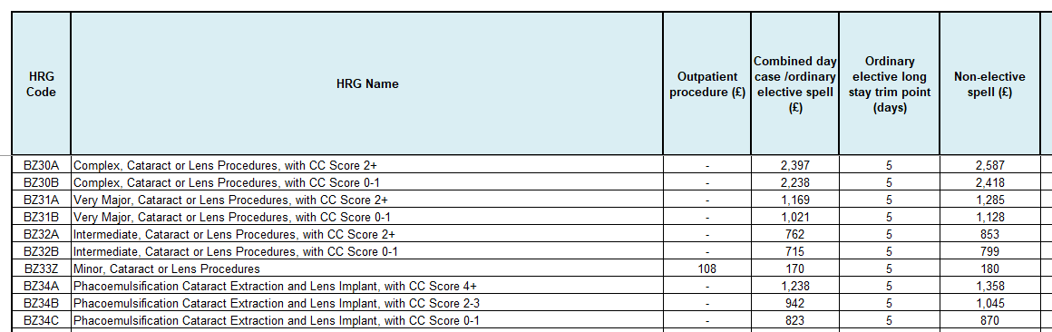

Details of the other tariffs can be found here - https://www.england.nhs.uk/wp-content/uploads/2020/11/22-23NT_AnnexA-National-tariff-workbook-Nov22-1.xlsx

- Please confirm the total fees paid in respect of the delivery of cataract surgery (including pre-assessment and post-operative fees) to each Independent Service Provider (as an individual entity) between 1 April 2022 and 31 December 2022.
The information sought in this request may be held by the ICB for this time period but it is not held in an easily retrievable format.
Section 12(1) of the FOIA (together with Regulation 4 of the Fees Regulations) makes provision for public authorities to refuse requests for information where the cost of dealing with them would exceed the ‘appropriate limit’. For NHS Lincolnshire ICB this limit is set at £450, or 18 hours work estimated at a rate of £25 per hour.
When calculating the cost of compliance, a public authority may only include the time that would be required to determine whether the requested information is held, and to locate, retrieve and extract the information.
The Freedom of Information and Data Protection (Appropriate Limit and Fees) Regulations 2004, Regulation 4(4)
http://www.legislation.gov.uk/uksi/2004/3244/regulation/4/made
To assist you further, the Information Commissioner’s guidance on Section 12 is available online at:
https://ico.org.uk/media/for-organisations/documents/1199/costs_of_compliance_exceeds_appropriate_limit.pdf
From a preliminary assessment, the ICB’s decision is that, in this case, even the time needed to determine whether information is held for this request and retrieve that information would exceed the ‘appropriate limit’ set out above.
This letter therefore serves as a refusal notice under section 17(1) of FOIA for the information sought relating to NHS Lincolnshire ICB.

The cost of complying with your request
In this case, it would greatly exceed the appropriate limit even to retrieve the data for the information sought.

This is because the request is seeking information regarding the fees paid in respect of the delivery of cataract surgery. Unfortunately, the ICB do not record this information in an easily retrievable format in an Outpatient Attendance perspective. The information requested may be held within a patient’s records history however it is not routinely recorded and the providers Patient Administration Systems should be able to link outpatient appointments to the Cataract pathway.

From the electronic records we have we would be unable to distinguish if the OP attendance was related to a Cataract referral/pathway or not.

The ICB is obliged, in compliance with section 16 of FOIA, to provide advice and assistance in refining the request to bring it within compliance of 18 hours.

In this instance it is challenging to provide advice regarding refining the request other than to refine the request by either: -
- Assume that applying the % of IP/OP Cataract activity to the remainder of Ophthalmology Outpatient to identify the cohort of activity would be cataract activity. E.g. if Cataracts takes 60% of IP/OP procs then apply this same percentage to the remainder of Outpatient face to face appointments to find the number of Firsts and FUPs for Cataracts
- Or you could generally assume that each patient has one new appointment with a 1 follow up appointment
- Take a sample of one months Cataract spells and see how many times those patients had a new and FUP OP appointment within a 3 month window of the treatment. In this scenario you would have to assume that the patient was only referred or treated for Cataracts and no other eye condition.
- Ask the providers direct for the information.

If you would like to make a request along these lines, please let me know. We will then proceed to retrieve the requested information and to determine whether the information may be disclosed or whether an exemption applies.

- Please confirm the fee paid per cataract pre-assessment (per individual and for all individuals collectively) to each Independent Service Provider (as an individual entity) between 1 April 2022 and 31 December 2022.
Please see response to Question 4
- Please confirm the fee paid per cataract post-operative assessment (per individual and for all individuals collectively) to each Independent Service Provider (as an individual entity) between 1 April 2022 and 31 December 2022.
Please see response to Question 4
- Please confirm the number of YAG capsulotomy procedures performed on behalf of the ICB by the Hospital Trusts (as an individual entity) between 1 April 2022 and 31 December 2022. (HRG BZ33Z)
39

- Please confirm the number of YAG capsulotomy procedures performed on behalf of the ICB by each Independent Service Provider (as an individual entity) between 1 April 2022 and 31 December 2022.

Anglia Community Eye Service Ltd 358
Circle Health Group 0
HMT Hospitals 0
New Medical Systems Ltd (ACG) 0
Ramsay Healthcare 0
SpaMedica 421
Other 0

- Please confirm the fee paid per YAG capsulotomy procedure to each Independent Service Provider (as an individual entity) between 1 April 2022 and 31 December 2022. Almost all patients who have a YAG attract the HRG tariff of BZ33Z. Based upon the November 2022 prices - £170 before Market Forces Factor (MFF)

- Please confirm the total fees paid in respect of the delivery of YAG capsulotomy surgery (including pre-assessment and post-operative fees) to each Independent Service Provider (as an individual entity) between 1 April 2022 and 31 December 2022.
Please see response to Question 4

I hope that this answers your queries with the information we currently hold, but if I can be of any further assistance please do not hesitate to contact me.

If you are dissatisfied with the handling of your request, you have the right to ask for an internal review. Internal review requests should be submitted within two months of the date of receipt of the response to your original letter and should be addressed to

Arden & GEM Greater East Midlands Commissioning Support Unit
FOI TEAM/Corporate Communications Team
1st Floor, St John’s House
East Street
Leicester
LE1 6NB
If you are not content with the outcome of your complaint, you may apply directly to the Information Commissioner for a decision. Generally, the ICO cannot make a decision unless you have exhausted the complaints procedure provided the ICB.

The Information Commissioner can be contacted at: telephone 0303 123 1113,
email icocasework@ico.org.uk and https://ico.org.uk/global/contact-us/

Under the terms of the Open Government Licence, you may use and re-use the information provided within this response (not including logos or photographs), free of charge in any format or medium; unless identified as another party’s copyright.
http://www.nationalarchives.gov.uk/doc/open-government-licence/version/3/

Yours faithfully

Lindsay Parker
Senior Freedom of Information Officer

On behalf of
NHS Lincolnshire ICB

