Lincolnshire Integrated Care Board (ICB)
Bridge House
The Point
Lions Way
Sleaford
NG34 8GG

Tel FOI team: 01246 514965
E-mail FOI team: agem.lincolnshireicb.foi@nhs.net
Web: www.lincolnshire.icb.nhs.uk
16 August 2023
FREEDOM OF INFORMATION – DECISION NOTICE

Dear Requester
FOI Reference Number: 71326

I refer to your email of 03 August 2023 requesting information in relation to of ear wax removal services.

I can confirm on behalf of NHS Lincolnshire Integrated Care Board (ICB) and in accordance with S.1 (1) of the Freedom of Information Act 2000 (FOIA) that we do hold the information that you have requested. A response to each element of your request is detailed below.

- Does the integrated care board currently commission an ear wax removal service or services within primary care or community ear care services, available to all patients registered with GP practices within the ICS’s boundary, as per NICE guidance?
Yes

- If it does, how can a patient access this service or services when it is considered clinically necessary and/or self-care advice, if appropriate, has been unsuccessful?
Patients are referred via their GP to the Elective Activity Coordination Hub (EACH)

- If the integrated care board does commission this service or services within primary care or community ear care services, please provide the name or names of those commissioned providers and their address or addresses.

Please see the table below
Please Note – These are the current commissioned providers as they have been appropriately accredited and mobilised, other providers are yet to be onboarded.

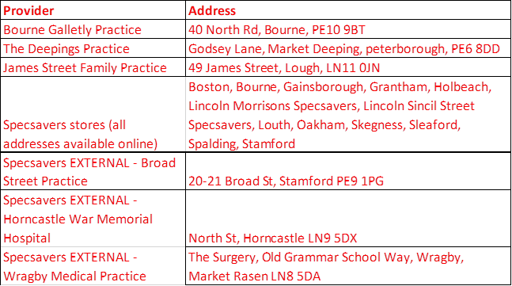

- Does the integrated care board have a policy or guidance on ear wax removal and/or referral pathways for its primary care providers for patients for whom the benefit of ear wax removal is clinically indicated?
Yes
- If the integrated care board has issued such guidance, please provide a copy.
Please see the attached file
I hope that this answers your queries with the information we currently hold, but if I can be of any further assistance please do not hesitate to contact me.

If you are dissatisfied with the handling of your request, you have the right to ask for an internal review. Internal review requests should be submitted within two months of the date of receipt of the response to your original letter and should be addressed to

Arden & GEM Greater East Midlands Commissioning Support Unit
FOI TEAM/Corporate Communications Team
1st Floor, St John’s House
East Street
Leicester
LE1 6NB
If you are not content with the outcome of your complaint, you may apply directly to the Information Commissioner for a decision. Generally, the ICO cannot make a decision unless you have exhausted the complaints procedure provided the ICB.

The Information Commissioner can be contacted at: telephone 0303 123 1113,
email icocasework@ico.org.uk and https://ico.org.uk/global/contact-us/

Under the terms of the Open Government Licence, you may use and re-use the information provided within this response (not including logos or photographs), free of charge in any format or medium; unless identified as another party’s copyright.
http://www.nationalarchives.gov.uk/doc/open-government-licence/version/3/

Yours faithfully

Lindsay Parker
Senior Freedom of Information Officer

On behalf of
NHS Lincolnshire ICB

