27 September 2023

FREEDOM OF INFORMATION – DECISION NOTICE

Dear Requester
FOI Reference Number: 71517

I refer to your email of 08 September 2023 requesting information in relation to the ICB’s spend on In vitro fertilization (IVF).

I can confirm on behalf of NHS Lincolnshire Integrated Care Board (ICB) and in accordance with S.1 (1) of the Freedom of Information Act 2000 (FOIA) that we do hold some of the information that you have requested. A response to each element of your request is detailed below.

I am looking for some information to be answered under the Freedom of Information Act relating to IVF.

Please could you confirm:
- The ICB’s total spend on IVF for the financial year 2022/23, broken down by cycle
The ICB’s total spend on IVF for the financial year 2022/23 is £321,818.
Please see breakdown by Treatment in the table below:
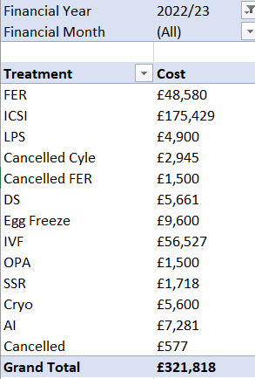

- If tenders for IVF cycle contracts are set at a fixed price or are open to bidding, or both?
  - How many were bids?
  - How many were fixed cost?
Commissioners from Nottinghamshire, Lincolnshire, Derbyshire and Northamptonshire went out to procure IVF & ICSI services in (year). As part of the procurement pack there was a well-defined pricing matrix with a range of treatment tariffs which each bidder was required to adhere to and there were no guaranteed activity levels. This pricing matrix now forms part of the contract held with each of the providers who were successful in the procurement process.
- The total number of cycles of IVF the ICB funded for the year 2022/23
The total number of cycles of IVF the ICB funded for the year 2022/23 is 202.
See breakdown by Treatment in the table below:
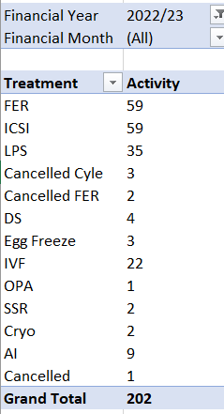

- The total number of people who received NHS-funded IVF in the ICB’s footprint for the year 2022/23
The total number of people who received NHS-funded IVF in the ICB’s footprint for the year 2022/23 is 117. Please note that there are NULL Local patient Identifiers (22 in total).
Also, please note that some patients may have been seen at more than 1 provider - there is not the ability to identify whether this is the case.

I hope that this answers your queries with the information we currently hold, but if I can be of any further assistance please do not hesitate to contact me.

If you are dissatisfied with the handling of your request, you have the right to ask for an internal review. Internal review requests should be submitted within two months of the date of receipt of the response to your original letter and should be addressed to

Arden & GEM Greater East Midlands Commissioning Support Unit
FOI TEAM/Corporate Communications Team
1st Floor, St John’s House
East Street
Leicester
LE1 6NB
If you are not content with the outcome of your complaint, you may apply directly to the Information Commissioner for a decision. Generally, the ICO cannot make a decision unless you have exhausted the complaints procedure provided the ICB.

The Information Commissioner can be contacted at: telephone 0303 123 1113,
email icocasework@ico.org.uk and https://ico.org.uk/global/contact-us/

Under the terms of the Open Government Licence, you may use and re-use the information provided within this response (not including logos or photographs), free of charge in any format or medium; unless identified as another party’s copyright.
http://www.nationalarchives.gov.uk/doc/open-government-licence/version/3/

Yours faithfully

Lindsay Parker
Senior Freedom of Information Officer

On behalf of
NHS Lincolnshire ICB

