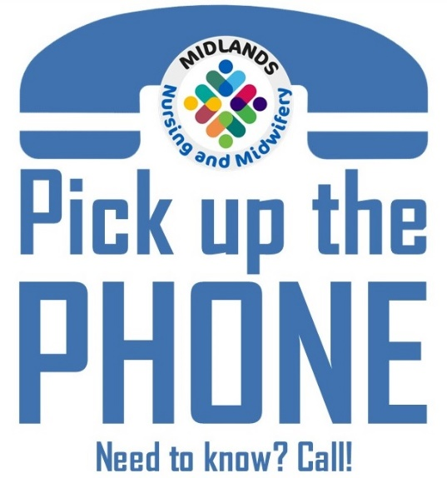

For more information visit:
www.lincolnshire.icb.nhs.uk/pick-up-the-phone-campaign
Do you have a new or emerging safeguarding concern?

Find a telephone number and pick up the phone to out of area colleagues to share information about concerns and referrals to children’s and adult social care.

Back
to basics
Pick up the phone

