

Mike Farrar consulting ltd

LINCOLNSHIRE INTEGRATED HEALTH AND CARE SYSTEM

AN INDEPENDENT REPORT ON THE DEVELOPMENT OF THE PROVIDER LANDSCAPE AS A MAJOR COMPONENT OF THE NEXT STEPS ON THE JOURNEY TOWARDS INTEGRATED CARE

DRAFT REPORT V1

An Independent Report by Mike Farrar CBE, FRCP, FRCGP
February 2023

EXECUTIVE SUMMARY

This independent report presents the findings from the Lincolnshire ICS Provider Landscape Review

It sets out the background and context for the review and the desire on the part of the Lincolnshire health and care system leaders to examine if changing the formal relationships between providers could create a better way to organise health and care that enables them to meet the considerable financial and service challenges they face.

These challenges are described in some detail within the Lincolnshire context including the real need for urgency and the opportunity now to make changes that have frustratingly eluded the health and care leadership community in the past. This context has been captured by five essential mindsets/collective positions that emerged through the review. These serve to frame the proposed changes to the way in which the system is currently governed and how it takes collective decisions.

These are set out in section 1 and summarised below -

- there is a shared desire to make changes - the status quo is definitely not considered an option
- leaders have attempted change before and believe that whilst they have shared the idea and have had some level of collective will, they have failed due to their inability to agree on the way to execute their ideas - it is now imperative that swift execution of the ideas raised through this review become the focus for agreement and implementation
- leaders are clear that the form of organisational structure and decision making must follow function; and that the benefits of any change must exceed the distractions from dealing with immediate operational pressures they will create. These changes are a solution to the current problems
- there are a number of changes that would benefit the health and care system that do not require structural changes but do require: cultural change; a refocusing of leadership priorities and the establishment of shared and binding leadership decisions, which need to be taken at the right level in the system
- these mindsets lead the health and care system leaders to 7 areas for focused action

The 7 areas are set out in section 2, where each is described in greater detail in order to help leaders understand what actions are possible and desirable. Where available, the suggested actions are reinforced by evidence of success from elsewhere in the NHS and globally. They cover

- developing provider collaboration and shared decision making at the right levels in the system
- supercharging the work at neighbourhood and locality level, including a commitment to subsidiarity, delegated decision making, oversight of existing spend and shifting resources
- developing a new relationship with Local Authority (LA) commissioned and provided services to mirror these proposed changes and include health and care leaders placing greater focus and priority on leveraging the ability of LAs to address the wider determinants of health
- formally strengthening operational relationships between providers at a Lincolnshire level with a consideration of a range of structural and decision making options
- recognising and sustaining the existing wider collaborative relationships that providers such as in mental health and specialised care services require (beyond those rooted in Lincolnshire health and care)
- enabling health and care leaders to make an effective case for change, that realises the benefits, reduces any distraction and accelerates the ability of the system to respond better to current challenges
- delivering a programme of cultural change that runs in parallel to any structural or formal decision making changes

Consideration of these issues leads to the production of 10 recommendations that are set out in section 3. The recommendations address the specific areas listed above and include proposals for the pace, scale and the process of implementing the changes.
BACKGROUND

Context

As a consequence of the Health and Care Act that became law in July 2022, the Lincolnshire Integrated Care System ((ICS) - overseen by the Integrated Care Board (ICB) and Integrated Care Partnership (ICP)) came into being on 1st July. At its heart is a range of statutory and non statutory health and care providers that serve as its engine room. They aim to drive population health improvement, reduce inequalities and deliver on key national health priorities including elective recovery and financial sustainability. Together, providers, the ICB and ICP are charged with improving the health of the people of Lincolnshire, increasing the effectiveness of integrated health and care services and doing both on a financially sustainable basis.

The current landscape of health and care organisations and services in Lincolnshire has evolved over the past 30 years and providers have made some progress over that period towards offering seamless, integrated services to the population. However all parties recognise that there is now an urgent need to consider the next stages of this journey if they are to capitalise on -

- the COVID-19 experience (with its lessons on:- swifter decision making; more effective collective working, new ways of providing care such as digital/virtual services; need for staff flexibility; and finally the stark truth of epidemiological and psychological impact of the virus on different population groups revealing major health inequalities)

- the immediate opportunity of policy and legislative change for the NHS and care system being implemented nationally and locally through the ICB and ICP structures, including the reform of NHS ‘commissioning’ with the abolition of CCGs and the need for providers to take on direct responsibility for resources and their use,

- the move away from competition to collaboration as the major driving philosophy, underpinning a new approach to delivering health and care, working even closer with strong local government in the county and seizing the opportunity to integrate services

and to use this to meet the massive challenges of -

- improving the financial circumstances for all organisations to bring the system overall back into a balanced position,

- improving the health of the people of the Lincolnshire, especially when the current levels of resources are juxtaposed against the population health and care need and the demands this creates (which outstrip the supply of money and labour),

- addressing the huge problems associated with patients waiting for urgent, elective, primary care (across all mental and physical service domains) and with rapidly increasing demands for social care, which taken together are leading to a significant risk of harm for patients and citizens as a consequence,

- responding to the need to reduce health and care inequalities in the area (specifically in the context of the recovery of service and economic standards post COVID),

- strengthening the current operational capacity in the immediate term where significant gaps are emerging and using this as an opportunity to bring organisations closer together through shared roles and by attracting and developing new talent in the patch

- alleviating the frustration that Lincolnshire leaders feel, borne out of their previous attempts to move to greater integration of care, which have been bedevilled by the lack of agreement across organisations as to how this should happen,

As a consequence, Lincolnshire health and care organisations and leaders have chosen now to assess the current position and consider what might be their next steps for the local health and care system relationships if the ICS is to deliver its mission. It’s leaders view the precise means by which they organise and govern the delivery of health and care over the next 3-5 years to be crucial if they are to be successful.

To enable this to happen, the ICS commissioned an independent review as the first stage towards identifying and subsequently, subject to agreement, implementing opportunities to reform its provider landscape, in terms of its culture, governance and potentially its structures.

Methodology

Mike Farrar Consulting Ltd was commissioned to undertake this independent review of organisational relationships and shared leadership across Lincolnshire in the context of the journey to greater integrated care delivery.

The fieldwork, undertaken between September 2022 and February 2023 included -

- interviews with individual leaders (executive and non executive)

- facilitated discussion sessions with Boards on their perspectives of organisational futures and options

- independent input considering evidence of approaches to integrated care from elsewhere and other sectors

- testing of emerging general insights with a wide group of leaders

- testing specific potential recommendations and options with affected groups and Boards

This, has been undertaken with a view to presenting the final report to the ICB and provider leadership group by early February.

Crucially the nature of the work has been designed to -

- recognise the local intrinsic drive for evaluating and improving these relationships rather than delivering compliance with any extrinsic, top down pressure or expectations

- bring in external expertise of integrated care models from across the wider NHS and, where relevant, from across the world

- start from a general/clinical management and governance perspective taking into account previous public engagement, consultation and insights

- recognition of the need to take immediate actions balanced by a medium to longer term direction of travel for service and organisational integrated working

- consider a range of options for reform along side some independent recommendations that leaders may choose to adopt

The process has been underpinned by a short review specification and broad terms of reference (which are appended).

Throughout the process, emerging thoughts and logistical arrangements have been coordinated through a small steering group

SECTION 1 - FRAMING THE CHANGES

Key Findings and Emerging Mindsets

It has been possible to distil five key findings/mindsets that reflect the current position of leaders across the Lincolnshire health and care system.

These are drawn from feedback emanating from the interviews, meetings and design day where leaders in the system were able to express their views individually and collectively.

They set the scene and frame the options for potential changes to the provider landscape -

1.1 Lincolnshire health and care system leaders have a shared desire and identified urgent need to explore how greater collective working (including binding decision making) could help them solve their current and long standing problems

The Lincolnshire health and care system has a long history of joint working between its constituent statutory, non statutory and independent health and care organisations. However the current structural organisational manifestation of this is often cited as a significant barrier rather than a facilitator of a greater level of integrated care, shared decision making and the optimal use of resources.

There is commitment to the shared mission and purpose of the ICS and its statutory triple aim of better health, better care and financial sustainability added to which Lincolnshire leaders are clear in their aim to address unfairness and inequality (in particular with reference to disadvantaged groups and specific geographical areas such as the Lincolnshire coast).

There is also complete agreement that the operational challenges are huge for the system and represent the toughest situation in NHS history, with demand outstripping supply, and workforce shortages, financial pressures and difficult industrial relations at national level to contend with.

The ICB is a also likely to be required to take on more responsibilities, emerging from the Hewitt Review, with a significant reduction in running costs/operating expenses, and must produce its 3-5 year Joint Forward Plan for addressing these challenges by the end of June 2023. In summary, the operating context, the resource available and the expectation of the new ICS presents a major requirement to reform to the previous way of working and any proposed governance changes need to be assessed as to how they will help the ICS to meet this challenge.

Lincolnshire organisations believe that the emerging new ICS could facilitate a new approach to provider collaboration but this will only happen if its operating model, its culture are aligned accordingly and its Integrated Care Board (ICB) and ICP act as a convenor and facilitative force rather than becoming a performance manager or a new larger form of a CCG. The ICB (including all its partners and members) have confirmed their intended approach is to be the former.

Finally, there is a clear aspiration that any new approach emerging from the review should be based as far as possible on evidence from elsewhere, However there is also recognition that identifying gold standard evidence from evaluation is challenging and that given the nature of Lincolnshire’s geography and demography, it is unlikely that any models from elsewhere are able to be simply ‘lifted and dropped’ into the system.

1.2 Lincolnshire leaders have had this idea and in many of their cases, the will in recent years to tackle this but have not had the same success in terms of the execution of their approach. This has generated a level of scepticism that this review will achieve any significant changes, however health and care leaders recognise this problem and are committed to developing a compelling narrative and business case for change

Whilst much has been achieved up to this point through previous joint working structures, there is a universally felt sense that the health and care system has greater potential to move its integrated health and care agenda forward. In short, that they should move from a system of ‘partnership working’ to one of ‘integrated working’. However, this is coupled with a sense of frustration that despite best efforts, the local system is still fragmented and sometimes witness to ‘individual, parochial’ behaviours, that belie the stated intent of all leaders and organisations to ‘act as one’.

Examples cited include the views of some leaders on the -

- failure to make shared organisational decisions based on the delivery of holistic, whole pathway, care,

- the problem associated with the difficulty in the range of organisational performance ratings that creates fear of ‘contamination’ that greater integration could impact adversely on the better assessed performing organisations

- multiple competing capital bids/developments revealing a lack of a coherent health and care strategy ,

- the lack of evidence that a long held intention to move resource to population health, prevention, primary care and earlier intervention has been realised

- failure of the system to align its resources with the patients, populations and places experiencing the greatest need for care

- the domination of acute hospital performance issues and the sense that previous reviews have started from this perspective rather than take a wider whole system approach

- the way in which the health and system is currently struggling to meet current financial and service challenges, where each organisation feels to be pursuing its own strategy

In summary, there is agreement to the idea of greater integration, there is a will expressed by all parties to achieve it, but there is a lack of agreement across them on how they would execute this, and a concern that for some, but by no means all, past experience would suggest a further risk that the joint working rhetoric will triumph once again over the reality.

Overcoming this scepticism, which is reportedly embedded into the management tiers of some organisations, will require a strong and shared leadership narrative that sets out a clear and compelling business case, along with a strong implementation plan and change/programme management resource.

1.3 Lincolnshire health and care system leaders have a strong belief that form should follow function but also that without some changes to form, the system is likely to fail to make progress. This is coupled with a sense that structural change may not be an easy starting point, and that if the system goes down that road, it will need to be accompanied by cultural change. Finally, all agree that the perceived benefits of any structural changes must exceed the distraction from tackling operational pressures they might cause.

There is scepticism emanating from the failure to execute previous approaches to ‘integration’. This now polarises leadership opinion. Some, but a minority of leaders in the system have a belief that structural change would be a distraction, but the majority of leaders now have a conviction, that greater integration will only be achieved through some form of structural change and/or more formal changes to current governance arrangements.

In my view this polarisation of views is causing a hiatus, in terms of integrating care beyond the small number of key shared appointments, which could, in practice, compromise the ability of providers to deliver collectively the ICS mission.

This presents a problem for the system which needs to be addressed honestly and transparently, and requires leadership views and organisational positions to be tested against the best fit with meeting patients’ and the wider population’ need.

It is also instructive to test these views against the emerging evidence of how high performing systems operate. Figure 1 identifies generic functions and the levels of delegated responsibilities that high performing systems are adopting (distilled from SOF descriptions)

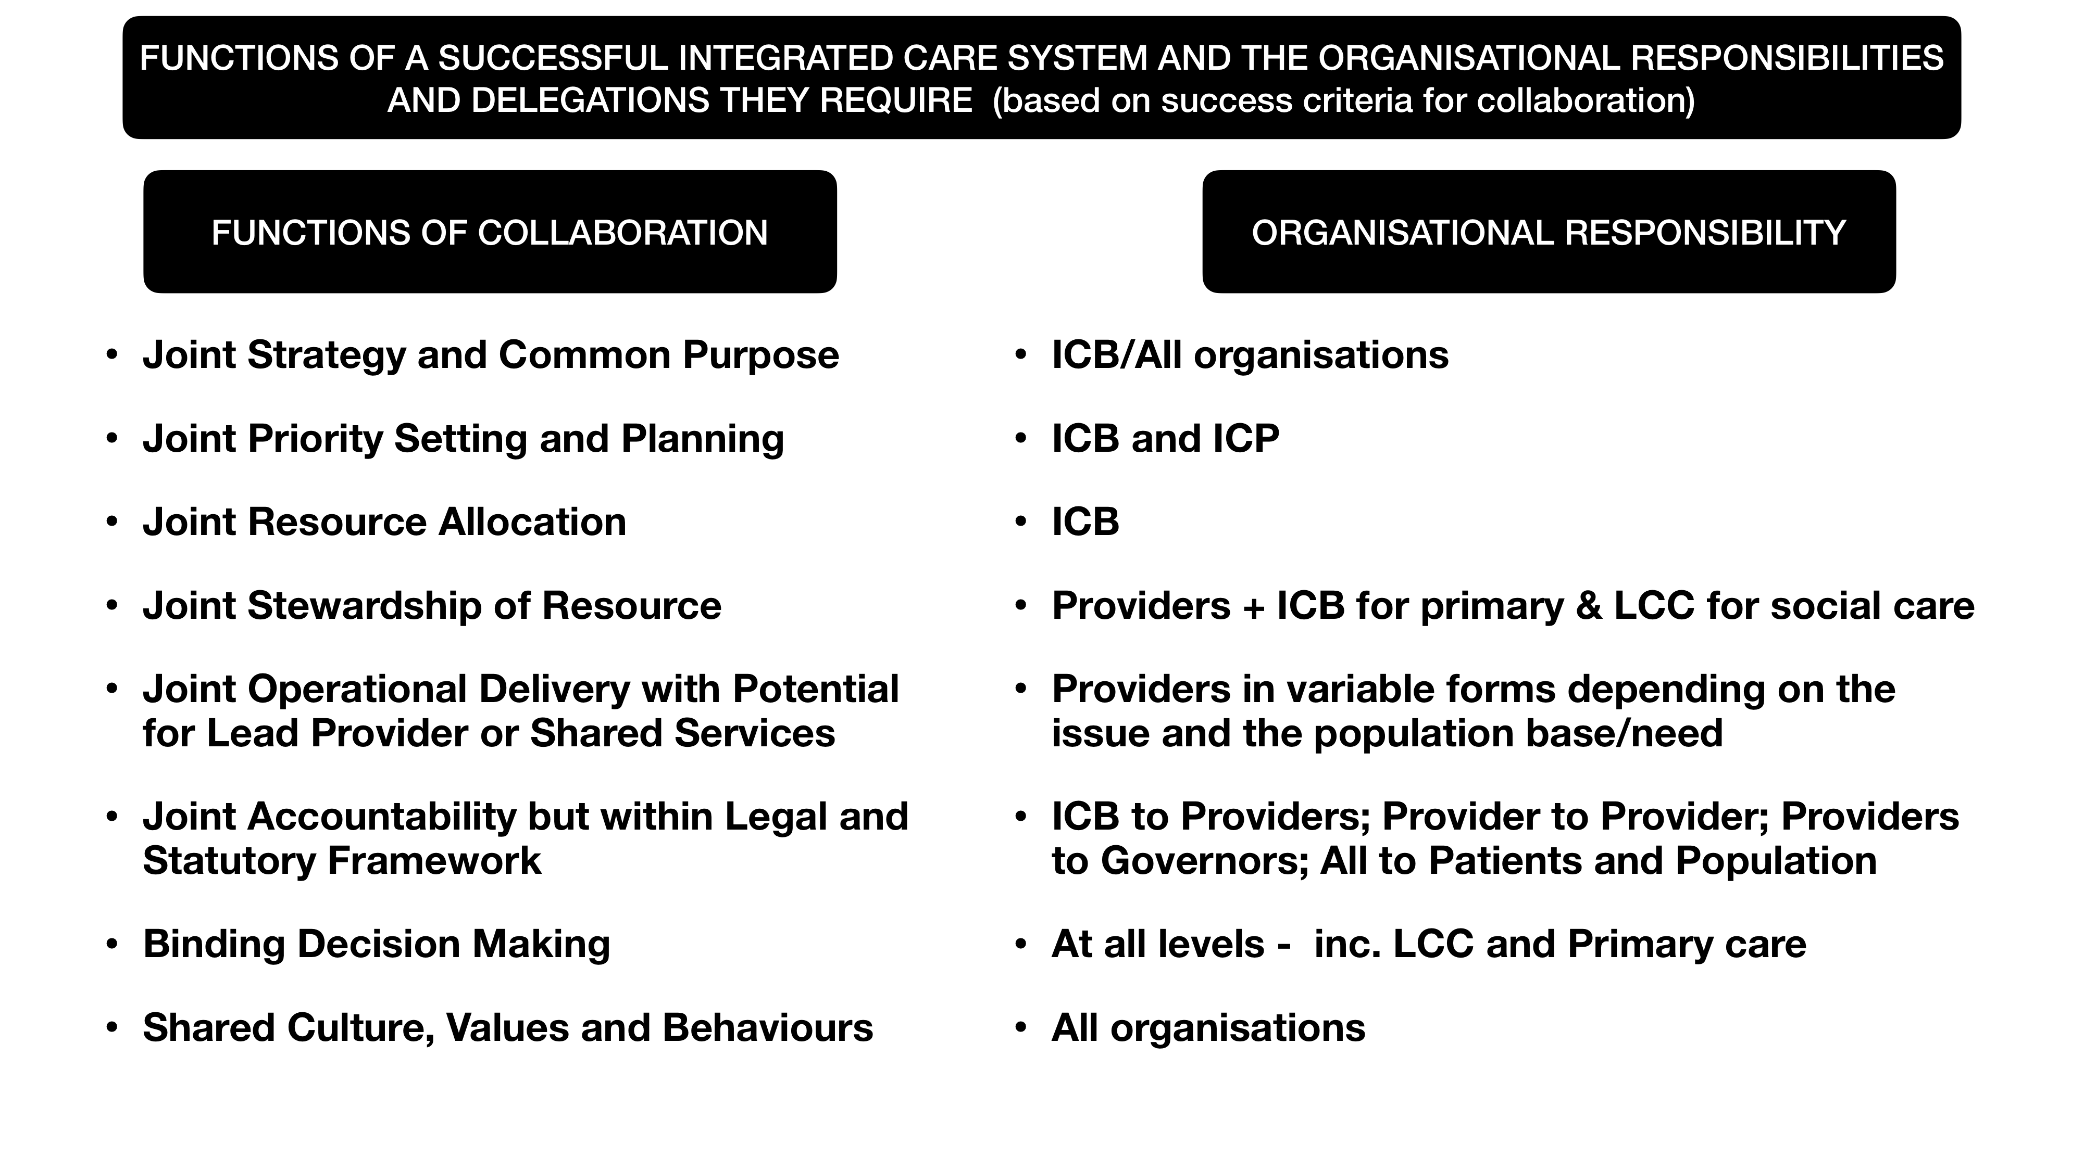
Figure 1 - Generic Functions and Levels of delegation in a Successful Integrated Care System

1.4 The successful delivery of Lincolnshire’s mission is also amenable to a range of actions that require little or no structural change. but do require cultural change, a refocusing of leadership priorities and the establishment of shared and binding leadership decisions, taken at the right level in the system

It is important to recognise that delivering the Lincolnshire ICS mission is amenable to actions that do not in themselves require significant structural solutions

Historically a lot of leadership effort has focused on the relationship between ULHT, LHCS and LPFT as the totem for integrated healthcare yet in terms of delivering improved health, better integrated healthcare within available resources on a fair and equal basis across the county ’, this would require a greater focus on prevention, community action (with strong VCSE action), population health, primary care, community, mental health and social care services.

There are also a number of key cultural aspects that leaders identify as mission critical irrespective of any structural change such as :- higher levels of trust; establishment of open and honest sharing of data and financial positions; listening to the voice of the population and service users (where the public in Lincolnshire expect the health and care organisations to act as one integrated system); devolving decisions to a more local level; empowering clinical and care professionals etc (these are set out in more detail in section 2.7)

Finally there are some pressing operational issues that require early resolution for any changes to be feasible. For example the need to recruit to the key critical C-suite roles in the main providers of services (eg ULHT and LCMS) in order to make immediate progress against service delivery challenges

1.5 Leaders identify seven broad key areas for action that they believe would strengthen Lincolnshire’s approach to integrated health and care and upon which health and care system leaders should focus

Irrespective of any scepticism, any difference of opinion on structural changes and more formal approaches to create shared decision making, the general view of leaders is that there is a significant opportunity to take some clear practical steps towards greater integration and collaboration in the system.

In landing on their 7 areas for action leaders identified a number of problem areas that they believed changes to the provider landscape must help to solve (the frequency of reference in interviews is bracketed) -

- Need to create an ability to deploy resources in a better joined up way - better ‘allocative’ efficiency (100%) ;
- Reduce service fragmentation - impact on operational delivery (90%);
- Address the variability of access to services (especially relating to the coastal areas) - (80%);
- Help tackle system wide financial problems - need to improve ‘technical’ efficiency (75%);
- Address the lack of confidence in individual providers to deliver their contribution to the collective purpose (70%);
- Improve the use of community hospitals - improving their role in access and overall system flow (50%);
- Tackle the inability to achieve national standards on a sustainable basis (50%);
- Address and reduce primary care pressures/workload and concerns over the sector’s sustainability (40%);
- Redress the lack of parity for mental health service problems (40%);
- Improve wider partnership working and address the inability to move to a model based on prevention (40%);
- Selective Others - Social care/delayed discharge; Workforce shortage; VCSE contracting and sustainability

Based on these problems, the design event debate, and the functions/delegated responsibilities set out earlier, the areas for further consideration and action in Lincolnshire coalesced into seven areas -

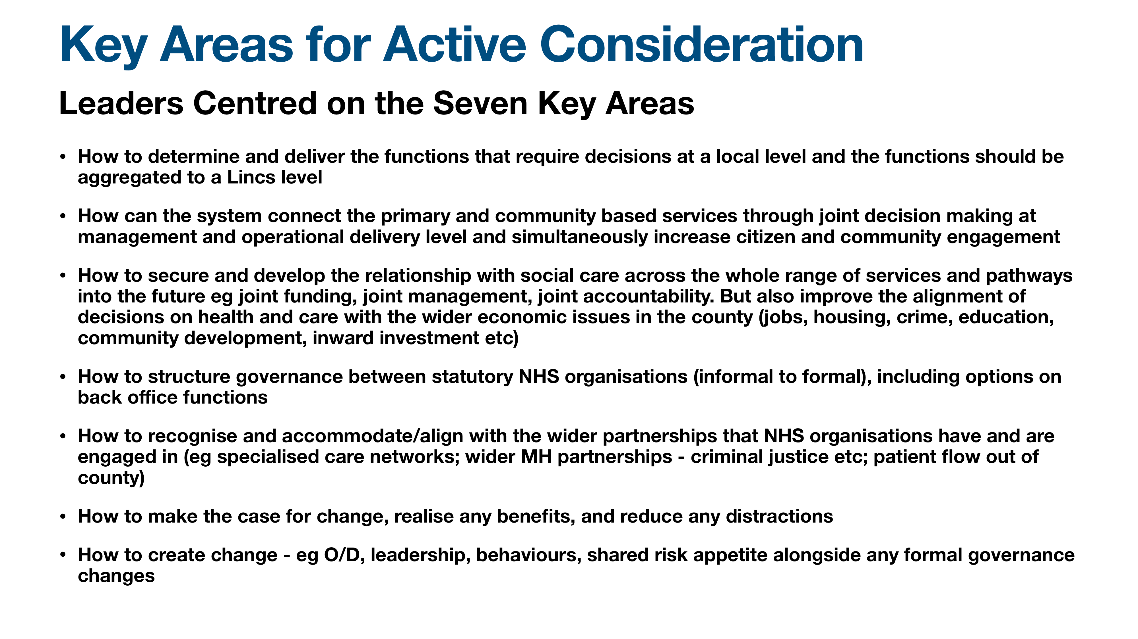
Figure 2 - Seven Areas for Consideration and Potential Action

These are considered in more detail in section two with consequent recommendations set out in section three.
SECTION 2 - DETAILED CONSIDERATION OF PROPOSALS FOR CHANGE IN THE KEY SEVEN AREAS

2.1 Developing provider collaboration at the right level in the health and care system

The evidence from successful integrated health and care systems elsewhere suggests that decisions and responsibilities for undertaking shared functions (between providers of care - see figure 1) need to be delegated and taken at the right level of population. But they also need to operate within a coherent strategic framework set by all providers and the overarching strategic body or statutory body (in this case, the Lincs ICB, ICP, and LCC for local authority duties and services)

In addressing this issue Lincolnshire is faced with six significant issues that need to resolved -

- Enabling binding decision making at the right level is mission critical for effective health and care systems but the absence of a consistent ‘collectively governed’ locality/neighbourhood structure for adult services means shared decisions can’t be taken easily and revert back to the Lincolnshire level, where primary care and community engagement are more difficult to facilitate,

- The absence of this consistent locality base within Lincolnshire at a structural level creates a challenge for enabling binding decisions at a local level that could embrace communities, primary care, mental health, social care and secondary care.

- This logistical difficulty means that well evaluated programmes with high resident and community engagement are much harder to deliver

- PCNs provide a welcome structure to engage with in terms of general practice and primary care but these are generally perceived to be variable in terms of capacity, capability and operating models at this stage - they also provide a logistical challenge as there are 15 networks and delegation to 15 areas is considered to be over bureaucratic and fragmented by some leaders

- The aggregation of functions and decisions to the Lincolnshire level needs significant thought regarding the role of Providers operating collectively visa vis the role of the ICB/ICP. There is a risk that functions could be duplicated leading to confusion (eg setting clinical strategy; standardising pathways of care; workforce planning etc)

- Aggregated decision making at Lincolnshire level may need stratifying into specific areas of activity and partnership where all organisations need to be involved (eg setting pay rates for comparable roles) but also those where not all organisations need to be involved (eg mental health and the criminal justice system)

- There is currently a clear intention as part of the system’s commitment to improve efficiency and effectiveness to develop shared ‘back office’ functions at Lincolnshire level. This needs swift and clear agreement on specific services, governance and service levels/contributions

Resolving these matters quickly will allow the Lincolnshire health and care system to improve its ability to deliver its mission, but will also allow providers to ascribe the appropriate specific decisions and delegated responsibilities to the right collection of organisations and the right population level.

2.2 Committing to a higher level of subsidiarity - Supercharging the neighbourhood and community level work - the potential to establish new ‘Community and Primary Partnerships (CPPs)’ (These would work alongside but not disrupt the current locality arrangements for Children and Young People)

Current arrangements are too varied, under resourced and underpowered.

The Lincolnshire system currently has a series of community partnerships and organisations that operate variably in tandem with 15 Primary Care Networks across its geography. These vary as to their role, approach, work programme, capability and effectiveness and yet they need to fulfil a vitally important role in the delivery of the ICS mission

To be successful, the level of shared decision making at sub Lincolnshire or ‘locality’ level needs to have some formal binding shared decision making structure/capability that does not exist today in the system. If Lincolnshire is to be successful, it needs to commit to a level of subsidiarity and to ‘supercharge its neighbourhood and community activity’ through a revamped and constituted new approach, which I have termed the development of ‘Community and Primary Partnerships (CPP)’ but these could be named differently to suit or match the Lincolnshire history and experience.

In order to explain the important role and function that these collaborative decision making bodies might play I have set out their 8 key functions (set out in figure 3 below), as I see it, that they would need to undertake (recognising that some programmes of work in these areas are already in place in Lincolnshire but would benefit from greater systematisation). These have great overlap with the establishment of integrated neighbourhood teams as set out in the Fuller Review, but would in my view benefit also from strong engagement by secondary care providers

Figure 3 - Eight Key Functions of Locality Working
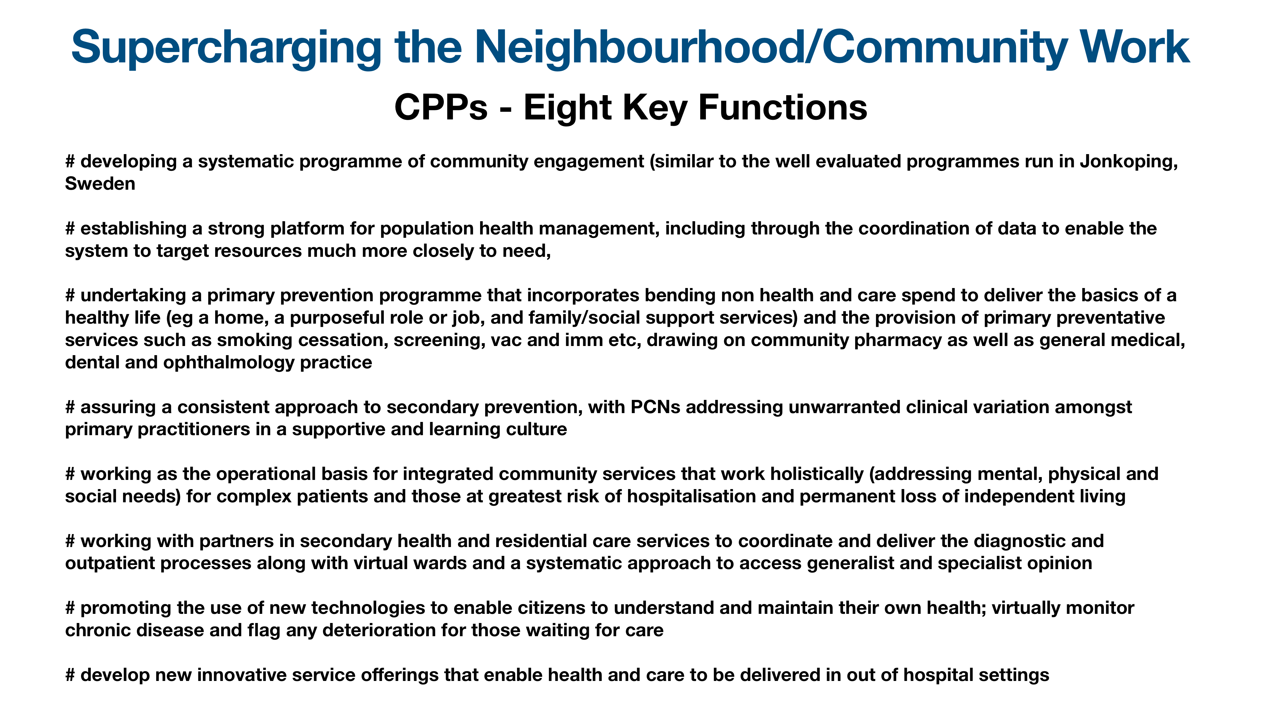

To make this system of local decision making work it would be necessary to put in place a number of key commitments -

- CPPs will need to have a much more systematic organisational development process accompanied by resources which deliver a core consistent evidence based approach but also have sufficient local variability to enable them to be sensitive to varying local need and to tackle inequalities

- The resource needed for CPPs will need to include both capacity and capability with investment in CPP leadership (using a clear competency based leadership model), and the introduction of good governance principles

- CPPs would have oversight of the resources used within the locality with delegation of resource use (but this would be in relation to the soft budgets rather than devolution of hard budgets)

- CPPs would be partnerships of all organisations in particular centred on VCSE, PCNs, Local Authority provided or commissioned neighbourhood based services and community mental and physical health services but also with the strong engagement of the acute services and Trust(s). They would need agreed approaches to governance (membership and leadership) which would sit within a broad consistent framework set by the ICB and provider group whilst also with flexibility to reflect local relationships. They should be supported by strong and effective community engagement and have a culture of citizen, clinical and care professional empowerment

- There will be a key role for the Community Trust, secondary care providers, PCN and VSCE leaders and the LAs to develop and support the establishment of CPPs, and this would include providing the infrastructure, O/D, leadership development and governance facilities

It should also be possible, alongside CPP stewardship of existing spend in these settings, to deliver a major commitment to begin to shift finance and resource from secondary to community based service development

In Lincolnshire’s current situation, money is incredibly tight and movement of resources looks difficult, however without movement of resource at all towards population health management, secondary prevention and demand management, there is no other option but to try and increase supply side growth using any new resource that could be generated and made available through central Government. This appears unlikely at present for some time to come.

As such Lincolnshire health and care system leaders could shift their focus to delivering a commitment of a 1-2% shift within existing resources towards prevention and earlier intervention, through new service developments that clinical and care professional leaders from the whole pathway would agree will impact positively on demand and patient flow. Subject to evaluating the impact of such a shift, there could be a commitment to make further percentage shifts each year for the next 3-5 years (This should be a commitment in the Joint Forward Plan)

The initial focus should also be in addressing Lincolnshire’s hotspots such as urgent care, primary care demand, inequalities along the coast, and long waiting times. Indeed I envisage that hospital and secondary care provider clinical and care professional leaders will be working with community based colleagues to design programmes of work that will impact on these hotspot areas. (NB in Alzira, Cardiology became a community based speciality which underpinned much of their success)

Such a policy from the ICB would give the new shared decision making arrangements at locality level a real kick start.

The NHS Trust Boards and LCC would need to recognise the value of subsidiarity and the delivery of services at community/neighbourhood level and agree within their own organisational operating principles to delegate decision making and to empower their own teams working at this level

2.3 Formally strengthening the operational provider relationships to capitalise on existing programmes and ensure joined up services for patients and the Lincolnshire population

There is a need to build on and develop further the previous changes, such as the shared senior posts (executive and non executive) to create more integrated provider relationships, but also to move forward from the status quo

The Lincolnshire system has previously adopted a series of models for provider collaboration including the establishment of Provider Collaboratives. These models have largely been perceived as useful but insufficient now to make the progress that leaders wish to see with the urgency they wish it to happen. However they do provide learning and a foundation for future change.

The deliberate intention of these moves has been to -

# begin to realise the benefits of the end to the purchaser provider split, thereby enabling providers to steer collective priority setting, decision making and allocation of resources

# enable decisions to be taken on the full Lincolnshire footprint when and as appropriate

# offer the opportunity for the engagement of providers from across the whole spectrum of VCSE, primary care, Local authorities and NHS Trusts as equal partners in shared management and oversight processes

# encourage providers to take responsibility for achieving key outcomes for the population within the fixed envelope of resources, thereby encouraging them to innovate and find both allocative and technical efficiency

These moves are strongly supported by constituent organisations and I would argue mirror global evidence on successful integration of health and care. The principles of these changes auger well for Lincolnshire in terms of strategic priority setting and resource allocation, but they need to be underpinned by a process that joins up the actual delivery of health and care on the ground, and I believe there is more that needs to be done on developing shared operational capability to achieve the outcomes that Lincolnshire health and care system leaders seek.

In order to enable leaders to debate the nature of changes they see as necessary I developed an illustrative model based on experience elsewhere that considers the degree of integration alongside the degree of organisational disruption (see figure 4 below)

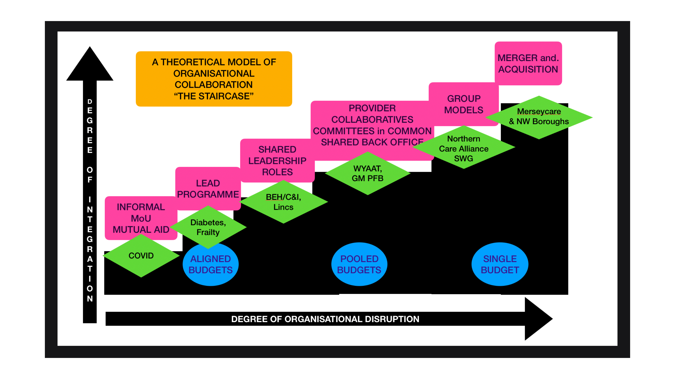
Figure 4 - An illustrative model of levels of provider collaboration

It is clear from the feedback of the leadership group and Boards that there is no complete consensus on a model of choice however there is consensus that neither the first or the last step of the staircase is an option they believe will meet the implicit criteria they have discussed (see figure 5 below)

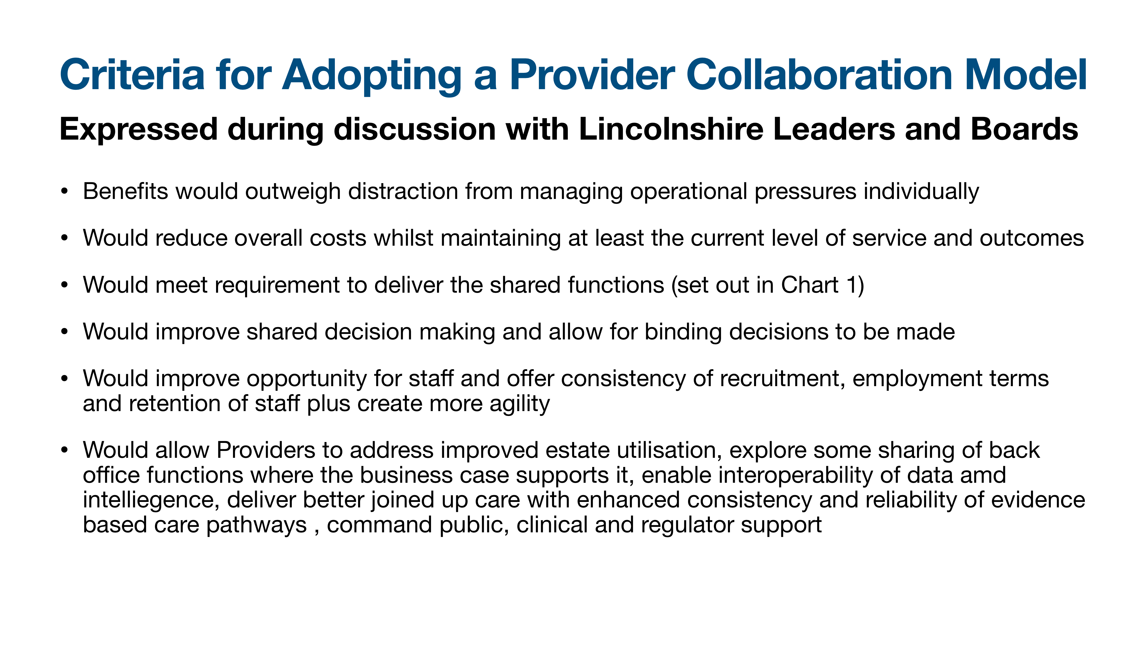
Figure 5 - Criteria for Adopting a Provider Collaboration Model

In applying the criteria to the model and it’s range of options, Lincolnshire leaders predominantly favour a combination of the options in steps 3,4 and 5, but there was a desire expressed at the design workshop to combine these into the option of a Group Model (step 5).

A group model would require a formal arrangement and the following paragraphs (in italics) are provided as an illustration of how such an approach might work in Lincolnshire -

The Group would need to be fashioned in a manner to fit the Lincolnshire system, and would start with ULHT and LCHS, and whilst preserving their existing Trust Boards, would commit each Organisation to take key decisions in relation to a number of agreed areas of strategic and operational collaboration collectively through a Committees in Common or Joint Committee/Board mechanism (these would include those areas and functions which meet the criteria above)

LPFT would be invited, for areas where it would add value to mental health and mental health care, to join the Committees in Common or Joint Committee/Board approach - again justified by identifying areas/business decisions that meet the key criteria listed above.

As a first step the Group should identify and resolve current director level vacancies and could consider the scope and benefit of developing the case for more formal joint operational delivery including the sharing of posts and services

Whilst LCC and the PCN Alliance would be invited to participate in the shared decision making process, they would need to align their formal decision making processes as appropriate as neither have an NHS Board.

The Group would oversee and empower the work done collectively in the CPPs at locality level and could resolve any disputes arising

In order for the Group to be able to make decisions on deploying resources, the ICB could consider the option to add a member of the ICB executive team who would join the Committees in Common or Joint Committee/Board, and subject to legal advice, could then enable the Group to operate as a joint sub committee of the ICB with powers to commit monies to meet need or improve the system’s allocative and technical efficiencies (this may be form a second step for the Group)

The Group would, subject to evaluating progress against their stated objectives, be enabled to make further decisions on the next iteration of their approach including the continued establishment of shared posts both at executive and non executive level, and the role of their separate organisational structures

In the immediate term, these NHS organisations would retain their responsibility for ensuring that they deliver on their own specific contributions to the overall performance of the system, where this is uniquely their responsibility (eg running their core in house services effectively, auditing accounts, meeting safe care requirements etc)

The Group would build on and supersede the work on the Provider Collaborative, as both approaches have the same aim in mind

2.4 Developing the relationship with social care, public health services and wider Local Authority duties for adults (eg jobs, housing, community safety, education, economic and community development, inward investment etc) but maintaining the strengths in their current approach to children and young people’s services

LCC have an expressed desire and track record of supporting integrated care and have a number of celebrated programmes that enable integrated financing such as LCC’s Section 75 Agreement with LPFT, a history of offers to expand this further, and a commitment through membership of the ICB and shared leadership of the ICP to play a significant role in the reformed health and care system.

They have a major role to play in achieving the ICS mission chiefly through the following areas -

- aligning and delegating resources into the new locality decision making structures (or CPPs - see 2.2), recognising that much of their adult services are commissioned through others rather than provided in house. Whilst also aligning their input strategically and operationally with any emerging shared provider governance structures or processes at Lincolnshire level (see 2.3).

- aligning budget setting schedules and processes to enable the health and social care planning and spend to be seen together (this will reveal a strong case for recalibrating spending between physical, mental and social health as the core components of demand - largely by increasing the proportion of spending into the latter two areas as a means to improve patient flow and reduce the manifestation of mental and social health problems as demand for acute physical hospital care)

- supporting and engaging with Lincolnshire wide provider collaborative approaches that consider workforce and labour issues (including pay rates, recruitment and retention)

- positioning health and care in the wider strategic context of economic well being to reflect the key relationship between health and wealth as a cause of problems and solutions in both sectors

- working and leading with the ICB and ICP on the identification of local priorities based on health needs and analysis (through JSNA and the role of the HWB) - to meet the outputs from the impending Hewitt Review

Where appropriate, in line with statutory duties it will also be helpful to align the functions held by District Councils such as housing with the new system of decision making that have a health impact

2.5 Recognising and aligning the wider provider collaborations that must exist and serve to support the delivery of the mission of the ICS

Lincolnshire houses and participates in a number of important provider collaborations that require providers to work collectively with

- other non health and care organisations (eg mental health and criminal justice organisations)
- other non Lincolnshire based organisations (eg ULHT and the wider providers of specialised care eg Cancer Networks; Mental Health Collaborative for specialised service commissioning)
- other ICSs for cross border patient flow
- other ICBs for primary care contracting and specialised service commissioning (eg with NHS England or neighbouring ICBs)
- non nhs providers of health care and social care (usually under specific MoU agreements)
- ambulance services that supply other ICSs

These are significant relationships for the relevant providers and service users and the care they oversee impacts on the ICS ability to deliver its mission. They should not be undermined or considered subsidiary to the proposals for greater collaboration within Lincolnshire. Indeed the presence of greater formal collaboration between providers within Lincolnshire may serve to strengthen the presence and impact of Lincolnshire providers when they attend and influence these wider collaborations.

2.6 Making the case for change, realising the benefits and reducing any distraction

There is already a strong shared sense that the status quo is not an option however any case for change will be undermined if there is no shared agreement on the specific changes that may be required. As a consequence there needs to be work undertaken to agree the case for change, and a compelling clear and simple narrative to explain the nature of the changes that are proposed. This should reinforce the need for urgency and the opportunity presented now for significant changes

The experience of the design event was positive in suggesting that the requirements above can be realised but there may be some key pointers that will help with this -

- commitment to a single side summary of the business case and narrative that all leaders and Boards sign up to. This can them be shared with wider stakeholders and regulators
- adoption of a ‘learn by doing’ approach that assures everyone of the ability to change course or tweak the proposals as organisations and leaders experience the implementation of their approach
- ensure that any legal issues have been checked through with qualified legal opinion (I suggest this is commissioned once for the whole system by the ICB)
- set a time frame which enables organisations to enter shared binding decision making, recognising the urgency of the current situation and the ability to put the recommendations into practice quickly. Once agreed they should commit a period of time in which to assess the benefits and by which they agree to the set procedures and agreements that govern the shared functions
- there is a clear commitment of resource from the ICB to accompany any changes and that funds will also be made available to support an OD programme for all relevant organisations (this will include a recognition of the reduction of running costs at the ICB and the need to devolve functions and resources to the provider collaborations in localities and the Group as a way of securing the more efficient use of resources overall)

In addition it will be important to be able to quantify and measure progress against the key benefits leaders are seeking. This can be achieved by looking again at the list of problems they believe these proposals might help to solve and measuring the baseline periodically as the new relationships and structures emerge, operate and evolve.

2.7 Developing and delivering a cultural change strategy to run along side these proposals

Leaders specifically referenced cultural change in the discussions and aspired to achieve - higher levels of trust; establishment of a single version of the truth through open and honest sharing of data and financial position; better listening to the voice of the population and service users; devolving decisions to a more local level; empowering clinical and care professionals

Taking each in turn, they would need to be supported by development work but the following suggestions may help to produce an effective OD approach -

There is a need to build higher levels of trust between organisations and leaders

As is often expressed, ‘trust is hard earned but easily lost’ and the key to securing and maintaining trust is the ability leaders and organisations have to do what they commit to, whilst also being overt and honest about any changes to the agreed position. In other words, ‘Leaders say what they will do and do what they say they will; and explain if and why they can’t proactively.

This commitment can be established at the early outset of the Lincolnshire ICS and leaders can hold themselves and each other to account for living up to it. The final aspect of this is to agree that health and care system leaders collectively agree that there will be consequence if this agreement is breached.

The absolute imperative to create open and transparent sharing of data and intelligence

The prospect of being able to maintain this approach is also tied into ensuring that everyone is looking at the same data and has the same picture of the whole system. This will ensure that any parochial non rational behaviour is more identifiable, and promotes the chances of leaders agreeing a common approach immeasurably.

In order to achieve this the Lincolnshire ICB could be asked alongside providers to ensure that Lincolnshire establishes a single data, intelligence and system planning capability that brings a flow of clinical, public health and population health data together with service supply side data to enable effective joint decision making, priority setting and care delivery.

Better listening to the voice of patients, service users and the population

Although this review has been commissioned as ‘a management led’ review, there is a very strong case for public engagement as part of the process at an appropriate stage. The development of population and community engagement not just in response to service change, but as active individual, family and community participants in health and care delivery, has been proven through work in mental health services and more generally across the NHS and LAs in the UK.

It is possible that the ICB or Lincolnshire provider organisations consider developing a technology enabled conversation with the population at an early stage in the ICS development and specifically in describing these proposals for joined up decision making in order to achieve integrated care.

Devolving decisions to a more local level - the need for subsidiarity

Section 2.1 above sets out the importance of creating decision making structures at locality level but ensuring this happens in practice is a cultural as well as structural challenge. Without a degree of flexibility in the model it is likely that local populations and disadvantaged groups are likely to experience a continuation of inequality but equally there is a case for developing greater standardisation of the service offer and access.

As a consequence, Leaders and Boards need to make judgement calls on how to calibrate these two important dynamics. Often the tendency is to err on the side of centralised decision making but this may be much less appropriate in the new system, when connecting the public to shared care and shared decisions appears to achieve enhanced outcomes.

There is a need to ensure that the system has a strong clinical and care professional empowerment culture at its heart

It is essential that the Lincolnshire clinical and care professional engagement culture is preserved and developed in order for their expertise to be built ‘in’ and ‘up’ in the new system to ensure a new level of clinical and care professional empowerment. In particular it is vital that the voice and influence of primary care is maintained now that the CCGs have been abolished.

For example, this could be demonstrated and delivered by the early adoption of the following 3 actions -

- ensuring that Lincolnshire ICB and any new form of Provider Group appoints clinical leaders to its membership and key groups (including representatives from primary care),

- that the ICB supports its new Clinical and Care Professional Directorate as the Professional Leadership Group as part of its governance. This would include PCN Clinical Directors, and some of the GPs previously in leadership roles in Lincolnshire CCGs, along with a full range of clinical colleagues from secondary care, mental health services and professional colleagues from social care

- creating a concerted approach to achieving a CCPL empowerment culture as defined by - Clinicians and professionals are listened to, are influential and impactful; Clinical and professional evidence and viewpoint is central to the ICS strategy and decision making; Management process is servant to clinical direction (not the other way round); Exists in the DNA of the ICS - fundamental mindset for all it does; and Consistently supports targeted action to deliver patient outcomes

SECTION 3 - IMPLEMENTING THE CHANGE - TEN RECOMMENDATIONS

3.1 Ten Key Recommendations for the Implementation of Change

Based on the detail in all the sections above I make 10 specific recommendations for action in order to make progress over the next 6-12 months -

Recommendation 1 - Lincolnshire health and care system leaders should focus their provider reform activity on the 7 distinct areas for action, (listed in Figure 2) with urgent action where signalled

Recommendation 2 - Lincolnshire health and care system leaders, should supercharge their activity for adults at locality level, by developing CPPs (or similar arrangements) that build on, standardise and aggregate their existing PCN and neighbourhood team arrangements and are empowered to deliver the 8 key functions (listed in Figure 3)

Recommendation 3 - Lincolnshire health and care system leaders (and their organisations) should delegate responsibility and commensurate authority to CPPs (or equivalent form) to deliver the 8 key functions and then commit resource, leadership development and organisational development to ensure that they can be successful, whilst offering governance support through the statutory provider organisations

Recommendation 4 - Lincolnshire health and care system leaders should explore a commitment to a 1-2% shift in resources towards prevention and earlier intervention where this is believed to have an impact on demand for acute hospital or residential care; and consider doing so on a progressive annual basis for the next 3-5 years subject

Recommendation 5 - Lincolnshire health and care system leaders should strengthen their ability to enable shared strategic and operational decision making to improve the delivery of integrated high quality health and care through

- establishing a formal provider group to include ULHT and LCHS as a start but also to engage and involve LPFT, PCNA - as agreed how and when by each party
- consulting LCC on the nature of their involvement recognising their relationship is predominantly with providers through their contracting and commissioning functions
- commissioning legal advice to establish a legal basis for binding shared decision making by the Group, beginning with exploration of the Committees in Common or Joint Committee/Board approach
- seek as a matter of urgency to fill current vacant executive roles, continuing to explore the immediate opportunity of shared posts in non executive and executive roles

Recommendation 6 - Lincolnshire health and care system leaders should specifically request Lincolnshire County Council to consider how it might best engage with these proposed new provider collaborative decision making structures at locality and Lincolnshire level in order to enable more integrated social care and public health provider services; whilst also enhancing their ability to address the wider determinants of health

Recommendation 7 - Lincolnshire health and care system leaders, irrespective of the development of more formal permanent shared provider governance, should initiate through their existing informal arrangements the development of shared back office services covering all relevant and willing providers

Recommendation 8 - Lincolnshire health and care system leaders should specifically create a work programme to support cultural change within the health and care system aimed at building higher trust between organisations, creating a shared database that establishes a transparent and open sharing of data/business intelligence, is built on better listening to patients and the population, supports the delegation of decisions to a locality level, and creates a culture of clinical and care professional empowerment at the heart of the ICS

Recommendation 9 - Lincolnshire health and care system leaders should commit fully to these recommendations and set up a series of development days to work out the important detail that needs to follow and then to develop a clear implementation plan

Recommendation 10 - Lincolnshire health and care system leaders should set a clear timeframe for implementing these recommendations in the first six months of 23/24, such that the full year effect of those changes could be available from 2024 onwards

Mike Farrar CBE, FRCGP, FRCP
February 2023

