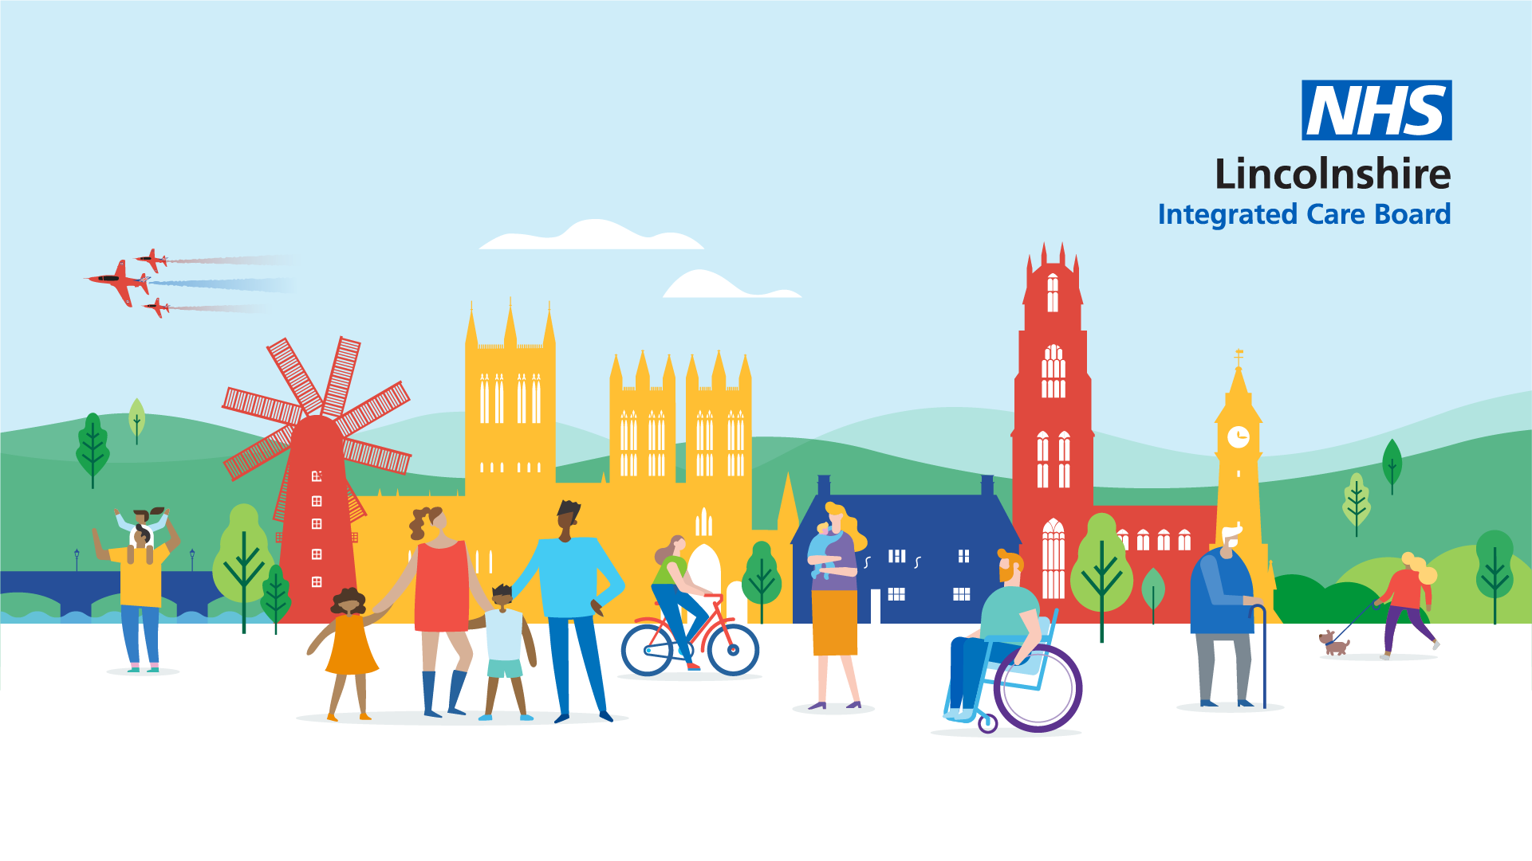

Lincolnshire Integrated Care Board
People and Communities Strategy

Our commitment to involvement

January 2024
Version 1.2
CONTENTS

- Context and Introduction
- ICB legal duties on public involvement
- Other duties which link to our approach to involvement
- What we mean by involvement
- How we will involve people and communities
- Understanding our people and communities (demographics and health inequalities)
- How Involvement will support Health Inequalities

- Aims and Principles
- Aim: to build a common purpose
- How Lincolnshire ICB will involve people and communities to deliver our principles
- How Lincolnshire ICB will involve individuals
- Lincolnshire ICS – Better Lives Lincolnshire

- Roles, responsibilities and resources
- Our teams
- Supported by our people and communities
- Supported by our partners
- People and communities in ICB governance and workstreams
- Monitoring and evaluating the strategy
Our Lincolnshire People and Communities Strategy has been developed during various stages in partnership with our communications and engagement leads across our NHS partner organisations and with our strategy and planning team.
We will continue to test this strategy and develop it further with our:
- People and Communities in Lincolnshire
- Our ICS partners including Healthwatch, VCSE organisations, stakeholders and community groups
- Key system partners such as leads for Equality and Diversity, Personalisation and Shared Decision Making and Health Inequalities
- System leaders who will champion and embed this work

- CONTEXT AND INTRODUCTION

The Lincolnshire ICB Constitution sets out the legal duties and principles we will adhere to when developing and maintaining arrangements for public involvement. This People and Communities Strategy demonstrates how we will deliver these to understand and empower our communities, ensuring the patient and public voice is at the heart of service design and decision making. The strategy is dynamic in nature, flexing in accordance with the needs and feedback of our communities. Therefore, some of the content is well established and progressed work, and some references are intended developments.
Our People and Communities in Lincolnshire: residents, people who access care and support (and those who do not), unpaid carers, representatives and families. We also commit to proactively involving those with health inequalities or who are seldom heard, staff, stakeholders and partner organisations.
ICB legal duties on public involvement

14Z45 - Public involvement and consultation by integrated care boards
In line with section 14Z44(2) of the 2006 Act, Lincolnshire ICB will ensure that we involve patients, their carers, representatives and the public and communities in
- The planning of commissioning arrangements
- The development and consideration of proposals
- Changes in the commissioning arrangements where the implementation of the proposals would have an impact on the manner in which the services are delivered to the individuals or the range of health services available to them
- Decisions affecting the operation of the commissioning arrangements where the implementation of the decisions would (if made) have such an impact.

In addition to these legal duties, our formal consultations will also meet Governments four tests for service change and the additional NHS England test on changes to bed numbers. If we decide to involve people through a formal consultation before reaching an ICB decision then the ICB will make sure the process is fair and proportionate and consistent with common law principles, including the following four rules (Gunning Principles), which if followed, are designed to make consultation fair and a worthwhile exercise:

- that consultation must be at a time when proposals are still at a formative stage.
- that the proposer must give sufficient reasons for any proposal to permit of intelligent consideration and response.
- that adequate time is given for consideration and response; and
- that the product of consultation is conscientiously considered when finalising the decision.

14Z52 – Joint forward plans for integrated care board and its partners
This duty requires the ICB to prepare a five-year joint forward plan (“forward plan”) before the start of each financial year and sets out what the plan must cover. This plan must include how the ICB proposes to involve people.

Section 14Z54 NHS Act 2006 imposes a duty on the ICB and its partner NHS trusts and NHS foundation trusts to consult “the group of people for whom the integrated care board has core responsibility” (defined in the Health and Care Bill) and “any other persons they consider it appropriate to consult”:

- when preparing the forward plan; or
- revising the forward plan in a way they consider to be significant.

Local Health and Wellbeing Boards will be involved in the preparation of the plan by providing them with a copy of it and consulting them on whether it takes proper account of each joint local health and wellbeing strategy in the period to which it relates.

The published plan will include a summary of the views expressed by stakeholders who were consulted, an explanation of how those views were taken account of and statements of the opinions of all consulted Health and Wellbeing Boards.

Click here to see Health and Care Act 2022


Click here to see Health Act 2006

Other duties which link to our approach to involvement

NHS Constitution
The NHS Constitution establishes the principles and values of the NHS in England. It sets out rights to which patients, public and staff are entitled and pledges which the NHS is committed to achieve, many of which are enshrined in law. One of these rights is the right to be involved in your healthcare and the NHS directly or through representatives.
Click here to see Lincolnshire ICB constitution

The Public Sector Equality Duty – The Equality Act 2010
The Equality Act 2010 promotes fair treatment of people regardless of any protected characteristic they may have. All of our communications and involvement activities will take this into account, paying due regard to those with protected characteristics and ensuring that they have equitable opportunity to be involved.
Click here to see public sector equality duty

Duties as to reducing health inequalities – s.14Z34 NHS Act 2006
We are also under a duty to have regard to the need to reduce inequalities between persons in respect of access to and outcomes from health services. We will factor this into our involvement activities by making sure we are considering how to involve individuals who are disproportionately affected by health inequalities.

Annual reporting – s.14Z58 NHS Act 2006
The ICB must prepare an annual report on how it has discharged its functions in the previous year including the duty to involve the public at s.14Z45 NHS Act 2006.

Duty to promote involvement of each patient – s.14Z36 NHS Act 2006
The ICB must, in the exercise of its functions, promote the involvement of people, patients, and their carers and representatives in decisions which relate to:
(a) the prevention or diagnosis of illness in the patients, or
(b) their care or treatment.
What we mean by involvement

NHS England defines involvement as: “Public involvement in commissioning is about enabling people to voice their views, needs and wishes, and to contribute to plans, proposals, and decisions about service. Different approaches will be appropriate, depending on the nature of the commissioning activity and the needs of different groups of people.”

Involvement of our people and communities will run throughout our commissioning arrangements, from identifying the need to make changes to co-production and empowerment. Involvement can be in the form of information provision, engagement, consultation and co-production.

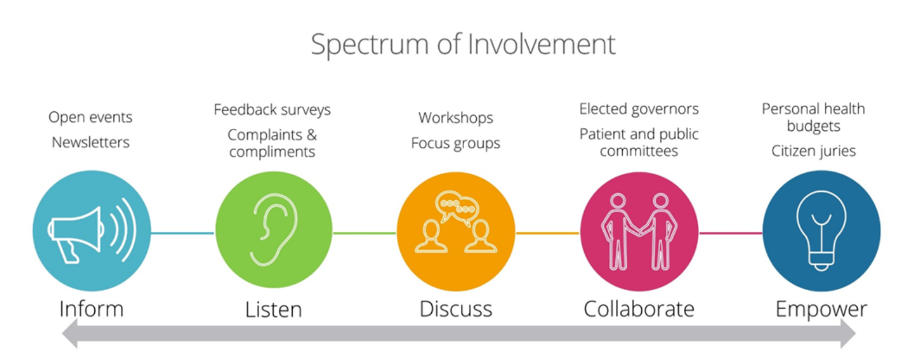

We will deliver this by ensuring our involvement:
- Focuses on people and what matters to them
- Is at an early, formative stage
- Is tailored to individual audiences
- Creates opportunities where they do not currently exist for voices that aren’t always heard
- Embeds co-production at the start
- Driven by insights, patient experience and data for a solid evidence base
- Triangulates with quality and patient experience
- Works across the system and not in silo organisations
- Informed by patient experience and insight
- Open and transparent with clear, communicated outcomes

How we will involve people and communities

We have a variety of ways we can involve people and communities on an individual, group and community basis. We will ensure that our methods and approaches are inclusive and tailored to all of the Lincolnshire population and stakeholders so they can have their say. To do this it is important that we recognise and understand who our stakeholders are and the most effective way to communicate and engage with them by undertaking stakeholder mapping and analysis.
Involvement activities could include surveys, focus groups, listening clinics, workshops and events. All of our engagement and consultation activities will be supported by appropriate and proportionate communications which can be translated into the languages required, and in alternative formats such as easy read, large print, braille/recordings etc if required.
We will also work in partnership with local support organisations who have established links to reach wider sections of the population and who are focused on providing access and amplifying the voice of hidden and hard to reach people of Lincolnshire.

Understanding our people and communities

We recognise the differences in our communities from their health needs, ability to access services (both digitally and in person), and the ways they want to get involved.
All of our commissioning and involvement activities will be built on a solid understanding of our population, service users, their experiences and the people that support them. We will utilise the knowledge, relationships, networks and strong links our partner organisations already have with our communities to ensure a fully holistic, system approach to involvement. We will use existing and tested opportunities to engage and communicate and seek to identify the best partner with the best relationship to lead the conversation. Working as partners will strengthen our collective messages and involvement activities. As well as joining up care, we will join up our engagement and experience work to capture and improve the patient journey and use this to empower joined up system working.
We will support our programme teams to make these links and ensure Equality Impact Assessments, Quality Impact Assessments and Health Inequality Impact Assessments (HEAT) are undertaken to fully understand the people and communities we serve who may be impacted by any changes along with monitoring the on going impact of any change The insights and diverse thinking of people and communities are essential to enabling Lincolnshire ICB to tackle health inequalities and the other challenges faced by health and care systems.

Headline Demographics
Lincolnshire is the 4th largest county in England with an area of 5,921 sq. km.
Lincolnshire is a unique county: it boasts a diverse landscape of sandy beaches, lush woodland, rolling fields and bustling communities. It is the proud home to some of the greatest traditional English seaside resorts in the country and Britain’s Best Small City.
Lincolnshire is one of the largest counties in England but has relatively few residents – its total population is 768,400 (Census 2021). However, its population density is 129 people per square kilometre, around a third of the average for England.
Residents are spread across the city of Lincoln, market towns and rural and coastal areas. A predominantly rural county, Lincolnshire has no motorways, little dual carriageway and 80 kilometres of North Sea coastline.
Socially the county is diverse too, with some of the most affluent and most deprived areas in the East Midlands. Some of our wards are among the poorest in Europe, our population is older than the English average and we have proportionally more adults aged over 75 than elsewhere in England. The number of people in this age range in Lincolnshire is expected to increase significantly over the next 20 years.
The general pattern of deprivation across Lincolnshire is in line with the national trend in so much that the urban centres and coastal strip show higher levels of deprivation than other parts of the county. Resort towns, such as Skegness and Mablethorpe, are among the 10 per cent most deprived localities in England. All this means it’s challenging to deliver high-quality healthcare across the county.
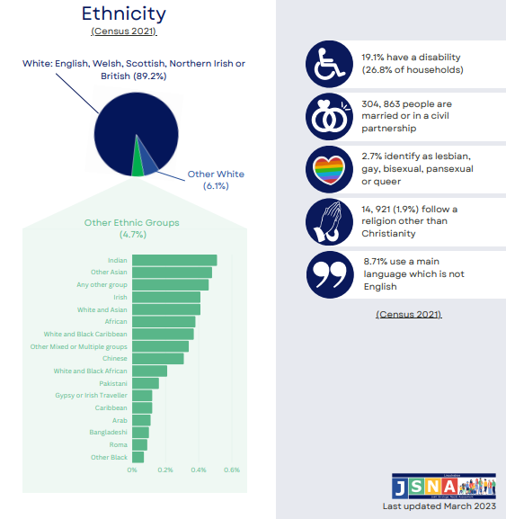
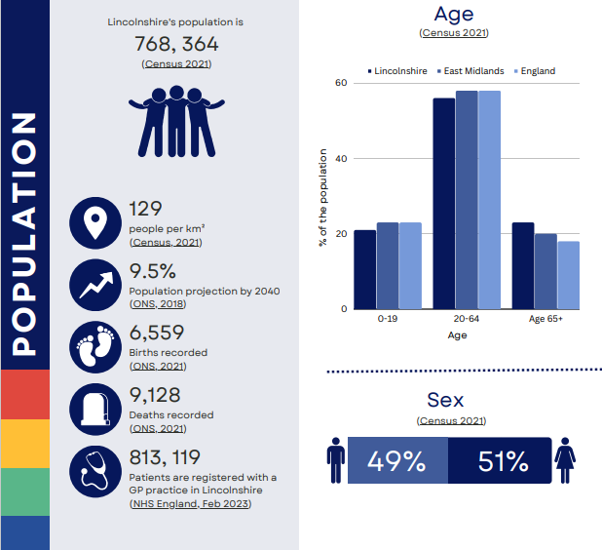

Health Inequalities

Our ambition for the Better Lives Lincolnshire by 2030 is ‘for the people of Lincolnshire to have the best possible start in life, and be supported to live, age and die well’.
Lincolnshire has a challenging combination of rurality, coastal and urban deprivation, an ageing population, and a low-wage economy; this combination defines the difficulty of the mission to improve its population health.
While most of our population enjoys good health and have better health outcomes compared with the rest of the country, we know that significant health inequalities exist and some of our residents are dying from illnesses such as circulatory diseases, cancer and respiratory diseases at a younger age than we would expect.
There is a stark 20-year difference in healthy life expectancy between the highest and lowest socio-economic deciles of the population – based on Index of Multiple Deprivation (IMD) quintiles.
The Chief Medical Officer’s annual report 2021: Health in Coastal Communities, elucidates these challenges and specifically references the east coast, for example, communities in Skegness and Mablethorpe. According to ‘The Centre for Towns’ measures these conurbations rank: 1st (Mablethorpe) & 4th (Skegness) in the 20 most deprived places in England and Wales.
Mablethorpe is fifth in the top 20 places for social isolation. It is already known that residents of such communities find access to healthcare problematic, face a declining bus network and experience poor broadband relative to the major cities/ urban areas.
The maps below show (left) the concentration of older adults in the Eastern parts of the county along with the large areas of socio-economic deprivation in the urban areas, in rural Eastern areas and along the coastal strip (right). This is a specific problem in Lincolnshire with two of its three major secondary care facilities (marked in red on the map) are located well away from the coast.

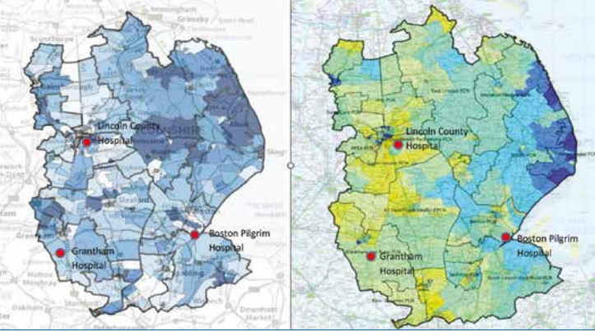
Our Health Inequalities (HI) Framework for action approach promotes primary and secondary preventative services and addresses the inequalities in access and uptake, alongside work led through the ICP which targets the wider determinants of health. Core20PLUS5 is embedded in our work.
Reducing health inequalities and improving health equity is everyone’s business and will be a “golden thread” through all our work and at all levels from all partners. We need to think about health inequalities and shifting to equality of outcomes for all by connecting the dots between the wider determinants of health and the population’s health outcomes e.g., impact of jobs or housing on people’s health.
Core20
The 20% most deprived communities as identified by the Index of Multiple Deprivation (IMD) – 120k patients, 15% of Lincolnshire population. Index of Multiple Deprivation (IMD)

PLUS
- ICS locally determined population groups (evidence and insight based) experiencing poorer-thanaverage health access, experience, and/ or outcomes who may not be captured within the CORE20 alone and would be benefit from a tailored health care approach – key groups identified for Lincolnshire include travellers, people who are homeless, rural, and coastal communities, farming and military families.
- Plus – People from a black, Asian and ethnic minority communities (101k patients, 13% of Lincolnshire), with the largest ethnic minority group being “any other white background” (8.2%) - a significant proportion of this group is people from an Eastern European background.

5
There are five clinical areas of focus which require accelerated improvement. Governance for these five focus areas sits with national programmes; national and regional teams coordinate activity across local systems to achieve national aims.
1. Maternity
- Ensuring continuity of care for women from Black, Asian and minority ethnic communities and from the most deprived groups. This model of care requires appropriate staffing levels to be implemented safely.
2. Severe mental illness (SMI)
- Ensuring annual health checks for 60% of those living with SMI (bringing SMI in line with the success seen in learning disabilities).
3. Chronic respiratory disease
- A clear focus on Chronic Obstructive Pulmonary Disease (COPD) driving up uptake of COVID, flu and pneumonia vaccines to reduce infective exacerbations and emergency hospital admissions due to those exacerbations.
4. Early cancer diagnosis
- 75% of cases diagnosed at stage 1 or 2 by 2028.
5. Hypertension case-finding and optimal management and lipid optimal management
- To allow for interventions to optimise blood pressure and minimise the risk of myocardial infarction and stroke.
The local areas of focus in Lincolnshire are:
- Farming and Rural
- Temporary residents
- Travellers
- Military families
- Eastern European communities
- Coastal communities
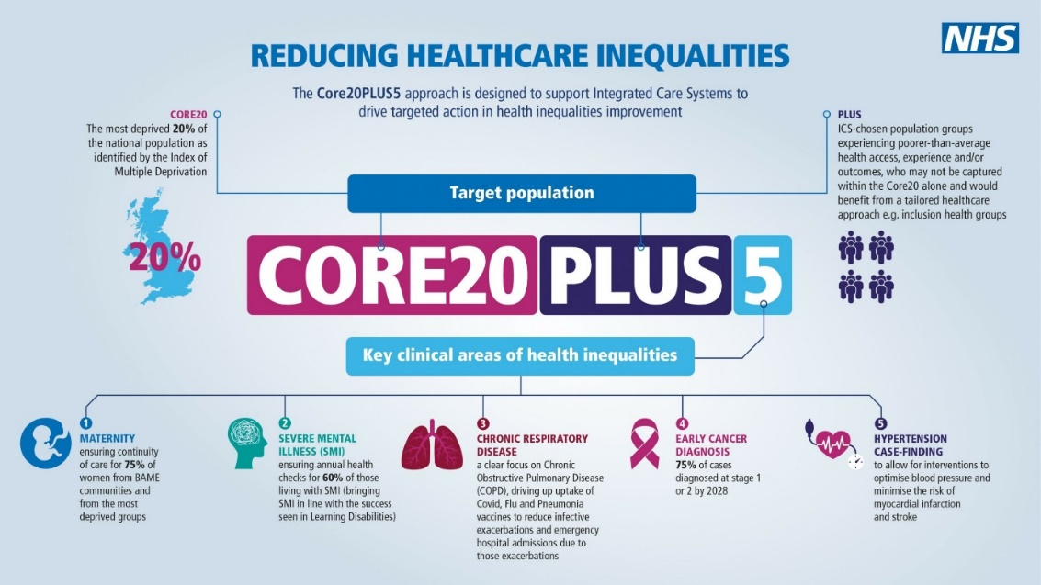

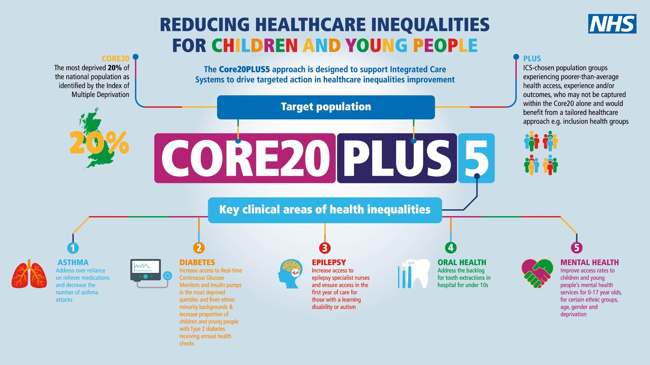

How involvement will support Health Inequalities

Our NHS System Engagement Team will have a dedicated team member to support tackling health inequalities, embedding consistent, best practice activities and empowering Lincolnshire’s people and communities to be involved in all aspects of the programmes.
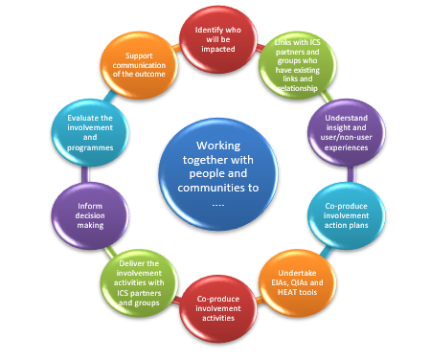
This approach of putting people and communities at the heart of tackling our health inequalities will be replicated across all priorities and programmes. Our people and community representatives will have clear roles and responsibilities within our programmes, governance and decision-making processes.
Especially important is to use the learning from the Covid19 Pandemic and the strengthened relationships with our partner organisations, reduction of duplication, collective responsibility to reach out to the people and communities we share using the best methods and links available regardless of organisational boundaries.
This will continue to evolve through the ICS as we embed shared working and governance processes such as development of the Lincolnshire System Partnership Communications and Engagement Steering Group with attendance from Healthwatch, VCSE partners, local authority partners etc.

- AIMS AND PRINCIPLES

AIM: to build a common purpose

Our legal duties and commitments are clear – people and communities need to be involved in all stages of service development, design, change and decision making.

Our ambition to achieve this is illustrated well using the model from NHS Confederation’s ‘Building Common Purpose, Learning on engagement and communications in integrated care systems’.

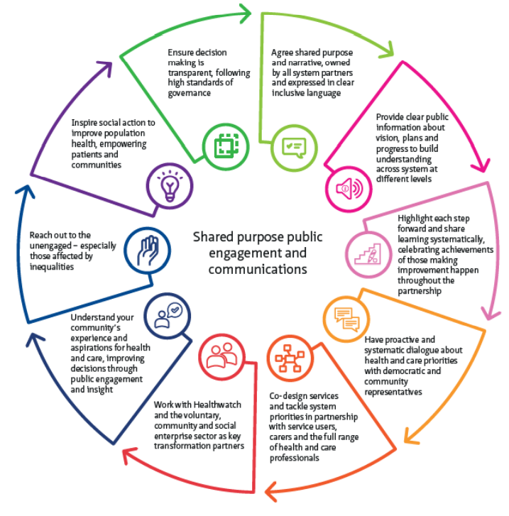

How Lincolnshire ICB will involve people and communities to deliver our principles

Lincolnshire ICB has adopted the ten principles set out by NHS England in the ICS design framework – these have been developed from work with systems across the country and, when embedded effectively, will create a golden thread running throughout the ICS, whether involvement takes place within neighbourhoods, in places or across the whole of Lincolnshire.

Delivering our principles will demonstrate and evidence our commitment to involving our people and communities.

We will deliver this by:
- Through the continued development and evolvement of the ‘shared agreement’ work outlined in the Joint Forward Plan.
- Patient and community representative attendance at key Committees and meetings
- Continued development of Patient and Community Partners, integral to the decision making in all NHS organisations e.g. Patient Safety Partners; Expert Patient Groups; Co-production groups.
- Continued strengthening of our Involvement Champions who will monitor this strategy and plan, it’s achievements and outcomes
- Oversight by our governance structure to ensure delivery of our statutory duties to involve
1. Put the voices of people and communities at the centre of decision-making and governance, at every level of the ICS
We will deliver this by:
- Providing guidance and training for Executive teams and decision makers; contracting teams when they start to look at changes to services; programme boards to ensure involvement is integral to all projects
- Ensuring involvement advice and support is accessible for our staff and partners with clear promotion of the team, dedicated email and telephone contact details to access to our team
- Continued strengthening of our community and stakeholder databases and involvement channels to increase reach to our population
- Regular, clear and timely updates on our involvement activities
- Development of interactive involvement web-based platform to share involvement opportunities and outcomes
2. Start engagement early when developing plans and feed back to people and communities how their engagement has influenced activities and decisions.

We will deliver this by:
- Development and increased partnership contribution to our Involvement Insight database
- Continuing to link with our provider quality leads to understand the day-to-day feedback and incorporate it into our understanding of our community’s needs
- Continue to monitor the experiences of our people and communities using our ongoing Experience of Care survey
- Linking with feedback collected by others such as Healthwatch and Patient Participation Groups

3. Understand your community’s needs, experience and aspirations for health and care, using engagement to find out if change is having the desired effect
We will deliver this by:
- Dedicated involvement resource for Health Inequalities Programme to ensure all programmes and HI workstreams are informed by the voices of service users, public and communities
- Continue community development work to strengthen links with community groups such as our Traveller Link Worker, Neighbourhood Leads, Eastern European communities and faith groups
- Continued strengthening of our stakeholder database, inviting groups and communities to join to enable ongoing engagement

4. Build relationships with excluded groups, especially those affected by inequalities
We will deliver this by:
- Working with our partners across the ICS to support Integrated Care Partnerships to have representation from local people and communities in priority setting and decision-making forum
- Work with our partners to develop a system-wide Insight Database, collating feedback and experiences from people and communities across all channels and organisations to inform our involvement activities and decision making.
- Commissioning partners such as Healthwatch and Every-One to enable collaborative engagement

5. Work with Healthwatch and the voluntary, community and social enterprise (VCSE) sector as key partners
We will deliver this by:
- Remaining connected with our partner communications teams, and informing their work, as well as gaining their support for involvement messaging and priorities
- Encouraging staff across the system to play their part in involvement, not only harvesting information and data for us to consider, but sharing opportunities and encouragement to the service users they see to engage

6. Provide clear and accessible public information about vision, plans and progress, to build understanding and trust
We will deliver this by:
- Retaining our close working relationships with local authority and district council colleagues, as well as voluntary and third sector teams to create as far reaching and relevant connections as possible

7. Use community development approaches that empower people and communities, making connection to social action

We will deliver this by:
- Our involvement activities will be built on insight and patient experience
- Triangulate patient experience, quality and involvement
- Working with the personalisation team in developing the approach to co-production to ensure the outcomes drive improvement in services
- Continued development of system wide survey and analysis software, Qualtrics and development of system wide Insight Database

8. Use co-production, insight and engagement to achieve accountable health and care services.
We will deliver this by:
- Utilising our governance and reporting structure to ensure that public and community feedback is heard and referenced by our strategic and operations colleagues
- Having an involvement representative present at the ICB board to identify service redesign opportunities
- Placing involvement representatives alongside operational colleagues in early strategic discussions
- Embed co-production as a ‘business as usual’ approach to service review and design
9. Co-produce and redesign services and tackle system priorities in partnership with people and communities.

We will deliver this by:
- Our routine system involvement steering group, at which all ICS partners are invited to share best practise and leverage assets and networks to broader advantage
- Leveraging the relationships our partners and community groups have with their service users and communities

10. Learn from what works and building on the assets of all ICS partners – networks, relationships, activity in local places.

How Lincolnshire ICB will involve individuals

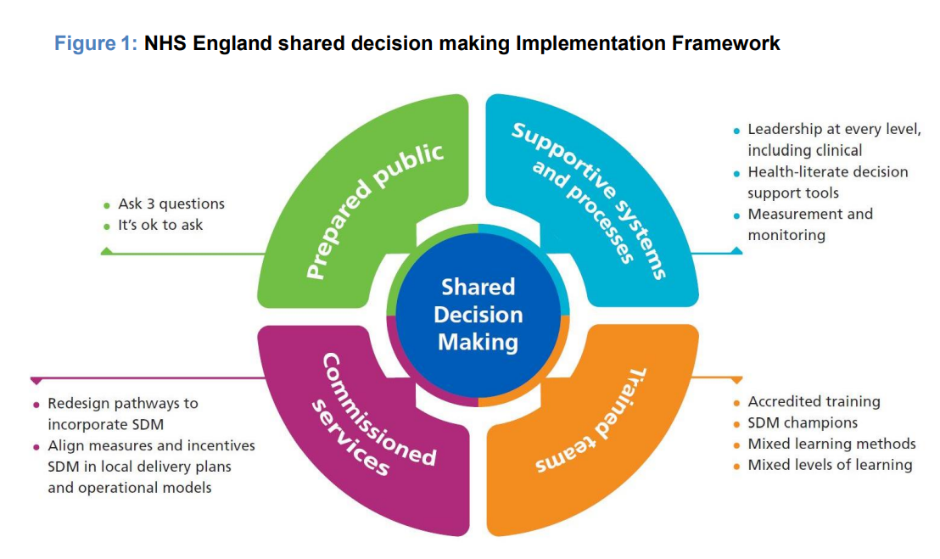
The ICB also has a duty to promote involvement of each patient (s.14Z36 NHS Act 2006) in decisions which relate to the prevention or diagnosis of illness in patients or their care or treatment. We will do this by strengthening shared decision making and personalisation approaches.

Lincolnshire ICS – Working Together

There is a long history of joint working in Lincolnshire between the Local Authority, the NHS, and wider partners. We have worked hard to build the relationships needed to support the people of Lincolnshire to enjoy the highest quality health and wellbeing for themselves, their families, and their communities. We are pleased with the progress we have made and are confident we have developed the right principles and values to guide us.
However, we know that more needs to be done to give everyone the very best start and every chance to live a long and healthy life. We also know that to have the best chance of achieving this we need to think and work differently with each other and with our communities.

Together we will:
- Create a shared agreement
  - Work together with the public about what the best wellbeing, care and health for Lincolnshire looks like, as well as learn how staff across the NHS and its partners can confidently adopt new ways of working in their daily work.
  - Demonstrate the impact this new relationship could have on staff and people by highlighting where it is working well so we can build on strengths.
- Support shared decision making
  - Helping people to make informed decisions about their care and treatment and delivering this with a focus on what matter most to them, their family, and carers. This includes asking ‘what matters to you?’ on a routine basis and learning from work already being done in some services and communities.
- Develop and design services together
  - Build stronger relationships with the public, volunteers, and community groups, working alongside them to improve health and care services.
  - Include all sectors of society including hard-to-reach groups, creating safe and inclusive spaces to give everyone the confidence to contribute to discussions and use our new relationship with the public as a framework for developing and designing services together.
- Work with people and their families to manage their own health and wellbeing
  - Better understanding of how well patients can manage their own health and support them to be more independent and make positive changes to their lifestyle as well as introducing health and wellbeing coaches to work with individuals to better manage their own care.
  - Using care coordinators to work with people and their carers to identify what is important to them and creating groups of people with similar needs who can support each other.
More recently there has been a committed increase in the strength and effectiveness of this partnership working. However, we know we have more to do. We need to continue the journey we have started to ensure the best health and care in Lincolnshire and we know this needs to:
- Be done through engaging and listening to the local population
- Describe a new relationship between the health & care system and the people of Lincolnshire, where individuals play an equal part in their health, well-being and care

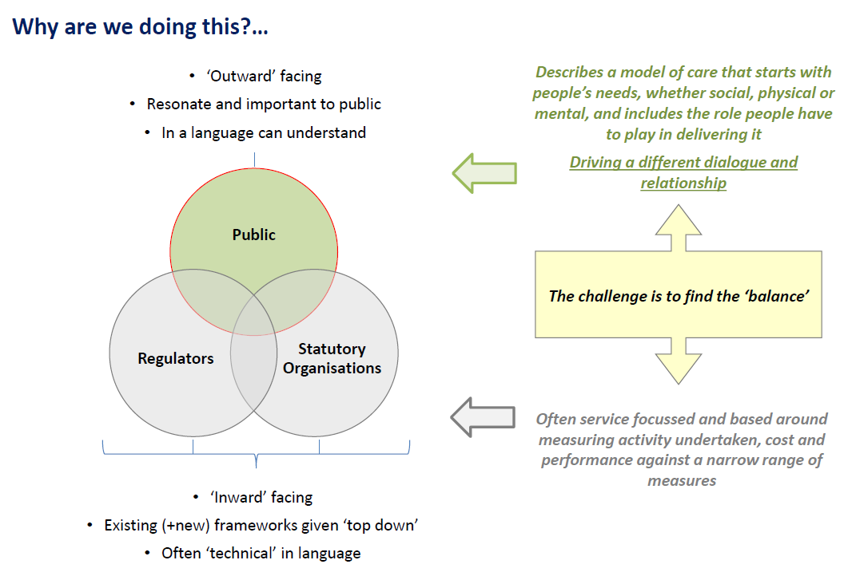

The purpose of this programme of activity is so that, together with the public, we can build a shared view and agreement on what the best health and care for Lincolnshire looks like.

As a result, we will be able to describe a new relationship, and the roles health & care providers and the local population have to play in this, show that what’s important to people is being achieved and set out how success should be measured and how learning should be used, including:

- The local population’s views and experiences on progress and impact
- Engaging local people in the process of analysing results and working out what this means for services, people and communities
- This will provide the foundations for meaningful ongoing engagement and dialogue with the people of Lincolnshire and empowering them to be part of delivering the best health and care for Lincolnshire.

This fully integrated approach is a progression for the county and the below summarises the initial outcomes of this co-production emphasis.

Better Lives Lincolnshire – our shared agreement
individuals

Over a few years, the people of Lincolnshire have been sharing their views on their health and care and how it could be improved via a number of involvement opportunities: Joint Health and Wellbeing Strategy for Lincolnshire 2017; The Lincolnshire Public ‘Talk About’ NHS Long term Plan 2019; Healthy Conversation 2019; NHS Lincolnshire Citizen Panel Survey 1 - personalised Care 2021; Engagement Team Summer Roadshows 2022; and The NHS Lincolnshire Joint Forward Plan 2023-28. This feedback has been used to develop a Shared Agreement. This describes a new relationship between the health & care system and the people of Lincolnshire, where individuals play an equal part in their health, well-being, and care.
This shared agreement is one of our priorities of the NHS Lincolnshire Joint Forward Plan 2023-28. – ‘a new relationship with the public’.
Together with the people of Lincolnshire, we want to build a shared view and agreement on what the best wellbeing, care and health for Lincolnshire looks like.
At its core this will describe and illustrate the foundations of a new relationship.
An initial description of these foundations, have been developed by working with people from Lincolnshire, and is set out below:
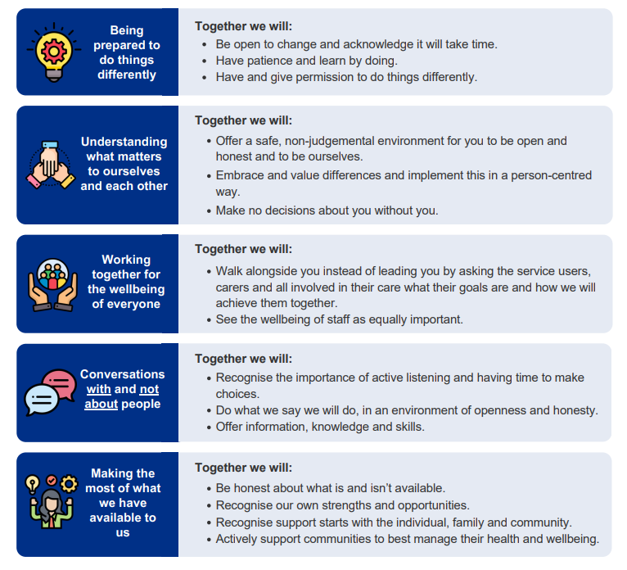

- ROLES, RESPONSILIBITIES AND RESOURCES

Our teams

The ICB have an experienced and dedicated Engagement Team, providing strategic advice and guidance, management of involvement activities within priority programmes and development of building blocks to provide a solid basis of relationships and links with our people and communities.

The Engagement Team have developed strong links across all NHS organisations in Lincolnshire – the ICB, Acute Hospital Trust, Community Hospital Trust, Mental Health Trust and the associated provider collaborative programmes. NHS providers have their own statutory duties under s.242 NHS Act 2006 when considering service changes, and the teams work collaboratively to deliver this duty to involve following these approaches and principles in this strategy. Its ethos is ‘system first’ and will continue to develop and undertake involvement with the people and communities of Lincolnshire, regardless of organisational boundaries. Key developments such as our Citizens Panel, Insight Database and online Engagement Hub are created for all organisations and not just the ICB. As the ICS evolves and matures over time, we will explore ways of encouraging greater collaboration across the system, sharing these mechanisms and opportunities with our other ICS partners.

Beneficially, our ICB Communications and Engagements teams work alongside colleagues ring fenced for programmes such as Better Births, Continuing Healthcare, Lincolnshire’s Provider Collaborative and Mental Health, Learning Disabilities and Autism Alliance. This arrangement is supported by all partners in the system as it ensures consistent and continuous approaches are received by our shared public and service user groups. It also means that team members have strong links and visibility of quality groups across the system, meaning that data, intelligence and feedback reported in each inform activity and priorities within the ICB, such as service change proposals. Finally, our in reach to place, at multiple levels is enhanced through this arrangement.

The Personalisation team is made up of colleagues from health, social care and the VCSE sector, with people with lived experience volunteering to support the work. The team are leading on the ‘Our Shared Agreement’ and are the enablers and facilitators who are developing and exploring new relationships and ways of working between the people of Lincolnshire and the Health and Care workforce.
Our patient experience and complaints teams work closely with the Engagement Team to share insights and data which is vital to understanding how our patients are experiencing services and highlighting any emerging themes or issues. This is triangulated and reported into the Quality and Safety Committee.

Supported by our people and communities

Our teams embedded within the ICB and ICS are supported by a strong network of people and community groups who initiate and contribute to our work.

Our Involvement Champions are advocates for the groups and communities they represent. They will work with us to test our plans and strategies, monitor progress and evaluate outcomes. They support our engagement with local people and communities by sharing messages and gathering feedback to create a two-way communication process between the ICB and their communities.

Our Citizen Panel aims to be reflective of people and communities in Lincolnshire, taking part in surveys about planning and improving local health and care services.

Patient Participation Groups - (PPGs) are designed to give patients and practice staff the opportunity to meet and discuss issues and opportunities and supporting their wider practice population to get involved and increase understanding in their healthcare services. PPG representatives come together as a Lincolnshire Patient Council where they feed the views of their practice patients into the ICB and are involved in programmes and projects.

NHS Provider Organisations support Patient Panels and Patient Experts to regularly influence and shape the work of the system service developments.

Supported by our partners communities

Healthwatch are key partners and will act as a critical friend, as well as representing an independent view of the patient and public voice. Healthwatch will be integral members of Lincolnshire’s ICB Board and ICP Board as well as sit on various programme steering groups to support and undertake some engagement activities.

A representative of the Voluntary and Community Sector will also be an integral member of Lincolnshire’s ICB Board and an associate member on the ICP Board.

Public Health and Local Authority representatives sit alongside our involvement board representative at every ICB board formally. This is supported by their membership of the ICS communications and involvement steering groups, to which members from across the system are invited to participate as collaborative leaders, to share best practise and leverage assets and networks to broader advantage.

Our provider and primary care colleagues for part of our extended team and therefore are integral to the development and delivery of our shared strategic priorities.

We will engage with our Health Overview and Scrutiny Committee on potential service changes, enabling them to consider whether it is a substantial and significant service change requiring consultation process. We will work to assure them that healthcare is planned and delivered in ways that reflect needs and aspirations of local communities, plans for substantial service changes are reasonable and that everyone has equal access to services.

Co-production in Lincolnshire
Co-production is people working together to make things better for all. It is an authentic relationship built on respect and honesty between people who access services and those who design and deliver services.
It is an approach that values everyone’s lived experience, bringing people together to shape and improve the things that matter to them for the benefit of the people of Lincolnshire.
The Better Lives Lincolnshire Integrated Care System (ICS) has an ambition to be recognised as excellent at ‘co-producing’ health and care with communities, citizens, patients, carers, and families across Lincolnshire.
Work is underway to embed co-production approaches across the system. It will require a real change in ethos and behaviours at all levels of health and care in Lincolnshire and it will necessitate a shift in power dynamics accompanied by positive risk taking and individual / systemic reflexivity.

- PEOPLE AND COMMUNITIES IN ICB GOVERNANCE AND WORKSTREAMS

The voice of people and communities is integral to the functions and governance of the ICB, ensuring their voices are heard to have the biggest impact and improve outcomes. Strong links with quality and patient experience and insight will inform all levels of the ICB through programmes, priorities and decision making.
Timely and meaningful engagement is a priority for us, and a strong framework, with clear structures and assurance processes, plays a key role in making sure that patients and communities are central to our decision-making.

Reports on the outcomes of our engagement activities are reported to the ICB Operational Quality Assurance Group Meeting with escalation as required to the System Quality and Patient Experience Committee (QPEC) and to our Primary Care Commissioning Committee (PCCC) if it is regarding a GP surgery. Feedback from programme specific engagement is also shared with our project leads to help shape and steer their programmes of work.

Feedback from our engagement activities and consultations is also reported into our Board meetings to inform decision making on large projects and programmes of work.

Our engagement and involvement function is part of the ICB’s Strategic Planning, Integration and Partnerships team, ensuring patients and our communities are at the heart of service development, improvement, and transformation. Strong links are maintained with the ICB Nursing and Quality Team to align patient experience and engagement with quality and safety.
We have also established a dedicated communications and engagement team to focus solely on primary care, recognising the vast array of specific feedback we receive from patients and the public and enabling us to ensure this reaches the teams developing primary care and its services in a timely manner for them to respond to.

How we report and listen to the feedback we’ve heard:

- MONITORING AND EVALUATING THE STRATEGY

We want to develop a way of measuring involvement and the impact it has in a meaningful way. One of our key priorities for 2024-25 will be to develop a framework and process with people and communities to do this, recognising that it will mean different things to different people.

Working with system wide communications and engagement groups, we will ensure feedback is triangulated and reported into the most appropriate programme board or ICB committee to drive change and is actionable at the most appropriate level.

Regular reporting into the ICB and the wider ICS is essential to demonstrate progress against plans and to evidence the outcomes of involvement, culminating ultimately at the ICB Board, championed by our senior leaders. We will communicate this using several established methods including our website, Engagement Bulletin and via partner organisations.

All feedback from involvement activities will be collated on our System Insight Database.

