Care Portal: Care Plans Hints,Tips and FAQs
Title | Care Portal : Care Plans hints, tips and FAQs

Change History
Version | Status | Date | Author / Editor | Details of Change  (brief detailed summary of all updates/changes)
1 | Draft |  | Anthony Gorman | 1st draft hints and tips
2 | Draft |  | Anthony Gorman | Further hints and tips and a FAQ appendix added
The latest approved version of this document supersedes all other versions; upon receipt of the latest approved version all other versions should be destroyed, unless specifically stated that previous version (s) are to remain extant. If any doubt, please contact the document author.
Contents
1. Introduction 3
2. Care Planning eLearning 4
2.1. Comparing Care Plan Versions 4
2.2. Publishing a Care Plan 6
2.3. Marking Care Plans as Active 7
2.4. Saving / Printing a PDF (Published Care Plan) 8
2.5. Viewing a Care Plan 9
2.6. Locked Care Plans 10
3. Appendix 1 – FAQs 11

Introduction
The Lincolnshire Care Portal has seen year on year growth in the number of user account profiles as well as a steady increase in the number of daily active users. These users include professionals across Acute, Community and Primary Care and in the main are from staff across the three trusts (ULHT, LCHS & LPFT) as well as Social Care staff from Lincolnshire County Council (LCC) and of course our GP Practices and staff from St Barnabas.
Electronic Care Plans was introduced in 2020 where Care Plan templates can be built on behalf of the service. The service remains accountable for the template content and how they (the service) intend to use the Care Plan operationally for their service and patients. This includes responsibility for any process / pathway which involves use of the electronic Care Plan features.
Once a Care Plan template is validated by the service and published, it becomes available to be added as a Care Plan via the Care Portal.
As of May 2021 there are four Care Plans live that can be added to Care Portal patients records. These are:-
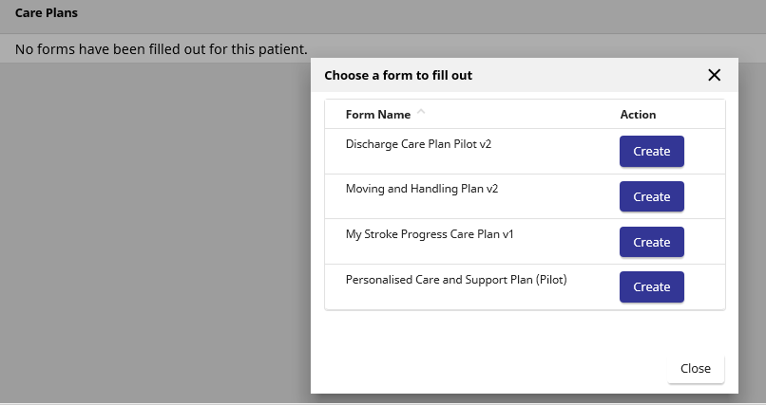
This document will provide some additional “hints and tips” for staff that are involved in adding and/or contributing to electronic care plans via the Care Portal.
It’s purpose is to support staff and answer typical questions that have been raised during Care Plan demonstrations and once staff have started to use the Care Plan capability.
As a reminder, many questions will be answered when staff complete the eLearning Care Plan module (covered in section 2 of this document) as this module provides a guide of how to add a plan and contribute to the single shared care plan. All staff should complete both eLearning modules before they start to use the Care Plan capability.

Care Planning eLearning
Please note, this document does not replace the eLearning module(s) that are available once the user is logged in to the Care Portal. As a reminder, the modules are available by clicking on the “help” in the menu banner.

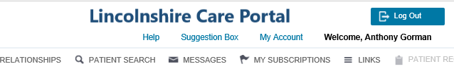
A separate window will open and you simply click on the relevant eLearning package which provides the user with a guide navigating the care portal (Care Portal e-Learning Package) or using the Care Plan capability (Care Planning e-Learning Package).

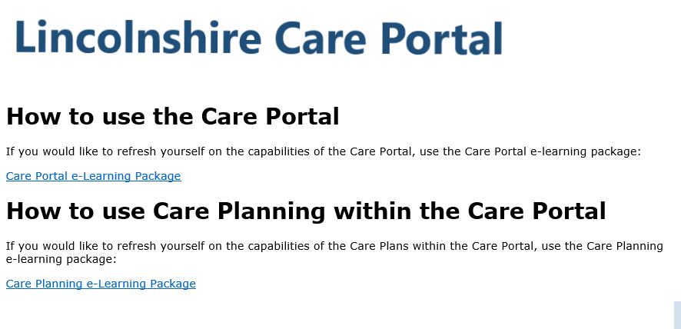

Comparing Care Plan Versions
The Care Portal’s Care Plan capability has full audit history and version control. This includes the name, date and time of those staff that either add and/or contribute to a Care Plan. The Compare Version feature will display ALL historic versions of the Care Plan and indicate that versions status, such as if it is Active, Final and includes if it has been Published. This is a step by step guide to assist you if you need to either view a previous version or compare two versions of the same Care Plan type to see what changes have been made over time.

- Log-in to Care Portal, search and claim legitimate relationship with the patient. When the information is presented, click on the Care Plans tab and on the appropriate Care Plan (i.e. Discharge or M&H) and under Actions click on the 3 dots
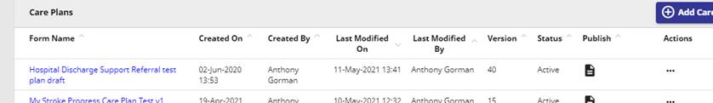
- Select View Version History

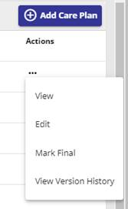
The following information is presented – if you want to see one previous version click on the VIEW button against the version you wish to see. Note: in the example below the User name and Date and Time that version was added to Care Portal, whether published or Active, will be shown.


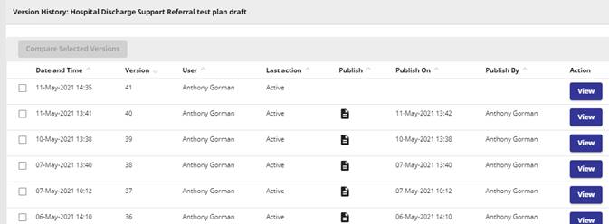
If you want to compare two versions click on the small boxes on the left.
Once two boxes are selected you will see the Compared Selected Versions button turn blue. Click on this to see the versions.
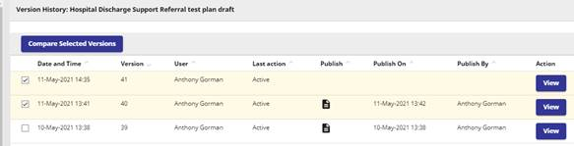

You will then be presented with the following on your screen. The latest version selected will be on the left (i.e. version 41 in this example).
Click on the “scroll down bar” in each version to align each section up. To see if any changes made.

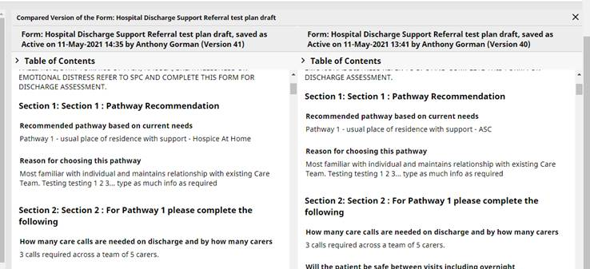
In the example above you can see the Recommended pathway based on current needs question has a different response to the previous version – continue scrolling down each version and aligning each section and you will be able to compare the entered data between those versions selected.

Publishing a Care Plan
Once a Care Plan is added and/or contributed to it and it is Marked as Active it can be published. Note: A Care Plan can be published at any point in time. If a Care Plan is published all that happens is that the Care Plan will also be visible in the Published Care Plans tab. Once published the Care Plan can continue to be contributed to. If the newer version is published it will replace the previous published version in the Published Care Plans tab.
Having a care plan published allows for more users to see the latest version of the Care Plan. For example, some GP Practice and hospital administration staff (i.e. GP receptionists, medical secretary’s) have a Clinical Admin role in the Care Portal. This role is not as enriched as Clinicians or Social Worker roles allocated to staff in Acute, Community, LCC, LPFT therefore they cannot see the Care Plans tab, only the Published Care Plans tab.
Please Note:
- If a Care Plan is published it can still be contributed to by staff with the appropriate Care Portal access (i.e. Clinician, Social Worker roles).
- If published the Care Plan is not sent anywhere outside of the Care Portal (the Care Portal is a secure computer system)
- Once published the Care Plan is available as a PDF document. This allows the version of that care plan to be printed or saved to user’s device. If saving to a device you need to adhere to any data sharing protocols and policies especially if sending this PDF to another clhealth and social care system. Similar if printing a document so ask yourself if this is necessary. Your service / operational leads are responsible for providing you with the expected process / pathway you should follow which should include how you manage published versions and use of any other systems involved or used by the service. Remember if you send a version to another system (i.e. Systm1) if the Care Portal version is contributed to further, the version in the other system will be out of sync.
- Remember, if you mark a care plan as active and then publish the care plan you need to reclaim the relationship with that patient as this allows the systems to refresh. Once you have claimed the legitimate relationship with that patient you can see the published care plan in the Published Care Plans tab.
- If the Care Plan is then changed (contributed to) and republished, the previous version of that Care Plan will be replaced in the Published Care Plans tab. Therefore only the latest published version will be visible in the Published Care Plans tab.

Marking Care Plans as Active

Once you have added a Care Plan and/or contributed to an existing active care plan NEVER leave the Care Plan in Draft status. If you log out of the Care Portal or if the Care Portal “times out” after a period of inactivity and you have left the Care Plan in draft it prevents other professionals contributing to that Care Plan. If one of your colleagues, or other health and social care professionals, need to contribute to the patients Care Plan they will see that the Care Plan is locked by the user (will show date and time of last edit as well as user that has it locked). Therefore to avoid your colleagues having to contact you, because they are unable to contribute, always ensure you mark the care plan as ACTIVE. If you have left a Care Plan in draft status only you can make that care plan active.
Audits are run monthly to check if any Care Plans are left in Draft status. Those users that have left Care Plans in draft will be contacted via their Team Leads. They will be instructed to log-in to the Care Portal, search and claim the legitimate relationship with the patient and access the Care Plan they have locked (for them it shows it is in Draft status) and mark the care plan as active. See section 2.6 for steps to follow if you are asked to unlock a Care Plan.
As a reminder, if a Care Plan is locked it is no longer seen as a single shared care plan. The point of moving to the electronic care plan via the Care Portal is to promote having single shared care plans available via a single source system that allows health and social care professionals to view and contribute to that single shared care plan.
Marking the Care Plan as Active is covered in the Care Planning e-Learning Package as mentioned in section 2 of this document.

Saving / Printing a PDF (Published Care Plan)
If the service requires you to print or save a Published Care Plan (PDF document) follow this guidance. However, it is essential you consider any risk associated with printing or saving to a device when the Care Plan is available on the Care Portal (as mentioned earlier in this hints and tips guide).
Once you have “Published a Care Plan” (and reclaimed the patient relationship) click on the Published Care Plans tab (left side of screen)
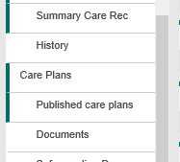
Click on the title of the Care Plan you wish to open (i.e. Discharge Care Plan Pilot v2)
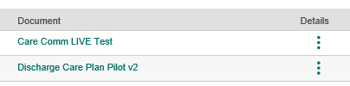
This opens up the PDF. Move your mouse/cursor over the document and this bar appears
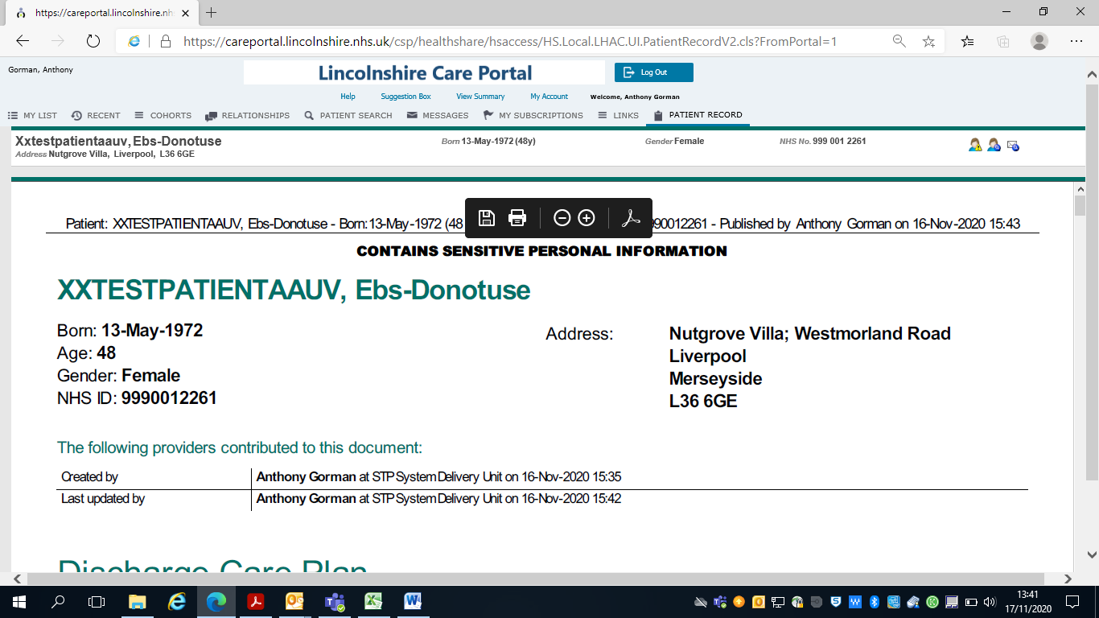
If you move you mouse/cursor over the “printer” icon and “left click” your mouse it allows you to print the document. Alternatively you can click on the file icon (to the left of the printer icon) and save the file and then print.
You service / operational lead will confirm any process you are expected to follow with respect to saving and printing a Care Plan.

Viewing a Care Plan
If you wish to View an individual’s Care Plan purely to view it’s content then always access via the 3 dots under the Actions heading


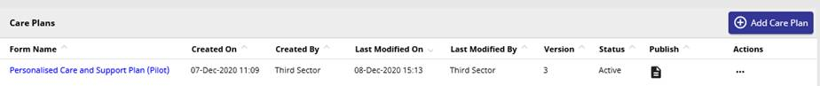

When you click on the 3 dots you will be presented with the following

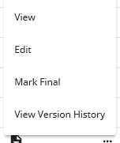
View = allows the user to view the content of the Care Plan only. When you have finished viewing the Care Plan click on the Close button at the bottom (ensure you use the scroll bar to scroll down to the bottom).
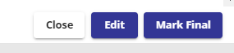
Edit = if you are viewing and you need to contribute to the Care Plan then select edit and make the necessary changes. If you click on this “in error” you can discard changes which will be presented at the bottom of the Care Plan form.

Remember – once you have made changes to the Care Plan ensure you click on Save as Active. If you Save as Draft and exit the Care Portal the care plan will be locked against your name and prevent others contributing to the single shared care plan.
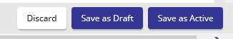

Locked Care Plans
There are instances where Care Plans are shown as “Locked by…”.
This could be a result of either accessing the Care Plan and saving it as Draft after editing, or during your editing activity the Care Portal has timed out after a period of inactivity.
The system will indicate to others that the Care Plan is locked against your name which means no one else is able to contribute to the single shared care plan. You will see that the Care Plan is in draft status, however your colleagues across the system will see these as locked against your name.
If you are contacted by your colleagues or service leads you need to take immediate action:
- Log in to the care portal
- Search/claim a legitimate relationship with the patient (they will advise you of the NHS ID)
- Click on the Care Plans tab and open the appropriate Care Plan they have advised you is locked by you, always using the 3 dots under the Action menu heading.
- Mark the Care Plan as Active
- Advise your service/operational lead you have Marked it as Active.

Please remember to never exit the Care Portal if you have not saved the care plan as active.

Appendix 1 – FAQs
The following is a series of frequently asked questions that will provide users with an answer or where the answer can be found. This may include references to earlier sections in this document to provide the appropriate response and material to assist the users understanding. All users are advised to complete both eLearning modules as covered in Section 2 of this document. The Care Portal eLearning provides a very comprehensive guide to navigating around the Care Portal where the Care Planning module focuses on how staff expected to add and contribute to Care Plans navigate and use the features available.

Q. What is the Lincolnshire Care Portal (LCP)?
A. The LCP is a secure computer system (hosted by ULHT) that enables users to view an integrated care record for patients. It brings together selected patient information, from multiple organisations and systems in real time. In 2020 we introduced two new tabs in the chartbook which are the Care Plans and Published Care Plans tabs. These new tabs allow staff with the appropriate Role Based Access Controls (RBAC) to add and contribute to an electronic single shared care plan via the Care Portal.
Q. How do I get access to the Care Portal?
A. Each organisation (i.e. ULHT, LCHS, LPFT) are responsible for providing their staff with access to the Care Portal through established processes. The respective organisations are responsible for ensuring their staff follow existing policies and complete the eLearning modules.
Q. I can’t find or I don’t recall my Care Portal Log in ID and Password?
A. as above, all login and password issues are managed by your respective organisations via recognised processes.
Q. I’m getting access denied when I try to log-in to the Care Portal, what do I do?
A. Each organisation is responsible for managing access issues for their staff. Please refer to your respective organisations process if you experience Care Portal access issues and require your user ID and/or password reset.
Q. I’m a LCC Adult Social Care staff member supporting ULHT/LCHS on the hospital wards, can I get Care Portal access?
A. Yes, we have an agreed SPOC (Single Point of Contact) process with LCC. The SPOC will co-ordinate access for you. They also act as the SPOC for LCC staff experiencing Care Portal access issues.
If you are a LCC staff member, please contact samantha.francis@lincolnshire.gov.uk with your Care Portal request and rationale.
Q. Where can I find the Care Portal application?
A. For NHS staff this is likely to be available via your desktop/laptop and may be pre-loaded or bookmarked accordingly. If you cannot find these contact your respective organisational IT departments for help.
Q. Where can I find the eLearning modules?
A. First check your desktop/laptop as your organisation may have bookmarked this in your favourites as part of your induction. Alternatively, once you are logged in to the Care Portal click on “help” and the modules are available.
Please refer to section 2 of this document as screen shots have been added to assist. If both options aren’t working then try option accessing via the link below https://careportal.lincolnshire.nhs.uk/csp/docbook/lhachelp/help.html
Q. What is the difference between making a Care Plan Active and Publishing a Care Plan?
A. Publishing a Care Plan results in the Plan being added to the Published Care Plans tab which allows for those Care Portal users who are allocated a “Clerical Admin” role to view the Care Plan. Active means the Care Plan becomes visible to other professionals where they are able to contribute to it as it is a “single shared Care Plan”. When publishing a Care Plan all that happens is that the particular version is available in the Published Care Plans tab. It is not sent anywhere else outside of the Care Portal. This is covered in the Care Planning eLearning module.
Q. Can I add two Care Plans of the same name to a patient’s record?
A. No, the system recognises if there is already a Care Plan of that type in the patient’s record. There is full version control and history of previous versions available so no content is lost. Refer to the Compare Care Plan versions section of this document.
Q. What about Out of Area (county) Patients
A. At present only patients present on a ULHT system are available on the Care Portal, however, once an out of area patient is admitted into a ULHT Hospital they should be recorded on the PAS. As soon as the patient’s details are processed on PAS (“clerked in on PAS”) it generates a message to the Lincolnshire Care Portal to add the patients record immediately, unless that is, the patient has opted out. If the patient Opts out then their record will not appear in Care Portal so you will not be able to use the care Portal Care Plan capability and you will need to follow any manual process for your service. Note: the NWAFT interface with the Care Portal is currently in progress and likely to be LIVE by summer 2021 (date TBC).
Q. Who marks the Care Plan as final?
A. This is an operational decision, please contact your service lead or operational lead and refer to any process they are responsible for. Once a Care Plan is marked as final no one will be able to contribute to that Care Plan.
Q. Can I print a Care Plan?
A. Once a Care Plan is published it is available as a PDF in the Published Care Plans tab and can be printed. However consideration should be given to if this is absolutely necessary as the idea of using an electronic Care Plan is to reduce printed versions, as the most recent Care Plan is always available on the Care Portal as a single shared care plan. This is an operational decision, please contact your service lead or operational lead and refer to any process they are responsible for
Q. How can I compare two Care Plan versions to see what changes were made?
A. Yes, any previous version of a Care Plan can be viewed as there is full audit history and version control available. You can either view a single previous version to see what content was added or you can compare two versions. Refer to section 2.1 of this document for more information on how to do this.
Q. Who is responsible for starting / adding the initial Care Plan to the patient’s record?
A. This is an operational decision, please contact your service lead or operational lead and refer to any process they are responsible for.
Q. I have a concern that another professional will overwrite the information I added to a Care Plan and my contribution will be lost?
A. It’s inevitable that a Care Plan’s content could change over time, hence why there is full version control and all previous Care Plan versions are never lost. You are able to see the previous version(s) that you contributed to and marked as active as well as comparing Care Plan versions. Refer to section 2.1 of this document for details of how to view previous versions and comparing any two versions of the same Care Plan type.

Q. How do I search for a patient on the Care Portal?
A. Your organisation is responsible for ensuring you complete the eLearning module prior to using the Care Portal. Refer to section 2 for more details as the Care Portal eLearning covers how to navigate around the care portal including searching for patients and claiming legitimate relationships.
Q. How can I find out more about the Care Portal?
A. The Care Portal eLearning as covered in section 2 provides a comprehensive overview of navigating around the Care Portal. All staff accessing the Care Portal should have completed this prior to using the Care Portal.
Q. Do I have a “go to” person if I need to check my understanding of using the electronic Care Plan features?
A. This is an operational decision, please contact your service lead or operational lead and refer to any process they are responsible for. If you require a demonstration please ask your operational team lead to request this via email to: lccg.stpdigital@nhs.net
Q. Can I print a blank version of the Electronic Discharge Care Plan (or any other Care Plan) from the Care Portal?
A. No, a Care Plan is prebuilt as a template that becomes available to add as a Care Plan to the patient’s record once you have searched and claimed a legitimate relationship with the patient. The service maintains accountability for the Care Plan template content.
Q. Can I create my own version of a Care Plan on the Care Portal
A. No, only dedicated resource can build a Care Plan template on behalf of the service. This is to prevent variation of documentation where some teams may wish to customise a Care Plan for their team’s needs. As mentioned earlier, the service and it’s operational leads are accountable for the content of a Care Plan and will provide an example of their Care Plan requirements and ensure any patient and clinical safety risk is completed before requesting a template is built. Once a Care Plan template is built it will be demonstrated to the service / operational leads prior to its use on the Care Portal. The service / operational lead will advise teams once a Care Plan is available via the Care Portal and provide users with their expected process to follow.
Q. Can I suggest changes to a Care Plan template in use on the Care Portal?
Yes, as the service/organisational leads own the content and decide how their electronic Care Plan will be used across their service/operationally. They will encourage users to raise change proposals to their Care Plan via team calls and working group calls. Any changes will be agreed by the service lead who is responsible for contacting the STP Digital team (via lccg.stpdigital@nhs.net ) with their revised Care Plan. Once the new Care Plan for the service is built as a template this will be shared with the service lead to confirm it meets needs. Once confirmed the new Care Plan template will be added and any previous template used will be archived.
Q. Can a Paper Respect Form or an Advanced Decision Care Plan be uploaded to the Care Portal?
A. No, the Care Portal doesn’t allow for forms to be scanned in.
Q. Can I arrange Care Plan demonstrations for my staff members?
A. If you require a Care Plan demonstration please ask your operational team lead to request this via email to: lccg.stpdigital@nhs.net
Q. Why can’t I leave a Care Plan in draft status?
A. If you leave a Care Plan in “Draft” status this will lock the care plan against your name which prevents any other professionals contributing to the Care Plan. To purpose of moving to an electronic version is for the Care Plan to be a single shared care plan that others across the system (Acute, Community & Primary care) can contribute to as required. You must always ensure the Care Plan is Marked as Active before logging out of the Care Portal. If you are contacted where you have a Care Plan locked you need to follow the actions as covered in section 2.6
Q. As I work in the same organisation or ward as a colleague then can I leave the Care Plan in draft.
A. No. As above, leaving a Care Plan in draft locks the care plan against that user regardless of organisation. Each version that is edited and marked active records the person that has made those changes and includes the date and time when those changes were made.
Q. Can I view the Care Plan only and not make changes?
A. Yes, refer to section 2.5. However if the Care Plan is shown as Published it will also be available to view in the Published Care Plans tab.
Q. Can anyone make changes to a Care Plan?
A. Anyone with the appropriate Role Based Access Controls (RBAC) will be able to view and/or contribute to the Care Plan. Note: there is full version control and any changes made to a Care Plan will be auditable and users can see previous versions. Each version will show the person that made changes to that Care Plan including the date and time changes were made. The Care Portal Role Based Access Control has Clinical Reference Group (CRG) governance. Each organisation is responsible for allocating the appropriate RBAC for their staff.
Q. Once a Care Plan is Published can I or anyone still contribute to the Care Plan?
A. Yes, publishing a Care Plan means that the version published is placed in the Published Care Plans tab. The Care Plan can still continue to be contributed to once it is published. As previously mentioned there is full version control. Republishing a later Care Plan version means that the most recent version will be placed in the Published Care Plans tab and will replace any previous versions in that tab. Remember, once published you need to reclaim the patient relationship to see that published care plan.
Q. How do I have a different conversation with the individual in the relation to their Care Plan (i.e Personalised Care and Support Plan)?
A. The Care Portal does not provide how to have a different conversation with a patient/individual that should be part of any systems/service Learning and Development training. The Care Portal care planning capability just provides the method to record the outcome of that different conversation. Please contact your operational lead if you require training in having different conversations.

