Let’s get you
home to
what matters
to you

Partner toolkit

Staff/Stakeholder briefing summary
We know that it’s much better for people’s physical and mental wellbeing to leave an acute hospital as soon as they are medically ready to do so. That’s why we are doing everything we can to reduce prolonged hospital stays in Lincolnshire and ‘Let’s get you home to what matters to you’.

Helping patients safely back to everyday life
The ‘Let’s get you home to what matters to you’ campaign aims to ensure patients avoid staying in hospital any longer than they need to. There’s lots of evidence to show that patients recover better at home once their treatment in hospital is complete and they are ready to leave.
This approach is supported by all partners in health and social care and it is very important that everyone shares the same messages and works in the same way. Working together means we can make a difference.

How you can support the campaign
Your support is crucial in helping to make this campaign a success and helping to drive down long hospital stays in Lincolnshire. We can achieve a significant reduction in long stays by working together and each of us playing our part. Making this happen is a team effort, and as health and social care professionals, we must all do what we can to ensure our patients are discharged in a safe, appropriate, and timely manner.
There are several digital and social media resources available to download from lincolnshire.icb.nhs.uk/when-am-i-going-home to use across your digital and social media platforms.
This includes:
- Social media posts for Facebook and Twitter and accompanying copy
- Translated materials
- Public Leaflet and FAQ
- Posters

Long hospital stays – the facts
- Evidence shows it’s much better for a patient’s physical and mental wellbeing to
leave hospital as soon as they are medically fit, yet nearly 350,000 patients in
England spend three weeks or more in acute hospitals each year, even if they are medically fit to go home
- Hospitalised patients are 61 times more likely to develop disability in everyday activities than those not hospitalised
- Each week in a hospital bed means a frail older person loses 10% of their muscle strength
- Hospitalised patients spend up to 83% of their time in bed
- 35% of 70-year-old patients experience functional decline during hospital admission in comparison with their pre-illness baseline; for people aged over 90 this increases to 65%
- 48% of people over the age of 85 die within one year of hospital admission
- Hospital stays expose patients to the risk of infections

Website content
We know that it’s much better for your physical and mental wellbeing to leave hospital as soon as you are medically ready to do so. That’s why we are doing everything we can to reduce prolonged hospital stays and ‘get you home to what matters to you’, this can be to your beloved pet, your favourite armchair, or simply using your own tea bags again. If you can’t go straight home, we will work with you to provide an alternate place most suited to your needs.
Once we are happy that you can be discharged, your hospital bed will become available to another person who needs a high level of care.

Why your hospital discharge is important
When you no longer need hospital care, it is better to continue your recovery at home or at another location in the community. This is because:
- Nobody wants to stay in hospital any longer than is necessary
- Being in hospital with others who are unwell can sometimes expose you to infection
- Extremely poorly patients may not be able to access an urgent hospital bed if they are occupied by patients who no longer need them
- Meaningful and accurate assessments of your needs, as well as long-term decisions about your care, are better made when you are outside of the hospital
- If you stay in bed for long periods, you will lose muscle strength

What we will do for you and how we will
help prepare for discharge
As soon as you arrive in hospital, our main priority is to get you better again so you can return to the comfort of your own home, or a suitable alternate place. Your nurse will be responsible for planning your care and discharge with you and your family/carer.
To read more about your time in hospital, visit:
About your stay and discharge - United Lincolnshire Hospitals (ulh.nhs.uk)
Never be worried about speaking to staff in charge of your discharge to make sure you have everything you need. This includes a date, care plan and equipment. It is also very important that you ask four questions every day when you see the team caring for you:
- What is the matter with me?
- What is going to happen to me today?
- When am I going home?
- What is needed to get me home?
You'll be involved in the discharge planning and agree a care plan together.
This should include things like:
- Treatment and care when you get home
- Who's in charge of your care and how to contact them
- When and how often you need care

After you are discharged

Follow-up appointments
If you need a follow-up appointment or any further investigations, we will arrange this before you leave, or will contact you as soon as we can when you get home.
When you are discharged, we will send a letter to your GP explaining the reason why you were in hospital. This will tell your GP everything they need to know about your stay in hospital, your medication and your discharge location.

Help at home
If you need help at home when you are discharged, community support services will be arranged before or upon your return.

Information for carers and family members
If a family member or a friend care for you on a regular basis, they can access free support and advice from Support and benefits for carers - NHS (www.nhs.uk) and may be eligible for a carer’s grant.
For more information on grants, visit:
Benefits and financial support if you're caring for someone - GOV.UK (www.gov.uk)
If you would like a copy of this information in the form of a leaflet to be given to someone else, please speak to your nurse or discharge coordinator.

Further assessments
Once you have been declared medically well, you may require further health and social care assessments. These will be completed outside of the hospital and wherever possible, within your own home.
Our Transfer of Care Hub has a range of services in place to help you to return safely to your own home. If you can't return home when you are ready to leave hospital, your assessment will be completed in the place you go to on discharge.
If you need support at home, the Adult Social Care Team will arrange this prior to discharge and complete an assessment of your needs when you are at home. If a carers assessment is required, this will be completed either before your discharge or once you are at home.

Next steps after leaving hospital

Temporary care
If you have had a short illness or an operation, you might only need care for a short time to help you recover. The aim of this type of short-term care is to help you:
- Look after yourself rather than having someone care for you all the time
- Stay as independent as possible
- Avoid unnecessary hospital stays
Most people receive this care for around one or two weeks.
More information can be found at:
Care after illness or hospital discharge (reablement) - NHS (www.nhs.uk)

Ongoing and transitional care
Returning you back to the comfort of your own home is a priority for us, however, sometimes this may not be the best option for you.
Bridging the gap between hospital and home to maximise recovery and promote independence Lincolnshire Community Health Service (LCHS) is working Alongside Lincolnshire Reablement Service to develop a range of reablement services to promote faster recovery from illness, prevent admission into hospital or residential care, support timely discharge from hospital and maximise independent living.
LCHS wish to make your stay with them as pleasant as possible and aim to return you to your normal place of residence as soon as you become well enough and no longer require transitional care.
More information can be found at:
Transitional Care :: Lincolnshire Community Health Services NHS Trust and
Community Hospitals :: Lincolnshire Community Health Services NHS Trust

Care homes
If all other options have been explored and they are not suitable for your needs, another option may be going into a care home. However, all efforts will be made to support you to return home.
More information can be found at:
Care homes - NHS (www.nhs.uk)
You can also find information on Age UK’s website:
Care homes | Information and Advice | Age UK

How you can help with your discharge
To help us help you, there are a number of things in which you can do to help make the process smoother.
These things include:
- Arranging for a relative or friend to collect you when you are being discharged, or let the staff know if they need to make other transport arrangements for you
- Making sure you have everything you need for your recovery, (it may be helpful to ask a friend or relative to stay with you or visit regularly. If this is not possible, make sure you have plenty of food, drinks and other essentials at home)
- If you're sent home with a medical device, make sure you know how to set it up and have been shown how to use it
Other things you can do to help:
- Provide a forwarding address for any post
- Collect your hospital discharge letter for your GP or arrange to have it sent directly to them
- Ensure you have the medication you need
- Get a copy of your care plan (if applicable) – if you're being discharged to a care home, the home should be told the date and time of your discharge, and have a copy of the care plan
- Arrange your follow-up appointment if you need one
- Ask for any medical certificates you may need
If you require help with the above or for further information on leaving hospital along with other guidance, please visit:
Discharge from hospital: What support will I get | Age UK

Will I need to pay for my care?

Provision of care in your own home
If it appears that you have longer-term social care needs, Lincolnshire County Council Adult Social Care can offer you an assessment, which will determine the level of care and support you require. This may take place at home, in hospital, a community hospital or in a care home.
Adult Social Care can give you information and advice or, if required, link you into other appropriate services.
Adult Social Care staff will talk to you about which services are chargeable. If you receive services, you will need to complete a financial assessment form and any charges will apply from the start of the service.
A package of care and rehabilitation may also be provided by the NHS. This is subject to assessment by the team on the ward.

NHS Continuing Healthcare
If you have a high level of health or care needs the ward team involved in your care may complete an NHS Continuing Healthcare assessment. NHS Continuing Healthcare is a package of services arranged and funded by the NHS for people outside of hospital with complex continuing health needs. These services can be provided in your own home or in a care home with or without nursing. This assessment can also take place in the community.

NHS-funded nursing care
People with lower nursing needs who require a care home with nursing may be eligible for a weekly contribution towards registered nursing care. Your ward team can advise you on this.
For more information, please ask for the leaflet:
NHS continuing healthcare and NHS-funding nursing care - public information booklet.
It is also available at:
Public information leaflet: NHS continuing healthcare and NHS-funded nursing care - GOV.UK (www.gov.uk)

What if I have housing issues?
When you are admitted to hospital, it is important to consider whether you will have accommodation to return to.
Please consider:
- If your home may be unsuitable for your medical needs
- Whether a long-term stay in hospital may have an effect on your rent payments and tenancy
- If you have nowhere permanent to stay
Please tell your ward nurse if you have housing issues. There is a Homeless Team in the hospital who will provide advice and guidance.

What can I do as a friend, family
member or carer?
We understand that the hospital process can be stressful for those involved, especially when it comes to discharge. However, it’s important to understand that your loved one or the person you care for are more likely to recover quicker in a home environment.
Once they’re admitted to hospital, their treatment plan, including details for discharge or transfer, will be developed, and discussed with them. A discharge assessment will determine whether they will need more care after they leave hospital.
They should be fully involved in the assessment process and with their permission, you will also be kept informed and given the opportunity to contribute.

What next and how can I help?
If your loved one / the one you care for has been able to return to their home, there are things you can do to help.
These are things such as:
- Picking them up from hospital when they are ready to be discharged
- Staying with them until they re-gain their health / confidence or visit regularly
- Making sure they have everything they need for their recovery
- Stocking up on food, drinks, and other household essentials ready for them to come home
- Checking their home for any potential hazards, such a rugs which could cause trips and falls
If they are not able to return straight to their home, other options can be explored. This could be a recovery bed in the community or into a care home, but this will be discussed in hospital with the staff member in charge or a member of the Adult Social Care Hospital Team.

Aftercare costs
If someone you know has been in hospital or had an illness or fall, they may need temporary care to help them recover and stay independent.
This short-term care is sometimes called ‘intermediate care’ or ‘aftercare’. Reablement is a type of care that helps them relearn how to do daily activities, like cooking meals and washing.
Most people who receive this service usually only need a couple of weeks but, if necessary, it can be available for up to six weeks free of charge. However, if long-term needs are identified earlier, the service will end.
If they need care for longer than six weeks, they may have to pay for it.
For more information, visit:
Care after illness or hospital discharge (reablement) - NHS (www.nhs.uk)

Age UK
Age UK Lincoln and South Lincolnshire also offer many services to make the post-discharge process more straightforward for all.
These are services such as:
- Personal care
- House clearance
- Laundry service
- Lifestyle support
- Cleaning
More information can be found in this booklet:
Services Booklet (ageuk.org.uk)

Public-facing discharge posts
Image | Supporting copy
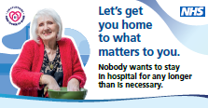 | There are many benefits to getting people home from hospital quickly and safely. Find out more about our campaign to reduce hospital stays in Lincolnshire at:  lincolnshire.icb.nhs.uk/when-am-i-going-home
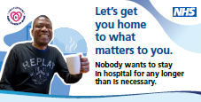 | There’s no place like home. Once people no longer need hospital care, it is best to get them home or to another community care setting as quickly as possible.  Find out more at: lincolnshire.icb.nhs.uk/when-am-i-going-home
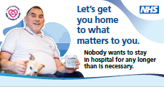 | We know that it’s much better for your physical and mental wellbeing to leave an acute hospital as soon as you are medically ready to do so. That’s why we are doing everything we can to reduce prolonged hospital stays and ‘get you home to what matters to you’.  Find out more at: lincolnshire.icb.nhs.uk/when-am-i-going-home
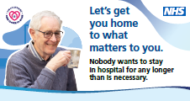 | Each week in a hospital bed means an older person loses 10% of their muscle strength. That’s why we are committed to reducing long hospital stays in Lincolnshire.  Find out more at: lincolnshire.icb.nhs.uk/when-am-i-going-home
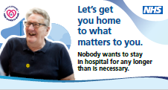 | Long stays in hospital can lead to worse health outcomes and increase long-term care needs. This is why we work with patients and their families to get them home to what matters to them.  Find out more at: lincolnshire.icb.nhs.uk/when-am-i-going-home
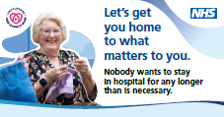 | Nobody wants to stay in hospital for any longer than is necessary. People recover more quickly surrounded by the people and things they love. So, we are working hard to reduce long stays in Lincolnshire hospitals.  Find out more at: lincolnshire.icb.nhs.uk/when-am-i-going-home

Staff discharge posts
Image | Supporting copy
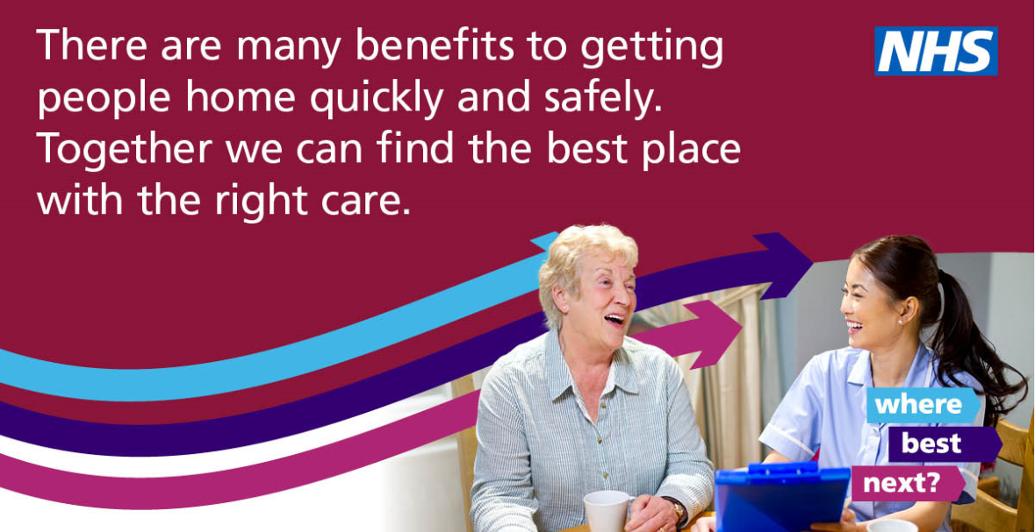 | Everyone has a key part to play in our determined drive to reduce long hospital stays in Lincolnshire. This is a team effort to get patients home to what matters to them.  Find out more at lincolnshire.icb.nhs.uk/when-am-i-going-home
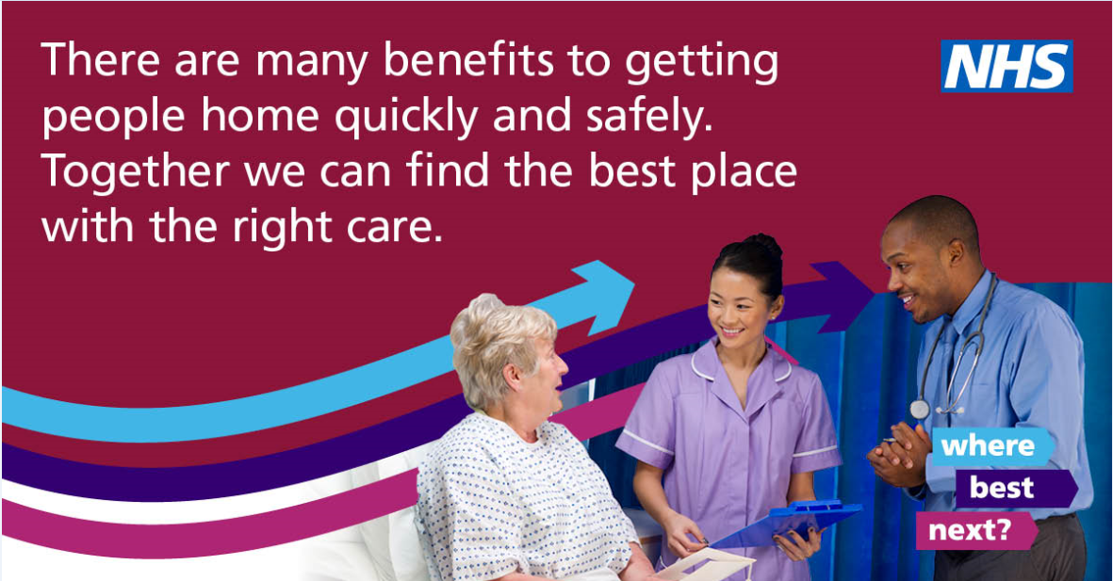 | By planning for discharge from admission and ensuring the plan is shared with the whole team and the patient, we can reduce long hospital stays.  Let’s get our patients home to what matters to them.
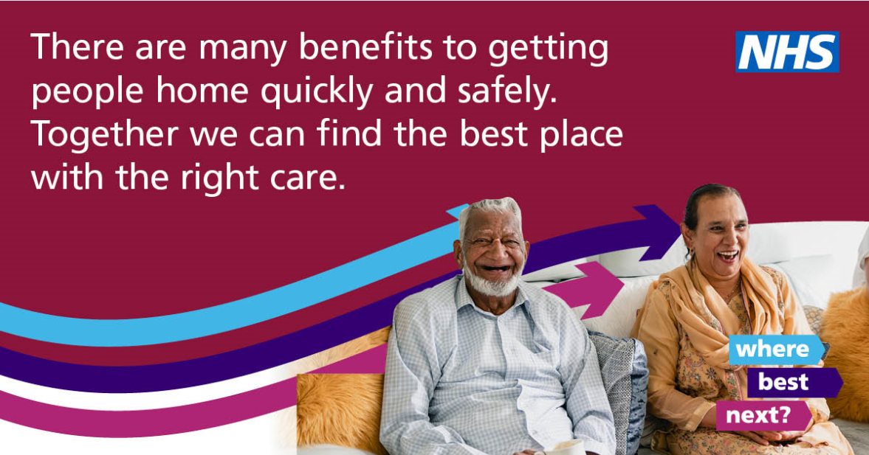 | Involve patients and their families in discharge decisions and share with them the benefits of leaving hospital at the right time.  Together we can get patients home to what matters to them.
Have weekly multidisciplinary team reviews for all long stay patients.
Together we can get patients home to what matters to them and reduce long hospital stays in Lincolnshire.
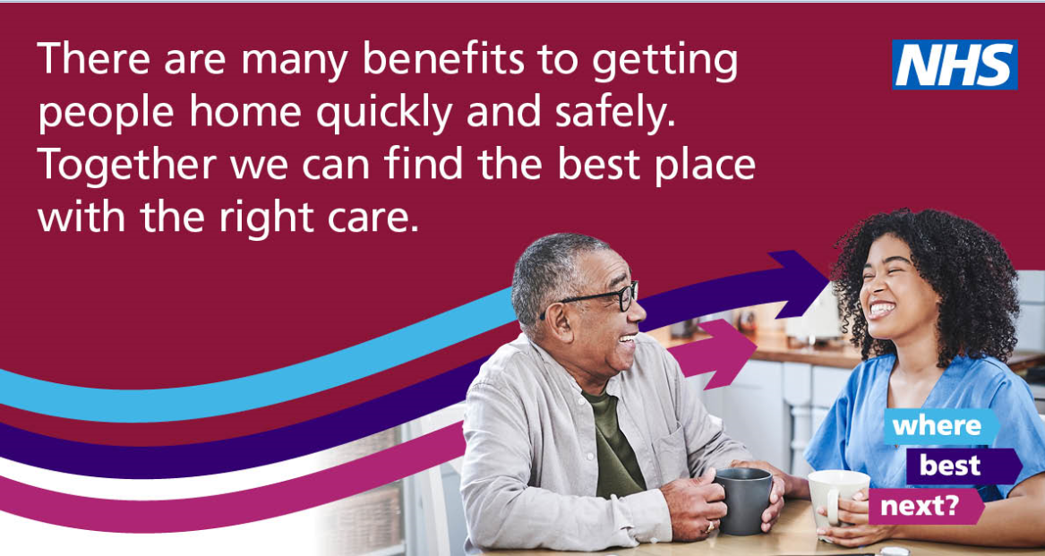 | We all have a part to play in enabling our patients, particularly older people, to continue their recovery in their own home environment. For those who cannot go straight home from hospital, we will continue this support within their care setting.  Together we can make it happen.

