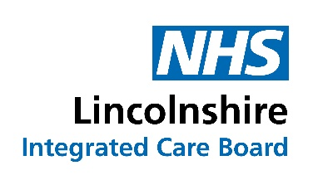

Board meeting - enquiry and comment form

This form enables you to make an enquiry, raise concerns or make comments about any aspect of discussion at the Board meeting. It can also be used to enquire about the work of the NHS Lincolnshire ICB.

Once completed please submit the form electronically to Mrs Jules Ellis-Fenwick, ICB Board Secretary and Head of Corporate Governance at julieellis1@nhs.net by no later than 5.00 pm on Monday, 27th March 2023.

A written reply will be sent as soon as possible after the meeting. To enable us to do this, please ensure that you provide us with your name and address in the space provided below.

Please indicate your enquiry, concern or make a comment below:

(Please use the reverse of the form if necessary)

To enable us to respond to you please indicate your name and address below.

Name:

Address:

………………………………………………………………..……………….Post code:

