

PRIMARY CARE MODEL
SAFEGUARDING POLICY

ICB document reference: | ICB SAFEGUARDING 010
Name of originator/author: | Safeguarding/Quality Team
Date of approval: | January 2023
Name of responsible Committee: | Clinical Policies Subgroup
Responsible Director/ICB Officer: | Martin Fahy
Category: | Safeguarding
EIA undertaken:

Date issued: | January 2023
Review date: | January 2024
Target audience: | All staff
Distributed via: | Email, Website, Intranet and Board Portal

Document Control Sheet

Document Title | Primary Care Model Safeguarding Policy
Version | 1
Status
Authors
Date | January 2023

Document history
Version | Date | Author | Comments
001 | January 2023 | Safeguarding Team/Quality

SAMPLE* Practice Policy for Safeguarding Adults and Children
*This document has been created by Lincolnshire ICB Safeguarding Team as an optional template for GP practices. The aim is that this can be used either as a replacement for any existing practice policy for safeguarding adults and children, or it can be used as a template to amend and adapt, to help ensure that information in any existing policy is up to date and comprehensive.
Sections in red should be amended/deleted.
All links and information are correct as of September 2022.
Dr Louise Roscoe, Named GP.

- Purpose and Declaration
- Legal Framework
- Sources of advice
- Training
- Information sharing
- Governance
- Mental Capacity and Consent
- Safeguarding Children
  - Recognising abuse
  - Making a referral
  - Parental responsibility
  - Was Not Brought (WNB)
  - Domestic Abuse
  - Childhood Sexual Exploitation (CSE)
  - Female Genital Mutilation (FGM)
  - Fabricated and Induced Illness (FAII)
  - Looked After Children (LAC)
  - Child Safeguarding Practice Reviews / SCR / CDOP
- Safeguarding Adults
  - Legislation
  - Recognising abuse
  - Making a safeguarding referral
  - Domestic Abuse
  - Forced Marriage
  - Prevent
  - SAR/DHR
- Escalations
- Appendix

Our Practice Safeguarding Policy:

This policy applies to all staff, volunteers and sessional workers, agency staff, students or anyone working on behalf of *name of practice.
The purpose of this policy is:
- To protect children, young people and adults at risk, who receive services at *name of practice
- To provide staff with the overarching principles that guide our approach to safeguarding adults and children.

Legal framework
This policy has been drawn up based on law and guidance that seeks to protect children and vulnerable adults, namely:
- Children Act 1989
- United Convention of the Rights of the Child 1991
- Data Protection Act 1998
- Human Rights Act 1998
- Sexual Offences Act 2003
- Children Act 2004
- Safeguarding Vulnerable Groups Act 2006
- Protection of Freedoms Act 2012
- Children and Families Act 2014
- Information sharing: Advice for practitioners providing safeguarding services to children, young people, parents and carers; HM Government 2015
- Working together to safeguarding children: a guide to inter-agency working to safeguard and promote the welfare of children; HM Government 2018
- Care Act 2014
- Mental Capacity Act 2005, and Mental Capacity (Amendment) Act 2019
- Domestic Abuse Act 2021

This policy should be read alongside our policies and procedures on: *
- Recruitment, induction, and training
- Managing allegations against staff and volunteers
- Information sharing
- Code of conduct for staff and volunteers
- Safer recruitment
- Anti-bullying
- Complaints
- Whistleblowing
- Health and safety
- Training, supervision, and support
- Lone working policy and procedure
- Quality assurance

^ *Delete or add to the above as appropriate according to your practice policies.

Links or overlaps with other key documents & strategies *check for updates annually

Document Title | Version and Issue Date | Link/Document
Lincolnshire Multi-Agency Safeguarding Adults Policy and procedures | January 2020 | Lincolnshire Safeguarding Adults Board – About the LSAB - Lincolnshire County Council  Safeguarding policy and procedures (lincolnshire.gov.uk)
Lincolnshire Multi-Agency Safeguarding Children’s Policy and procedures | Last update 2022 | https://lincolnshirescb.proceduresonline.com/
NHS England 2019 Safeguarding children, young people and adults at risk in the NHS: Safeguarding accountability and assurance framework | March 2013  updated July 2022 | https://www.england.nhs.uk/publication/safeguarding-children-young-people-and-adults-at-risk-in-the-nhs-safeguarding-accountability-and-assurance-framework/

Responsibilities
Dr/Nurse Xxxxx is the appointed Safeguarding Lead within the practice.
Dr/Nurse Yyyyy is the appointed Safeguarding Deputy Lead within the practice.
The Safeguarding Lead and Deputy are responsible for all aspects of the implementation and review of the safeguarding procedures in this practice.

Sources of advice and support
Practice Safeguarding Lead | Dr X  Contact number:
Practice Safeguarding Deputy Lead | Dr Y or nurse Y  Contact number:
Lincolnshire ICB Safeguarding Team:  Designate Nurse Safeguarding Children & Adults  Deputy Designate Nurse  Head of Safeguarding Adults and Primary Care  Head of Safeguarding Children, LAC, and Transition  Safeguarding Coordinator  Designated Doctor  Named GP  licb.safeguarding1@nhs.net | Lincolnshire Safeguarding Team - Lincolnshire ICB  Nicola Wilkinson  Gail Colley-Bontoft  Claire Tozer  Rebecca Pinder  Barbara Young  Dr Julian Saggiorato  Dr Louise Roscoe  For advice call: 01522 309317 / 309313  (Mon to Fri 0900-1700)
CSC Customer Service Centre—Children's Social Care | Tel: 01522 782111  Out of Hours: 01522 782333  Lincolnshire Safeguarding Children Partnership – About the LSCP - Lincolnshire County Council
Adult Social Care | Tel: 01522 782155  Out of Hours: 01522 782333  Lincolnshire Safeguarding Adults Board – About the LSAB - Lincolnshire County Council
PREVENT | National Counter Terrorism Hotline 0800 789 321 Or Police on 101 https://www.gov.uk/government/policies/counter-terrorism
Domestic Abuse | EDAN Lincs Domestic Abuse Service 01522 510041  DASH risk assessment form : www.domesticabuselincolnshire.com
Sexual Assault Referral Centre (SARC) | 01522 524402
NSPCC | www.nspcc.org.uk or 0808 800 5000

Training

The practice will ensure that all staff are up to date with their safeguarding training and are competent with the safeguarding processes. The following documents detail the required safeguarding training:
Adults: Intercollegiate Document; Adult Safeguarding: Roles and Competencies for Health Care Staff
Adult Safeguarding: Roles and Competencies for Health Care Staff | Royal College of Nursing (rcn.org.uk)
Children: Intercollegiate Document; Safeguarding Children and Young People: Roles and competencies for healthcare staff Safeguarding children and young people - roles and competencies | RCPCH
The RCGP Safeguarding Toolkit contains a training summary document, which summarises the level required and number of hours required over a 3-year period for all members of the primary care team (see appendix). Specialist safeguarding training for GPs and practice nurses can be accessed through the LSCP, LSAB and Lincolnshire CCG. safeguarding_training_requirements_for_primary_care_rcgp.pdf (gpappraisals.uk)
Access Lincolnshire CCG Safeguarding Training here; Advice and training for professionals - Lincolnshire ICB

Information Sharing, Consent and Confidentiality

Staff are required to have access to confidential information to do their jobs, and it is important to be aware that this may contain highly sensitive information.

If a member of staff is in any doubt about whether to share information or keep it confidential, he or she should seek guidance from the practice Safeguarding Lead.

Any actions should be in line with locally agreed information sharing protocols, and whilst the
Data Protection Act applies it does not prevent sharing of safeguarding information.

All professionals have a duty to disclose information where failure to do so would result in a child or children suffering from neglect, or physical, sexual, or emotional abuse, or a vulnerable adult suffering harm.

HM Government 2015 guidance for information sharing in safeguarding
There are seven golden rules of information sharing which emphasise that if possible, consent to share should be obtained from the patient and that any information shared must be necessary & proportionate, relevant, adequate, accurate, timely, secure, recorded and documented.

Data Protection Act 1998
This sets out the parameters for sharing information appropriately and safely.
‘Vital interest’ is a term used in the Date Protection Act to permit sharing of information where it is critical to prevent serious harm or distress.
Any personal information may be shared on the basis that it is:
- Necessary for the purpose for which it is being shared
- Shared only with those who have a need for it
- Accurate and up to date
- Shared securely and in a timely fashion

The Caldicott Standards
The Caldicott principles and processes provide a framework of quality standards for the management of confidentiality and access to personal information under the leadership of the Caldicott Guardian.

The named Caldicott Guardian / IG lead for the practice is: MR/S X………*

GMC Guidance

The GMC provides clear guidance that states the following.
- You must tell an appropriate agency promptly if you are concerned that a child or young person is at risk of, or is suffering, abuse or neglect.
- You should ask for consent before sharing confidential information unless there is a compelling reason for not doing so. Information can be shared without consent if it is justified in the public interest or required by law.
- Do not delay disclosing information to obtain consent if that might put children or young people at risk of significant harm.
- You should tell your patient what information has been shared, with whom and why, unless doing this would put the child, young person, or anyone else at increased risk

Ethical guidance for doctors - GMC (gmc-uk.org)

Governance
The practices hold regular (at least quarterly) safeguarding meetings where significant or critical incidents related to safeguarding can be reviewed. Those patients who are deemed as being at risk, including Looked After Children, on a Child Protection Plan, Child in Need Plan, or on an Adult Safeguarding Protection Plan are discussed. Relevant professionals allied to medicine are invited to these meetings.
To support this, the practice has a system that clearly identifies the following at risk patient groups:
- Subject to a Child Protection Plan (CPP)
- Subject to a Child in Need Plan (CIN)
- Looked After Child (LAC)
- Subject to a Safeguarding Adults Protection Plan
- Patients in high-risk Domestic Abuse cases including those heard at MARAC
Minutes from external meetings related to safeguarding (i.e. strategy meeting minutes or child protection case conference minutes) are attached in the notes and flagged on the IT system as containing third party information at the time of attaching
The practices respond to requests for safeguarding information, including reports, quality assurance data and information for statutory reviews including audits from the LCCG, the LSCP and the LSAB by submitting the required data or information within the requested timeframe.

Mental Capacity and Consent

Understanding the individual’s mental capacity is key to effective safeguarding and key to ensuring all the rights owed to the individual are met in full within the context of safeguarding, there must be evidence of due diligence and attention to mental capacity and consent.

The Mental Capacity Act 2005 provides a statutory framework to empower and protect people who may lack capacity to make decisions for themselves; and establishes a framework for making decisions on their behalf. This applies whether the decisions are life-changing events or everyday matters.

The Mental Capacity Act outlines five statutory principles that underpin the work with adults who may lack mental capacity:
- A person must be assumed to have capacity unless it is established that they lack capacity
- A person is not to be treated as unable to make a decision unless all practicable steps to help them to do so have been taken without success
- A person is not to be treated as unable to make a decision merely because they make an unwise decision.
- An act done, or decision made, under this Act for or on behalf of a person who lacks capacity must be done, or made, in the best interests of the patient
- Before the act is done, or the decision is made, regard must be had to whether the purpose for which it is needed can be as effectively achieved in a way that is less restrictive of the person's rights and freedom of action

The majority of adults that require additional safeguards are people who are likely to lack mental capacity to make decisions about their care and support needs.

Mental Capacity refers to the ability to make a decision about a particular matter at the time the decision is needed. It is always important to establish the mental capacity of an adult who is at risk of abuse or neglect, should there be concerns over their ability to give informed consent to:

- Planned interventions and decisions about their safety
- Their safeguarding plan and how risks are to be managed to prevent future harm

The Care Act 2014, statutory guidance advises that the priority in safeguarding should always be to ensure the safety and well-being of the adult.

Safeguarding Children Policy statement

Under the 1989 and 2004 Children Acts, a child or young person is anyone under the age of 18 years.
Safeguarding children is the action we take to promote the welfare of all children and protect them from harm.
Child protection refers to the activity that is undertaken to protect specific children who are suffering or at risk of suffering significant harm.
The practice recognises that all children, regardless of age, disability, gender, racial heritage, religious belief, sexual orientation, or identity, have a right to equal protection from all types of harm or abuse. The practice accepts its responsibility to safeguard the welfare of all children with whom staff may come into contact.
Working in partnership with children, young people, their parents, carers, and other agencies is essential in promoting young people’s welfare.

We intend to keep children and young people safe by:
- Valuing them, listening to and respecting them
- Responding quickly and appropriately where information requests relating to child protection are made, abuse is suspected, or allegations are made
- Providing children and parents with the chance to raise concerns over their own care or the care of others
- Having a system for dealing with, escalating, and reviewing concerns
- Providing effective management for staff through supervision, support, training to a level appropriate to their role and quality assurance measures
- Ensuring we have effective complaints and whistleblowing measures in place

Recognising Child Abuse and Neglect

The following NICE guidance offers excellent recommendations and advice about the recognition of child abuse and neglect in clinical presentations. All staff will be alert and aware of the following:

Overview | Child abuse and neglect | Guidance | NICE
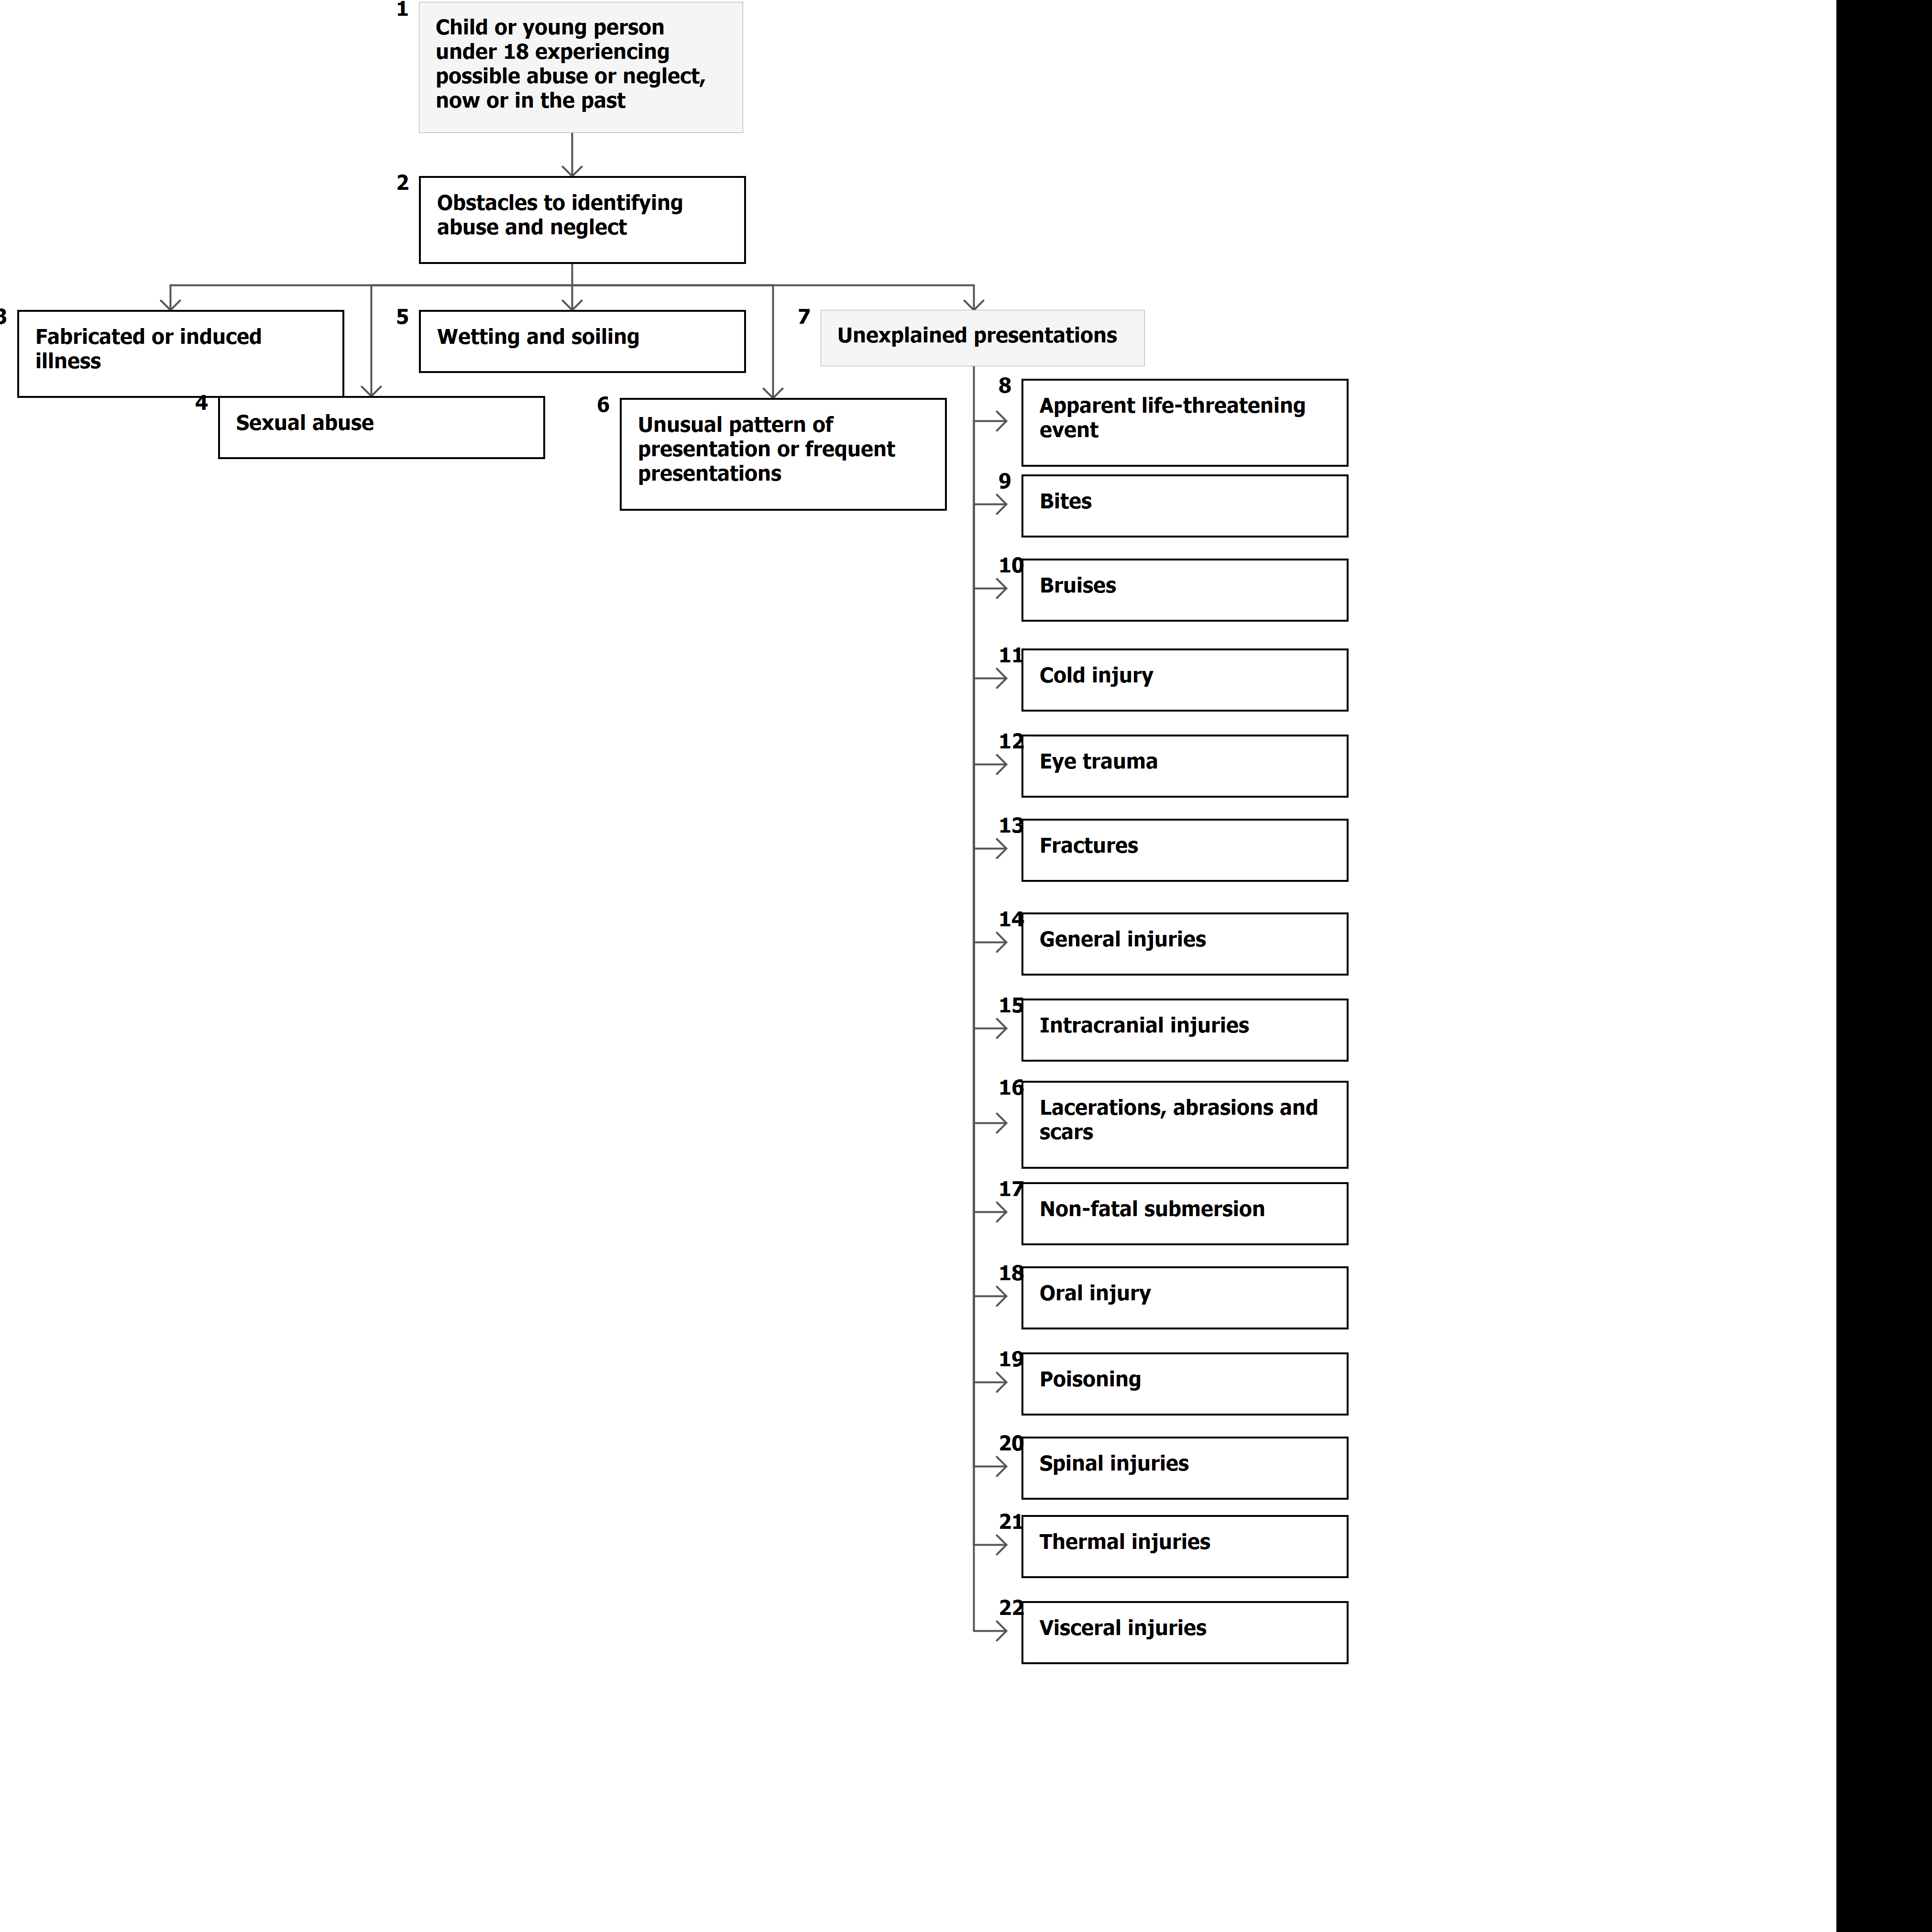
Immediate Action - Suspicion of Child Abuse:
- Concerns should be reported to the Lead clinician within the Practice or his / her deputy (above)
- Concerns should be discussed internally, and an action plan decided
- If referral is required, use the contact details below and the appropriate safeguarding referral forms
- If necessary, or in the absence of one of the nominated persons, consider discussing with the ICB Safeguarding Team
- If the suspicions relate to a member of staff there should be internal discussion with the Practice Safeguarding Lead or deputy, and a plan of action decided, the local Safeguarding Children team and / or social services should be contacted directly. Consideration should be made to involving the LADO
- Suspicions should not be raised or discussed with third parties other than those named above
- Any individual staff member must know how to make direct referrals to the child protection agencies and should be encouraged to do so if they have directly witnessed an abuse action
- Where emergency medical attention is necessary it should be given. If necessary, as per clinical judgement, the child should be admitted to the care of the emergency Paediatric service and a social services referral made. Any suspicious circumstances or evidence of abuse should be reported to the designated clinical Lead
- If making a social care referral, it is best practice to inform the parent(s) or carer unless doing so may increase the risk of harm to the young person. If referral is being made without the parent's knowledge or consent, social services should be informed of this and the reasons why
- Where sexual abuse is suspected the Practice Lead or Deputy will contact the Social Services or Police Child Protection Team directly. The Lead will not speak to the parents if to do so might place the child at increased risk
- Neither the Practice Safeguarding Lead or any other Practice team member should carry out any investigation into the allegations or suspicions of sexual abuse in any circumstances. The Practice Safeguarding Lead will collect exact details of the allegations or suspicion and provide this information to statutory child protection agencies: Social Care, the police or NSPCC, who have powers to investigate the matter under the Children Act 1989.

- Bruising and suspicious marks in non-independently mobile children
Bruising in a baby with no independent mobility is very uncommon and may be an indicator of serious medical condition or physical abuse. Immediate referral is required.

LSCP Policy can be found here: Bruising in Babies and Children who are Not Independently Mobile (proceduresonline.com)

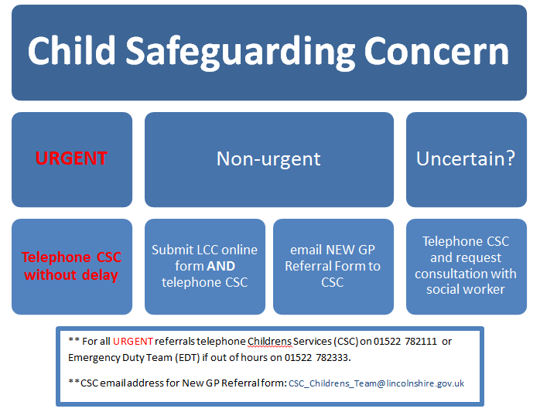

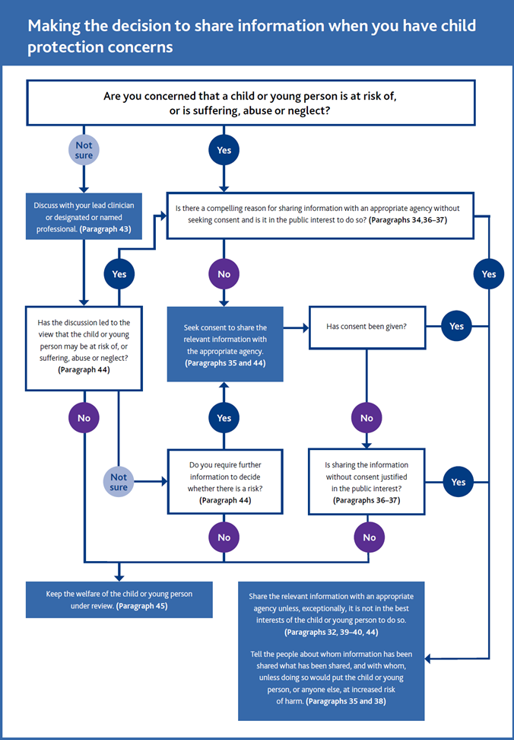
Parental responsibility (PR):
Birth mothers have parental responsibility. Fathers will have parental responsibility if named on the birth certificate, or if married to the mother at the time of birth.
In other scenarios the following may be helpful:

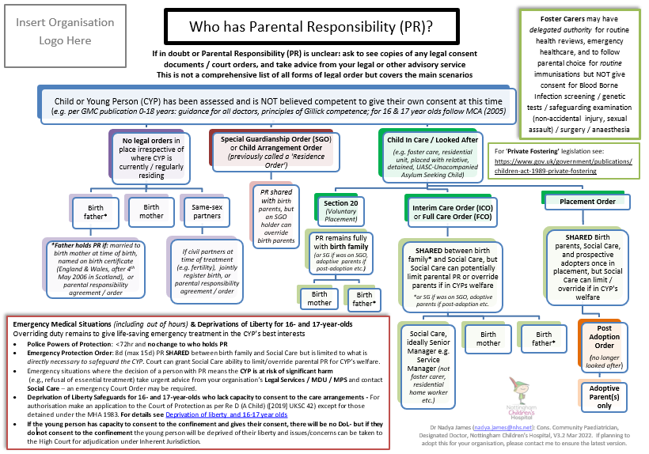

Was Not Brought / DNA:
Children missing a healthcare appointment should be coded as Was Not Brought (WNB) rather than Did Not Attend (DNA). We wish to emphasise that it is rarely the child’s fault that they miss appointments and that patterns of WNB may trigger concerns about welfare, given that they are reliant on their parent or carer to take them to the appointment. This is also relevant to vulnerable adults who rely on being brought to appointments, examples may include patients with learning disability, or dementia.
The National Service Framework for Children (2004) states that children or young people failing to attend clinic appointments “may trigger concern, given that they are reliant on their parent or carer to take them to the appointment. Failure to attend can be indicator of a family’s vulnerability, potentially placing the child’s welfare in jeopardy.”

Identify that child not brought to appointment in primary or secondary care

Assess the reason for the appointment and the impact on the health needs of the child/young person

If appointment known to be as a result of referral/recommendations from other Health Professionals notify these of the failure to attend

Consideration to be given to :-
- Clinical consequences of non-attendance – possible further appointment
- Safeguarding concerns, especially when there are multiple episodes of WNB – consider referral to social care
- Contacting the family, especially when there are multiple episodes of WNB
- Age of the child – do they have capacity to make their own choices?

Domestic Abuse
The Domestic Abuse Act 2021 created a new definition of Domestic Abuse:
The behaviour of a person (“A”) towards another person (“B”) is “domestic abuse” if—
(a)A and B are each aged 16 or over and are personally connected to each other, and
(b)the behaviour is abusive:
Behaviour is “abusive” if it consists of any of the following—
(a)physical or sexual abuse
(b)violent or threatening behaviour
(c)controlling or coercive behaviour
(d)economic abuse (see subsection (4))
(e)psychological, emotional or other abuse

Domestic Abuse is also safeguarding children issue:
- Risk of injury to unborn child
- Children can be injured or killed protecting the abused parent
- Abuser may also abuse children
- Children may be neglected physically or emotionally
- Emotional impact of hearing or witnessing events
- Difficulties making or maintaining relationships
- Difficulties and disruption to home and school life
- Children can become the victim’s confidante

The primary healthcare team’s role:

- Recognise patients whose symptoms mean they might be more likely to be experiencing domestic abuse, for example patients with mental health or drug and alcohol problems, or a previous history of DA
- Consider Stalking and Honour Based Abuse
- Enquire sensitively and provide a safe and empathetic first response
- Understand the practice’s process for responding to disclosure, and know what to do when there is immediate risk of harm to patients and their children
- Document domestic abuse within patient records safely and keep records for evidence purposes
- Consider making those entries NOT visible to online access in case perpetrator may be able to view them
- Share information appropriately. Information will be shared only with the consent of the patient, subject to practice policy on child protection and adult safeguarding. In exceptional circumstances information may be shared without the patient’s consent.

Immediate actions by the practice team:

- Complete a risk assessment: DASH form (domestic abuse, stalking and honour-based violence) - Forms available at www.domesticabuselincolnshire.com and via Ardens Templates on Systmone
- Identify those at high risk who should be referred to MARAC (multi agency risk assessment conference)
- Report to police if immediate risk is very serious, with consent if it is about a competent adult. If no consent, consider public interest test
- If below MARAC threshold, and there are no other concerns, help the person contact local specialist domestic violence services for help such as: changing locks; advice on legal routes, e.g., restraining orders or injunctions; emergency refuge accommodation; IDVA advocacy and support. Home - EDAN Lincs Domestic Abuse Service
- Make a MARAC referral based on professional judgment or if increasing frequency or severity of DA or concern of imminent risk:
- Secure email or fax both DASH and referral to maracreferral@lincolnshire.gov.uk or 01522 516092

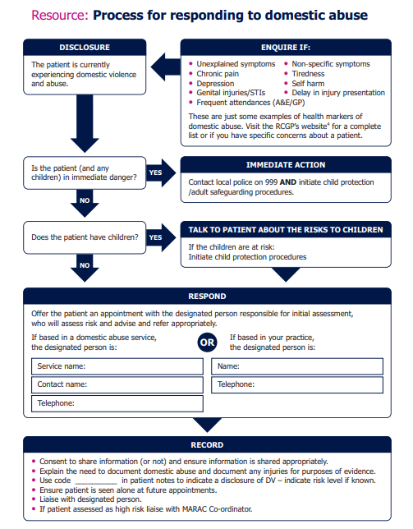

*Above flowchart: RCGP InnovAiT publication.

Childhood Sexual Exploitation
Practice staff must be aware of the risks of CSE and consider this in a variety of presentations.
CSE Warning Signs – SAFEGUARD:
- Sexual health and behaviour
- Absent from school/running away
- Familial abuse/problems at home
- Emotional and physical condition
- Gangs and involvement in crime
- Use of technology and sexual bullying
- Alcohol and drug misuse
- Receipt of unexplained gifts or money
- Distrust of authority figures
CSE may involve Inappropriate relationships, Grooming via a boyfriend figure, or organised exploitation via gangs or networks.

Practice Staff Actions:
- Talk to the young person alone (mobile switched off)
- Discuss with family – only IF appropriate to do so
- Refer via CSC or Police if immediate risk identified
- Lincolnshire Safeguarding Children Partnership – Child exploitation - Lincolnshire County Council
The link above contains access to CSE screening tool and referral information for MACE (Multi-agency Child Exploitation) for children whom you are concerned are at risk.
- Also use the above link for the partnership information form for concerns about child exploitation (criminal and sexual), human trafficking, modern slavery, county lines, cuckooing, knife crime

Female Genital Mutilation (FGM)
Female genital mutilation refers to procedures that intentionally alter or cause injury to the female genital organs for non-medical reasons. The practice is illegal in the UK. If someone is at risk of FGM or has had FGM, you must share this information with social care or the police.

UN Convention Rights of the Child 1989 protects from events that cause harm. Article 11 states parties shall take measures to prevent the illicit transfer and non-return of children abroad.
Article 19 states parties shall take appropriate legislative, administrative, financial, social and educative measures to protect the child from all forms of physical or mental abuse, neglect or negligent treatment, maltreatment or exploitation including sexual abuse whilst in the care of parents/guardians or other person who has care of the child.

GP’s now have a legal obligation to report suspected cases of FGM in patients under 18 years. (FGM Act 2003)
If a child is in immediate danger call 999 or 0808 800 5000
Practice Actions:
- Where possible offer to see the girl alone and with a female practitioner
- Remind them of their rights; FGM is illegal
- If it is a child, refer to childrens social care or police
- Read Code in patient notes
- Report in the following situations:
  - If informed by a girl under 18 that an act of FGM has been carried out on her
  - Observation of physical signs showing that an act of FGM has been carried out on a girl under 18
- Report to 101 (Lincolnshire Police Force Control Room)

Perplexing Presentations and Fabricated or Induced Illness

New RCPCH guidelines can be found here: Perplexing Presentations (PP)/Fabricated or Induced Illness (FII) in children – guidance – RCPCH Child Protection Portal

Term | Definition | Synonyms
Medically Unexplained Symptoms (MUS) | The child’s symptoms, of which the child complains, and which are genuinely experienced, are not fully explained by any known pathology but with likely underlying factors in the child (usually of a psychosocial nature), and the parents acknowledge this to be the case. The health professionals and parents work collaboratively to achieve evidence-based therapeutic work in the best interests of the child or young person. MUS can also be described as ‘functional disorders’ and are abnormal bodily sensations which cause pain and disability by affecting the normal functioning of the body. | Non-organic symptoms  Functional illness  Psychosomatic symptoms
Perplexing Presentations (PP) | Presence of alerting signs when the actual state of the child’s physical/ mental health is not yet clear but there is no perceived risk of immediate serious harm to the child’s physical health or life.
Fabricated or Induced Illness (FII) | FII is a clinical situation in which a child is, or is very likely to be, harmed due to parent(s’) behaviour and action, carried out in order to convince doctors that the child’s state of physical and/or mental health or neurodevelopment is impaired (or more impaired than is actually the case). FII results in emotional and physical abuse and neglect including iatrogenic harm. | Munchausen Syndrome by Proxy Paediatric Condition Falsification  Medical Child Abuse  Parent-Fabricated Illness in a Child (Factitious Disorder imposed on another when there is explicit deception)

It is very rare for parents or carers to deliberately induce illness in a child by, for example, poisoning them or withholding treatment. Most cases are based on incorrect beliefs or misplaced anxiety which, unchecked, can cause children to undergo harms ranging from missing school and seeing friends, to undergoing unnecessary and painful or even harmful tests and treatments. Health professionals have a duty of care to the child but, in almost every case, their work will form part of a collaborative approach which involves the parent or carer as well as the child.

The flow chart below shows action to consider if concerned about possible FII:
From RCGP guidance: Perplexing Presentations (PP)/Fabricated or Induced Illness (FII) in children – guidance – RCPCH Child Protection Portal

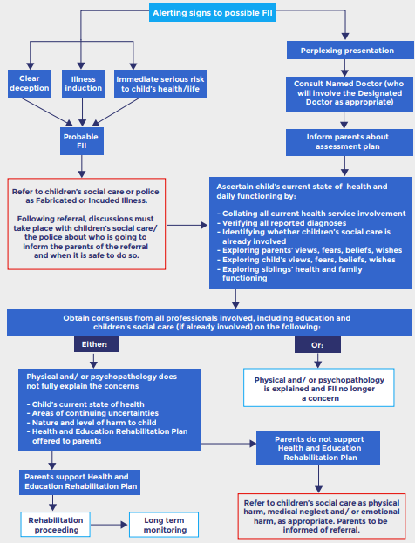

Looked After Children
The term ‘looked after children and young people’ refers to children and young people who may be accommodated under a voluntary agreement with their parents or their own, under section 20 (2) (I) of the Children Act (1989) or an Emergency Protection Order under Section 44 of the Children Act (1989).

Primary care responsibilities to looked after children includes:
- To act as advocates for the health of each child or young person who is Looked After.
- To ensure timely, sensitive access to a General Practitioner or other appropriate Health Professional when a child or young person who is looked after requires a consultation.
- To maintain a record of the health assessment and contribute to any necessary action within the health plan.
- To make sure that the clinical records, including referrals, make the “Looked After” status of the child or young person clear, so that their particular needs can be acknowledged. As such appropriate Read Codes should be used.

Rapid Reviews, SCR’s, Child Safeguarding Practice Reviews & CDOP
Child Safeguarding Rapid Reviews are a multiagency review of a case when a child has died or come to serious harm and abuse is either known or suspected. These enable a rapid evaluation of immediate actions that may be needed, and a decision is made on whether a case needs to proceed to a Child Safeguarding Practice Review.

Child Safeguarding Practice Reviews (previously called Serious case reviews, SCRs) are undertaken when abuse or neglect is known or suspected and either the child has died, or has been seriously harmed and there is cause for concern as to the way in which the Authority, their Board partners or other relevant persons worked together to safeguard the child (Working Together 2013)

The Child Death Overview Panel (CDOP) is a multi-agency group which reviews all child deaths up to the age of 18 years.

GPs will be expected to contribute to the above processes when requested, which may include providing a written report or liaising with LSCP.

Responding to requests for safeguarding/child protection information

Under section 14B of The Children Act 2004, the Local safeguarding Childrens Board (LSCB) can require a person or body to comply with a request for information. This can only take place where the information requested is for the purpose of assisting the LSCB to perform its functions. The request must be necessary and proportionate.

All requests for information relating to a child protection investigation or report for Case
Conference will be passed to the Child Safeguarding Lead or Deputy on the day received.
A response will be made in a timely manner, preferably within 48 hours.

The GMC guidance advises that ‘You should consider all requests for information for child protection purposes seriously and quickly, bearing in mind that refusing to give this information, or a delay in doing so, could increase the risk of harm to a child or young person or undermine efforts to protect them.’

Record keeping

All information received regarding children from the Safeguarding Children Team and any other associated Services should be regarded as strictly confidential.

- Child Protection Reports are as important as records of serious physical illness and should be recorded in the same way and with the same degree of permanence.
- Child’s records should be linked in some way to parents even if not living at the same address, siblings, and others in household by use of appropriate templates.
- Read codes expressing that a child is on a Child Protection Plan should be entered into notes of all individuals living at same address.
- It is vital that when a child who is or has been on a Child Protection Plan moves to another area that the full clinical record including Case Conference Reports be sent to the next GP. Therefore, they must NOT be kept separate or isolated from the child’s written or computer records.

Filing of Child Protection Documents
 | Read code  significant  details | Scan summary/  plan | Scan full  report
Subject  child | Yes | Yes | Yes
Other children in  household | Yes | Yes | No
Adults named  In report | Yes | Yes | No

If there are concerns about third party information, it is possible to remove this information if copies of the medical records are released for any reason, rather than not scanning it into the medical record in the first place.
It must be ensured that safeguarding episodes are coded appropriately. A full list of read codes can be found within the RCGP/NSPCC Safeguarding Toolkit available online at: RCGP-Safeguarding-Coding-Information-June-2017.pdf

Useful codes include:
64c (Ub0ex%) Child protection procedure – free text
13lv Child subject of a child protection plan
13ly Family member subject to a child protection plan
13lw (XaOtl) No longer on a child protection plan
8CM6 Child Protection Plan
9NZ1 Child not brought to appointment
9Ngj Adult safeguarding concern
13wx Child is cause for safeguarding concern
When entering THIRD PARTY information consider using the following format: ‘Family member (NHS no: XXXXX) reports X,Y&Z’ and add Read code 9LL ‘Record contains third party information’
Safeguarding Adult Policy statement

The aims of adult safeguarding are to:
- stop abuse or neglect wherever possible.
- prevent harm and reduce the risk of abuse or neglect to adults with care and support needs.
- safeguard adults in a way that supports them in making choices and having control about how they want to live.
- promote an approach that concentrates on improving life for the adults concerned.
- raise public awareness so that communities, alongside professionals, play their part in preventing, identifying and responding to abuse and neglect.
- provide information and support in accessible ways to help people understand the different types of abuse, how to stay safe and what to do to raise a concern about the safety or well-being of an adult; and
- address what has caused the abuse or neglect.

Definition of Adult Abuse:

“Any act or failure to act, which results in a significant breach of a vulnerable person’s human rights, civil liberties, bodily integrity, dignity or general well- being, whether intended or inadvertent, including sexual relationships or financial transactions to which a person has not or cannot validly consent or which are deliberately exploitative”

Categories of abuse:

- Physical abuse; including assault, hitting, slapping, pushing, misuse of medication, restraint or inappropriate physical sanctions including female genital mutilation.
- Domestic violence; including psychological, physical, sexual, financial, emotional abuse. So called ‘honour’ based violence and forced marriage.
- Sexual abuse; including rape, indecent exposure, sexual harassment, inappropriate looking or touching, sexual teasing or innuendo, sexual photography, indecent exposure and sexual assault or sexual acts to which the adult has not consented or was pressured into consenting.
- Psychological abuse; including emotional abuse, threats of harm or abandonment, deprivation of contact, humiliation, blaming, controlling, intimidation, coercion, harassment, verbal abuse, cyber bullying, isolation or unreasonable and unjustified withdrawal of services or supportive networks.
- Financial or material abuse; including theft, fraud, internet scamming, coercion in relation to an adult’s financial affairs or arrangements, including in connection with wills, property, inheritance or financial transactions, or the misuse or misappropriation of property, possessions, or benefits.
- Modern slavery; encompasses slavery, human trafficking, forced labour and domestic servitude. Traffickers and slave masters use whatever means they have at their disposal to coerce, deceive, and force individuals into a life of abuse, servitude, and inhumane treatment.
- Discriminatory abuse; including forms of harassment, slurs or similar treatment because of race, gender and gender identity, age, disability, sexual orientation, or religion.
- Organisational abuse: including neglect and poor care practice within an institution or specific care setting such as a hospital or care home, for example, or in relation to care provided in one’s own home. This may range from one off incidents to on-going ill-treatment. It can be through neglect or poor professional practice as a result of the structure, policies, processes, and practices within an organisation.
- Neglect and acts of omission; including ignoring medical, emotional, or physical care needs, failure to provide access to appropriate health, care and support or educational services, the withholding of the necessities of life, such as medication, adequate nutrition, and heating
- Self-neglect: this covers a wide range of behaviour neglecting to care for one’s personal hygiene, health or surroundings and includes behaviour such as hoarding.
Legislation

The Care Act 2014 introduced six principles that underpin adult safeguarding:

Empowerment – Personalisation and the presumption of person-led decisions and informed consent.
Prevention – It is better to take action before harm occurs
Proportionality – Proportionate and least intrusive response appropriate to the risk presented.
Protection – Support and representation for those in greatest need.
Partnership – Local solutions through services working with their communities.
Accountability – Accountability and transparency in delivering safeguarding.

We have a duty to promote these principles through discharging the functions of the CCG and by ensuring providers have these principles imbedded within their organisational philosophies and practices as they work with adults and adults at risk of abuse or neglect.

Section 42 Care Act 2014:
This section applies where a local authority has reasonable cause to suspect that an adult in its area:
- has needs for care and support (whether or not the authority is meeting any of those needs),
- is experiencing, or is at risk of, abuse or neglect, and
- as a result of those needs, is unable to protect him or herself against the abuse or neglect or the risk of it

Adult Safeguarding Referrals
What to do if you have concerns about an Adult’s welfare or an adult tells you about abuse:
- Concerns about the wellbeing and safety of an Adult at Risk must always be taken seriously. Any Practice member of staff who first becomes aware of concerns of abuse must report those concerns as soon as possible to the relevant senior manager/ safeguarding lead within the practice.
- When an adult makes a disclosure, it is important to reassure the adult at risk and that the information will be taken seriously. It is good practice to ensure that the adult is given information about what steps will be taken, including any emergency action to address their immediate safety or well-being.
- Using the principles of Making Safeguarding Personal (MSP), ensure that the adult at risk is consulted throughout and their wishes and views are central to any referral or actions taken as far as is possible.
- When suspecting or having abuse reported to them by a patient, practice staff will initially:
    - Take immediate action to ensure the safety or medical welfare of the adult
    - Not discourage the adult from further disclosure
    - Use active listening skill, clarify the main facts, and summarise what has been said to you
    - Remain supportive, sensitive, and attentive
    - Retain, record and report information
    - Inform the Practice Safeguarding Lead
- The human rights and views of the adult at risk should be considered as a priority, with opportunities for their involvement in the safeguarding process to be sought, ensuring that the process is person centred.
- If it is suspected that a crime could have been committed, contact the police 999 in an emergency or 101 for non-emergencies.
- Any disclosure must be recorded in the health records in the way that the adult at risk describes the events.
- If any member of the Practice team is unsure how to proceed or is in doubt about making an alert, the case can be discussed with a senior colleague/ line manager, Safeguarding Practice lead or a member of the ICB Safeguarding Team

If you wish to report abuse of an adult that is URGENT please contact the LCC team by phone:
Tel: 01522 782 155 out of hours: Tel: 01522 782 333
All other reporting abuse of an adult please contact LCC Safeguarding team above or complete the online form found at this address:
Adult_Safeguarding_Concern_Reporting_Form.docx (live.com)
This should be emailed to the Adult Safeguarding team at ASC@lincolnshire.gov.uk

Adults with capacity
A person’s ability to make a particular decision may at a particular time be affected by duress and undue influence or lack of mental capacity.
There may be a fine distinction between a person who lacks the mental capacity to make a particular decision and a person whose ability to make a decision is impaired, e.g. by duress or undue influence or the perceived lack of any alternative choice. Nonetheless, it is an important distinction to make.
Safeguarding interventions must ensure that when an adult with mental capacity takes a decision to remain in an abusive situation, they do so without duress or undue influence, with an understanding of the risks involved, and with access to appropriate services should they change their mind. The exception to this principle would occur in situations where the decision may have been influenced by threat or coercion and consequently lack validity and need to be over-ridden.
The Mental Capacity Act (MCA) 2005 provides a statutory framework that underpins issues relating to capacity and protects the rights of individuals where capacity may be in question. MCA implementation is integral to safeguarding vulnerable adults.
The 5 principles of the MCA must be followed and are directly applicable to safeguarding (see page 7)

Deprivation of Liberty Safeguards
The practice will also consider whether a person is deprived of their liberty as defined by the MCA in its Deprivation of Liberty Safeguards. If this deprivation is thought to be unlawful, this will be reported to the Local Authority within a reasonable time frame of usually no longer than 48 hours. The Local Authority holds the legal power to process an application and make a Deprivation of Liberty Safeguard (DOLS) order where it is decided that a person’s freedom needs to be restricted in their best interests.

Safeguarding adult review (SAR):
Commissioned by the LSAB under S.44 of the Care Act 2014, LSABs must arrange a SAR when an adult in its area dies as a result of abuse or neglect, whether known or suspected, and there is concern that partner agencies could have worked more effectively to protect the adult.
LSABs must also arrange a SAR if the same circumstances apply where an adult is still alive but has experienced serious neglect or abuse. SABs are free to arrange for a SAR in other situations where it believes that there will be value in doing so. This may be where a case can provide useful insights into the way organisations are working together to prevent and reduce abuse and neglect of adults and can include exploring examples of good practice

Forced Marriage

A forced marriage is where one or both people do not (or in cases where someone lacks capacity, cannot) consent to the marriage and pressure, coercion, threats or abuse are used. There may be a link to Honour Based Violence.

The Anti-social Behaviour, Crime and Policing Act 2014 makes it a criminal offence to force someone to marry.

- Contact Forced Marriage Unit on 0207 0080151
- Forced marriage - GOV.UK (www.gov.uk)

DNA/Was not supported to attend
LSAB have recently produced new guidance for vulnerable adults not supported to attend appointments:
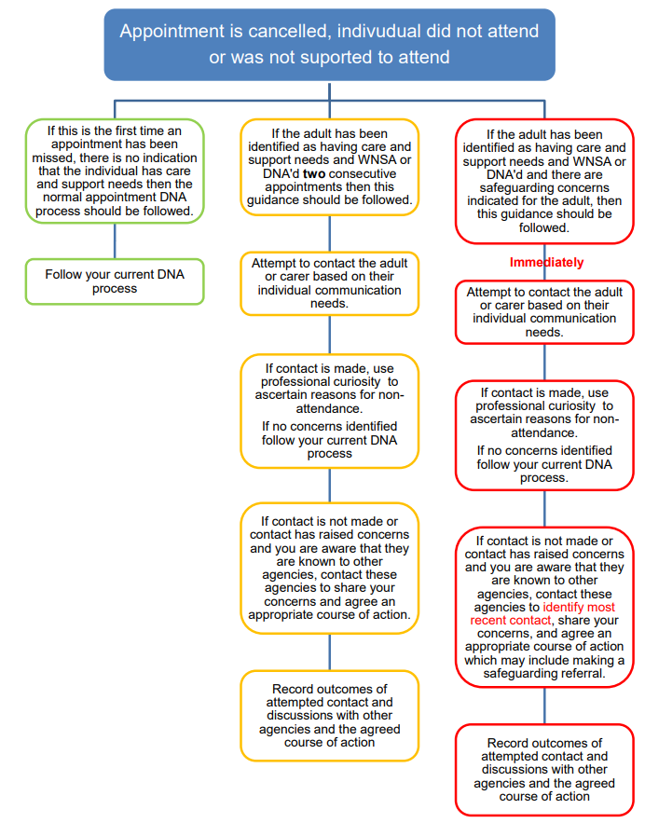

Lincolnshire Safeguarding Adults Board – Did not attend or was not supported to attend guidance - Lincolnshire County Council
PREVENT

The Government’s anti-radicalisation Prevent strategy aims to stop people becoming terrorists or supporting terrorism.

The Health Service is a key partner in Prevent and encompasses all parts of the NHS, charitable organisations and private sector bodies which deliver health services to NHS patients.
Three national objectives have been identified for the Prevent strategy:
- Objective 1: Respond to the ideological challenge of terrorism and the threat we face from those who promote it.
- Objective 2: Prevent people from being drawn into terrorism and ensure that they are given appropriate advice and support.
- Objective 3: Work with sectors and institutions where there are risks of radicalisation which we need to address.

Prevent focusses on working with vulnerable individuals who may be at risk of being exploited by radicalisers and subsequently drawn into terrorism related activity.

It is important to note that PREVENT operates within the pre-criminal space and is aligned to the multi-agency safeguarding agenda:
· Notice: if you have a cause for concern about someone, perhaps their altered attitude or change in behaviour
· Check: discuss concern with appropriate other (safeguarding lead)
· Share: appropriate, proportionate information (safeguarding lead/PREVENT lead)

Consider discussion with local safeguarding teams, or calling the anti-terrorist hotline 0800 789321

To access local referral forms, use this link: Prevent | Lincolnshire Police (lincs.police.uk)
Remember that a referral to PREVENT should be done without consent, as there is a risk that by asking for consent you may disrupt an active police investigation.

Domestic homicide review (DHR)

Commissioned by the Community Safety Partnership (CSP) under S.9 Domestic Violence, Crime and Victims Act (2004). The act states:
- In this section “domestic homicide review” means a review of the circumstances in which the death of a person aged 16 or over has, or appears to have, resulted from violence, abuse, or neglect by—
  - a person to whom he was related or with whom he was or had been in an intimate personal relationship, or
  - a member of the same household as himself, held with a view to identifying the lessons to be learnt from the death.
  - This scope also extends to include;
`Where a victim took their own life (suicide) and the circumstances give rise to concern, for example it emerges that there was coercive controlling behaviour in the relationship, a review should be undertaken, even if a suspect is not charged with an offence or they are tried and acquitted.`

Escalations – Children and Adults

At various times during the joint involvement and management of a case, professional differences of opinion and judgement emerge.
If this occurs the practitioner should discuss with the practice Safeguarding Lead in the first instance.
Please see Lincolnshire Professional Resolution and Escalation Protocol:
https://www.lincolnshire.gov.uk/downloads/file/3488/joint-professional-resolution-and-escalation-protocol

Additional Information
We recommend that all staff download the Safeguarding App to their desktop:
NHS Safeguarding (myguideapps.com)
We are committed to reviewing our policy and good practice annually.
This policy was last reviewed on: ……………………****……………………………. (date)

Signed: this should be signed by the safeguarding lead*

Appendix
- Useful contacts:

  - Lincolnshire Safeguarding Childrens Partnership Lincolnshire Safeguarding Children Partnership – About the LSCP - Lincolnshire County Council
  - CSC Children Social Care 01522 782111 (OOH 01522 782333) Childcare and family support – Lincolnshire County Council
  - Lincolnshire Safeguarding Adults Board Lincolnshire Safeguarding Adults Board – About the LSAB - Lincolnshire County Council
  - Adult Social Care 01522 782155 Adult social care – Lincolnshire County Council
  - Edanlincs Domestic Abuse: Home - EDAN Lincs Domestic Abuse Service
  - Sexual Assault referral Centre (SARC) 01522 524402 Home :: Spring Lodge Centre (lpft.nhs.uk)
  - 24 hour national domestic violence helpline. 0808 2000 247 www.nationaldomesticviolencehelpline.org.uk
  - Respect Phoneline 0808 802 2040 www.respectphoneline.org.uk
  - NSPCC 0808 800 5000 www.nspcc.org.uk
  - Forced Marriage Unit: 0207 0080151 Forced marriage - GOV.UK (www.gov.uk)
  - Lincolnshire ICB Safeguarding Team licb.safeguarding1@nhs.net
  - FGM Guidance fgm-hp-guide.pdf (england.nhs.uk)
  - Perplexing Presentations Guidance Perplexing Presentations (PP)/Fabricated or Induced Illness (FII) in children – guidance – RCPCH Child Protection Portal
  - Prevent Guidance Building Partnerships, Staying Safe (publishing.service.gov.uk)
  - Lincolnshire Prevent Prevent | Lincolnshire Police (lincs.police.uk)
  - National police prevent advice line 0800 0113764

Equality Impact Analysis Form

Project Details

Project Name: | GP Practice Safeguarding Policy
EA Author: | Dr Louise Roscoe
Team: | ICB Safeguarding Team
Date completed: | December 2022
Version: | 2

What is the aim of the project/proposal?
This policy contains key information for safeguarding adults and children in primary care; the information is up to date, with local referral processes, and is collated in a single document.
Practices are not obliged to implement this policy, it is done in a supportive manner to enable practices to make a choice in how it will best help them; they can use this as their own practice policy, or adapt it as they see fit, or take sections from it and amend their current policy.

Who will be affected by this work? e.g., staff, patients, service users, partner organisations etc.
Implementation of this policy will have a positive impact on service users as it will provide staff with a pathway and framework to follow which they can refer to if they have any safeguarding concerns. At risk service users will benefit from any issues being identified and interventions being made at an early stage to support them.

Stage 1, Scoping point

Is a full Equality Impact Analysis required for this project?

You should consider whether a full EIA is required, referring to the relevant guidance for information and guidance on making this decision.

It is important this decision is made with an open mind and correctly, advice should be sought from the EIHR team if you are unsure.

Yes |  | Proceed to the full Equality Impact Analysis form | No |  | Explain why further analysis is not required.
If no, explain below why further Equality Impact Analysis is not required. E.g., ‘This report is for information only’ or ‘The decision has not been made by the ICB’ or ‘The decision will not have any impact on patients or staff’. (Very few decisions affect all groups equally and this is not a rationale for not completing an EIA.)

Equality Impact Analysis Form

If at an initial stage further information is needed to complete a section this should be recorded and updated in subsequent versions of the EIA. An Equality Impact Analysis is a developing document, if you need further information for any section then this should be recorded in the relevant section in the form and dated.

1. Evidence used

To demonstrate that the decision made has been informed you should include examples of the information used to determine the impact and complete the EIA.

Examples are likely to include:

- Population Data - e.g., demographic profile (Census),
- Service Activity Data e.g., profile of patients using a service
- Consultation and Involvement findings - e.g., any engagement with service users, local community, specific groups.
- Research - e.g., good practice guidelines, service evaluations, literature reviews, reports
- Participant knowledge - e.g., experiences of working with different or population groups, experiences of service users in other service areas / localities

It is recommended that GP practices have an up-to-date Safeguarding Policy for Adults and Children. Some practices may have policies that are outdated or do not contain full necessary guidelines.
Creating this template Practice Policy means that GP practices can adapt it, knowing that it contains up to date relevant information for the Lincolnshire population. The hope that this will help practitioners by having a clearly written policy to refer to, and a standardised approach to safeguarding in primary care, backed up by policy and guidelines. It is important to remember that this is an optional policy, as each GP practice works independently and will have variations in their day-to-day practice, however the safeguarding principles will remain the same and that is what is outlined here. This policy is relevant to all ages and all vulnerability groups.

2. Impact of decision
In the following boxes detail the findings and impact identified (positive or negative) within the research detailed above; this should include any identified health inequalities which exist in relation to this work.

As part of these considerations, you should consider how the ICB will be meeting the requirements of the Public Sector Equality Duty

• Removing or minimising disadvantages suffered by people due to their protected characteristics.
• Taking steps to meet the needs of people from protected groups where these are different from the needs of other people.
• Encouraging people from protected groups to participate in public life or in other activities where their participation is disproportionately low.

Before completing this section, you should ensure you can suitably answer the following:

What is the equality profile of the population i.e., service users/patients and/or workforce that is intended to benefit from the activity/project?
(By collecting and analysing demographic data of protected characteristics relating to patients/service users and/or workforce, within the geographical area concerned, the ICB will be able to identify the groups that may be adversely affected at a greater proportion to others).

2.1 Age
Describe age-related impact and evidence. This can include safeguarding, consent, and welfare issues.
Implementation of this policy will support safeguarding in CYP and in adults.

2.2 Disability
Describe disability-related impact and evidence. This can include attitudinal, physical, communication and social barriers as well as mental health/learning disabilities, cognitive impairments.
Implementation of this policy will support safeguarding in this vulnerable cohort of patients.
2.3 Gender reassignment (including transgender)
Describe any impact and evidence in relation to transgender people. This can include issues such as privacy of data and harassment.
This is not covered as a separate entity within the policy but transgender people face the same safeguarding risks as others. However, they may be at greater risk of some types of abuse, for example sexual abuse, online abuse or sexual exploitation which is covered in the policy. Further guidance will be considered in future updates in line with national policies or guidance that may be released.
2.4 Marriage and civil partnership
Describe any impact and evidence in relation to marriage and civil partnership. This can include working arrangements, part time working and caring responsibilities.
n/a

2.5 Pregnancy and maternity
Describe any impact and evidence in relation to Pregnancy and Maternity. This can include working arrangements, part time working and caring responsibilities.?
There is an increased risk of domestic abuse in pregnancy and practitioners should follow the guidance within the policy relating to domestic abuse.
2.6 Race
Describe race-related impact and evidence. This can include information on different ethnic groups, Roma gypsies, Irish travellers, nationalities, cultures, and language barriers.
The impact of this policy will be of a supportive nature with the contact numbers listed being relevant to this cohort of patients. There is crossover between Race (culture), Religion/belief and there may be a requirement for additional training in this. E.g Some people in the travelling communities do not allow females to attend GP appointments without a male present - this could be picked up as a safeguarding concern where in actual fact it may not be. Cultural sensitivity is required.
2.7 Religion or belief
Describe any impact and evidence in relation to religion, belief or no belief on service delivery or patient experience. This can include dietary needs, consent, and end of life issues.
None identified
2.8 Sex
Describe any impact and evidence in relation to men and women. This could include access to services and employment.
n/a
2.9 Sexual orientation
Describe any impact and evidence in relation to heterosexual people as well as lesbian, gay and bisexual people. This could include access to services and employment, attitudinal and social barriers.
Those patients who identify as LGBTQ+ face the same risks as other members of society but they may be at greater risk of some types of abuse. For example, they might experience homophobic, biphobic or transphobic bullying or hate crime. They might also be more vulnerable to or at greater risk of sexual abuse, online abuse or sexual exploitation. These types of abuse are covered within the policy.
2.10 Carers
Describe any impact and evidence in relation to part-time working, shift-patterns, general caring responsibilities. (Not a legal requirement but a ICB priority and best practice)
Implementation of this policy will support caregivers in cases where there is a potential that they may be harmed/abused by the person they are looking after.
2.11 Other disadvantaged groups
Describe any impact and evidence in relation to groups experiencing disadvantage and barriers to access and outcomes. This can include socio-economic status, resident status (migrants, asylum seekers), homeless people, looked after children, single parent households, victims of domestic abuse, victims of drug/alcohol abuse. This list is not finite. This supports the ICB in meeting its legal duties to identify and reduce health inequalities.
The safeguarding policy includes consideration of vulnerable groups.

3. Human rights
The principles are Fairness, Respect, Equality, Dignity and Autonomy.
Will the proposal impact on human rights? | Yes | x | No
Are any actions required to ensure patients’ or staff human rights are protected? | Yes |  | No
If so, what actions are needed? Please explain below.
Human rights are specifically considered within the policy, for example there is consideration of capacity and consent.

4. Health Inequalities.

The Health and Social Care Act 2012 established the first specific legal duties on s ICB’s to have regard to the need to reduce inequalities between patients in access to, and outcomes from, healthcare services and in securing those services are provided in an integrated way. These duties had legal effect from April 1st, 2013.
The duties require that ICB’s properly and seriously considers inequalities when making decisions or exercising functions, and has evidence of compliance with the duties, whilst also assessing how well commissioned providers have discharged their legal duties on health inequalities.

- What evidence have you considered to determine what health inequalities exist in relation to your work?

This can include local and national research, surveys, reports, research interviews, focus groups, pilot activity evaluations or other Equality Analyses. If there are gaps in evidence, state what you will do to mitigate them.

(This may be different or similar to that which has informed the EIA)

The policy is applicable to all patients within primary care which will include all vulnerability groups
- What is the potential impact of your work on health inequalities? Can you demonstrate through evidenced based consideration how the health outcomes, experience and access to health care services differ across the population group and in different geographical locations that your work applies to?

If you feel that the project will not impact / be relevant to Health Inequalities, please give a rationale.

3. How can you make sure that your work has the best chance of reducing health inequalities?
Vulnerable groups are included within the policy.

5. Engagement/consultation
What engagement is planned or has already been done to support this project?

It is expected that the ICB will have carried out a level of engagement with those affected whether formal or informal. This should be focussed to the groups most affected.

Engagement activity | With whom?  e.g., protected characteristic/group/community | Date
Discussion and review | Safeguarding Team Lincs ICB | OCT 2022
Please summarise below the key finding / feedback from your engagement activity and how this will shape the policy/service decisions e.g., patient told us, so we will… (If a supporting document is available, please provide it or a link to the document)
Some minor amendments were made based on discussion within the team.

6. Mitigations and changes
If you have identified mitigations or changes, summarise them below. E.g. restricting prescribing over the counter medication. It was identified that some patient groups require high volumes of regular prescribing of paracetamol, this needs to remain under medical supervision for patient safety, therefore an exception is provided for this group which has resolved the issue.

Are these vital to the project continuing?
n/a

7. Is further work required to complete this EIA?
Please state below what work is required and to what section e.g., additional consultation or engagement is required to fully understand the impact on a particular protected group (e.g. disability)
Work needed | Section | When | Date completed

8. Development of the Equality Impact Analysis
If the EIA has been updated from a previous version, please summarise the changes made and the rationale for the change, e.g. Additional information may have been received – examples can include consultation feedback, service Activity data
Version | Change and Rationale | Version Date
e.g., Version 0.1 | The impact on wheelchair users identified additional blue badge spaces are required on site to improve access for this group. | 26 September 2017

9. Final Sign off
Completed EIA forms must be signed off by the completing manager. They will be reviewed as part of the decision-making process. Service lines should maintain an up-to-date log of all EIAs.
Version approved:
 |  | Name | Date
Signature of responsible officer
Which committee will be considering the findings and sign off the EA?
Minute number (to be inserted following presentation to committee)

Stage One - Quality Impact Assessment Initial Screening Tool
Item 15e

The QIA Initial Screening Tool is required for all projects to identify the project’s impact on quality, be it positive, neutral, or adverse.

Five quality domains are thereby defined in the Initial Screening Tool, against which risks must be assessed and scored (see Appendix B for instructions on scoring).

For each quality domain in the Initial Screening Tool, highlight the proposal’s impact on quality as either positive (P), neutral (N) or adverse (A). For neutral and adverse impacts, add a score for consequence (C) and likelihood (L) (Appendix B). Multiply the consequence and likelihood scores and record that number as the total score (T), then enter yes or no regarding need for a Stage 2 QIA for any domains with scores of 8 or greater. Calculate and record the total score of all domains. Complete an Equality Impact Assessment (EIA) and the EIA section on the QIA screening tool.

Quality Impact Assessment - Initial Screening Tool |  |  |  | Instructions:
- Answer Positive, Neutral or Adverse (P, N or A) against each quality domain
- If Neutral or Adverse, insert a Consequence (C) and Likelihood (L) score, multiply the scores, and insert the total score in the Total (T) column
- Add a brief description of the potential impact and mitigating actions
- Insert Y (yes) indicating need for a Stage 2 QIA for any domains with scores of 8 or greater
- Record the total score of all domains
- Complete an Equality Impact Assessment (EIA) and the EIA section on the QIA screening tool
Quality Domain | Impact Question |  |  | P/  N/  A | C | L | T | Brief description of potential impact |  |  | Mitigation strategy and monitoring arrangements | Stage 2 QIA?  Y/N
Quality Domain | Could the proposal impact on any of the following?
Duty of Quality | - The duty to safeguard children and vulnerable adults  - The duty to promote equality – see https://bit.ly/3v85CNs  - The functions of other services within the organisation  - The clinical effectiveness of services  - Patients’ and public experiences of services  - Compliance with NHS constitution’s core principles - see https://bit.ly/37vzY4k  Any other factors related to the duty to uphold and improve quality |  |  | P |  |  |  | The policy relates entirely to safeguarding children and adults and will help to promote this and provide a framework to work to within general practices.
Patient Safety | - Avoidable harm; clinical/environmental/other  - Infection prevention and control practices, systems, statutory expectations and acceptable standards  - Referral to treatment times  - Safeguarding Adults, Young People & Children – see https://bit.ly/3jeY3ih  - Workforce levels and competencies  Any other risk indicators relevant to patient safety |  |  | P |  |  |  | The policy aims to help those working in general practice in fulfilling their safeguarding duties, providing detailed reference guides to follow and includes referral information to local agencies.
Patient / Staff Experi-ence | - Informed choice, autonomy, and involvement  - Access to services  - Dignity, respect, compassion, and consent  - Patients’ satisfaction with services  - Complaints and redress  Any other risk indicators relevant to patient experience: |  |  | P |  |  |  | Patient experience should be improved if practitioners follow the guidance within this policy as it should help to safeguard them from harm.  It also includes guidance on consent .
Clinical effecti-veness | - Evidence based practice & standards  - Clinical outcomes  - Clinical leadership and engagement  Any other risk indicators relevant to clinical effectiveness: |  |  | P |  |  |  | The policy is based on national guidance as well as legislative acts.
Non-clinical/ operati-onal impact | - Impact on cost effectiveness  - Impact on infrastructure  - Impact on staff satisfaction and welfare  - Impact on the public perception of the organisation  - Social value impact  - Relationships with partner organisations |  |  | P |  |  |  | Relationships with partner organisations will be strengthened by following referral guidance and information sharing guidance within the policy.
Non-clinical/ operati-onal impact |  |  |  | Total overall score =
EQUALITY |  | An Equality Impact Assessment must also be undertaken
Name of person completing  the Equality Impact Assessment: |  |  | Dr Louise Roscoe |  |  |  |  |  |  | Date: | Signature:  LR
Position: |  |  | Named GP Safeguarding Adults and Children |  |  |  |  |  |  | December 2022

